DOCUMENT
PcVue features

Last update : | May 2026
Revision : | 29
Content :  Confidentiality : | Technical features for PcVue  C0 - Public

The information in this book is subject to change without notice and does not represent a commitment on the part of the publisher. The software described in this book is furnished under a license agreement and may only be used or copied in accordance with the terms of that agreement. It is against the law to copy software on any media except as specifically allowed in the license agreement. No part of this manual may be reproduced or transmitted in any form or by any means without the express permission of the publisher. The author and publisher make no representation or warranties of any kind with regard to the completeness or accuracy of the contents herein and accept no liability of any kind including but not limited to performance, merchantability, fitness for any particular purpose, or any losses or damages of any kind caused or alleged to be caused directly or indirectly from this book. In particular, the information contained in this book does not substitute to the instructions from the products’ vendor. This book may contain material belonging to third-parties. Such information is used exclusively in internal work processes and is not intended to be disclosed. In addition, this notice is not a claim of property on such third-party information.
All product names and trademarks mentioned in this document belong to their respective owner.

Content

1. Quickstart project 2
2. Advanced Configuration Environment - ACE 4
2.1 Application Explorer 4
2.1.1 Configuration & Diagnostic 4
2.1.2 Configuration wizards 5
2.2 Application Architect 6
2.2.1 Application modeling 6
2.2.2 Partial Generation 10
2.3 Smart Generators 11
2.3.1 Available Smart Generators 11
3. Real-time Data 12
3.1 Structure 12
3.2 Generic Approach 14
3.3 Data Types 16
3.4 VTQ – Value Time Quality 16
3.5 Properties 16
3.6 Attributes and Filters 16
3.7 Associated labels 18
3.7.1 Bits and alarms associated labels 18
3.8 Associated behaviors 19
3.9 Alarms 19
3.9.1 Alarm levels 20
3.9.2 Temporization 20
3.9.3 Thresholds 21
3.9.4 Masking 21
3.9.5 Alarm counters 22
4. Data Acquisition 23
4.1 Drivers and communication interfaces 24
4.2 BACnet IP/BACnet SC 24
4.2.1 BACnet IP 24
4.2.2 BACNET SC 29
4.3 SNMP 30
4.4 IoT – Internet Of Things 33
4.4.1 PcVue IoT HUB 33
4.4.2 IoT Connectivity 33
4.5 Time-stamped data 34
4.6 Communication check 34
5. Interoperability with 3rd party systems 34
5.1 Data exchange standards 34
5.1.1 OPC 34
5.1.2 SNMP Agent 34
5.1.3 Files import/export 34
5.1.4 FTP 34
5.2 Universal Data Connector – ADO.NET 35
5.3 Software Development Kits 35
5.3.1 Generic Import Toolkit 35
5.3.2 Manager Toolkit 35
5.3.3 Protocol Toolkit 37
5.3.4 Web Services Toolkit 37
6. Graphical Interface – HMI 38
6.1 Design and animations 38
6.2 Libraries 40
6.3 Multi-language HMI platform ready 42
6.4 Multi-screen 42
6.5 Run-Time 42
6.5.1 Layers system 42
6.5.2 Zoom 42
6.5.3 The mimic tab control 42
6.5.4 The mimic Navigator 43
6.5.5 Contextual objects for easy access to data 43
6.5.6 The Alarm Viewer 45
6.5.7 Trending 47
6.5.8 The Events Log Viewer 51
6.5.9 Controls 53
6.5.10 GEO Map Control 54
6.5.11 Keyboard configuration 58
6.5.12 BIM operations 59
6.5.13 Video Integration 62
6.5.14 Instant messaging 65
7. Data processing 66
7.1 Archiving 66
7.1.1 SQLServer archiving using Historical Data Server (HDS) 67
7.1.2 Event log and Sequence Of Events (SOE) 67
7.1.3 VCR Replay feature 68
7.2 Data processing and Reporting 68
7.2.1 Data Export – Data Statistics from PcVue to Microsoft Excel® 68
7.2.2 Dream Report 70
7.2.3 SQL Server Reporting Services (SSRS) 72
7.3 AI, Optimization and Intelligent Control 75
7.3.1 Intelligent Assistance for Efficient Operation 75
7.3.2 Bots: Processing Agents 75
7.3.3 Jobs: Orchestration and Distributed Execution 76
7.3.4 Configuration Environment 77
7.3.5 Fields of Application 77
7.4 Energy Monitoring and Analysis – EmVue 78
7.4.1 Overview 78
7.4.2 Main Features 78
7.4.3 Technical advantages 81
7.4.4 Architecture and Integration 81
7.4.5 Summary 81
7.5 On Call management 81
7.5.1 SMS et Emails 82
7.5.2 Advanced On Call Management 82
7.6 Scheduling 83
7.6.1 WebScheduler 83
7.7 Recipes 83
7.8 Expressions 84
7.9 Events actions 85
7.10 Cyclics actions 86
7.11 Scripts Editors 86
7.11.1 SCADA Basic 86
7.11.2 Microsoft™ VBA Script Editor 87
8. Architectures & deployment 88
8.1 Supported platforms 88
8.1.1 Ressource requirements 88
8.1.2 Operating Systems 88
8.1.3 Virtual Environments 89
8.2 Multi Station Architectures 89
8.3 Central Project management 90
8.4 Web & Mobility 91
8.4.1 EasyMobileTechnology 91
8.4.2 Web deployment console 91
8.4.3 WebVue - HTML5 Web client 92
8.4.4 Remote access 95
8.4.5 TouchVue - Mobile application with alarms & events notification services 95
8.4.6 SnapVue - Geolocation and contextual mobile app 96
8.5 Example of Architecture 101
9. Security and Safety 103
9.1 Commitments and Security Policy 103
9.2 Regulatory Compliance and Certifications 104
9.3 Product Security — Design and Integrity 104
9.3.1 Authenticity and Integrity of Binaries 105
9.3.2 Attack Surface Reduction 105
9.3.3 Runtime Protection 105
9.4 Communication and Data Flow Security 105
9.4.1 Inter-workstation Communications 105
9.4.2 Field Data Acquisition 105
9.4.3 Network Isolation and Segmentation 106
9.5 Access and User Management 106
9.5.1 Profiles and Access Rights 106
9.5.2 Integration with the Corporate Directory (Active Directory) 107
9.5.3 21 CFR Part 11 Compliance 107
9.6 Supervision, Audit and Traceability 108
9.7 Table of Available Security Features 108
10. Creation of traffic restrictions Security & Safety 109
10.1 Authentication 109
10.2 User Right Management and Corporate Directory 111
10.3 Compatibility with Regulation 21 CFR Part 11 111
10.4 Security and cyber security features table 111
10.5 Security policy 112
11. Commissioning tools 113
11.1 Variables 113
11.2 System variables 114
11.3 Audit diagnostics 114
11.4 Monitoring 116
11.5 Cimway® data acquisition engine diagnostic tool 116
11.6 Logging and tracing 118
11.6.1 Event log 118
11.6.2 SYSLOG and Windows events viewer 118

Quickstart project

The quickstart project, delivered with Pcvue, allows the user to create in few clicks a custom designed project with a ready-to-go configuration without starting from scratch.
A configuration wizard helps you through the few steps to configure your project:
- select different designs and styles
- select the screen resolution
- create your menus
The Quickstart project generates a “ready to go” project including standard mimics and configuration:
- Trends viewer
- Logs and archiving ready
- Alarms viewer and system alarms ready
- User profiles
- Sample scripts…

Many styles and ergonomics are available:
- 5 styles
- 2 themes : Light/Dark
- 4 color skins
- 4 resolutions

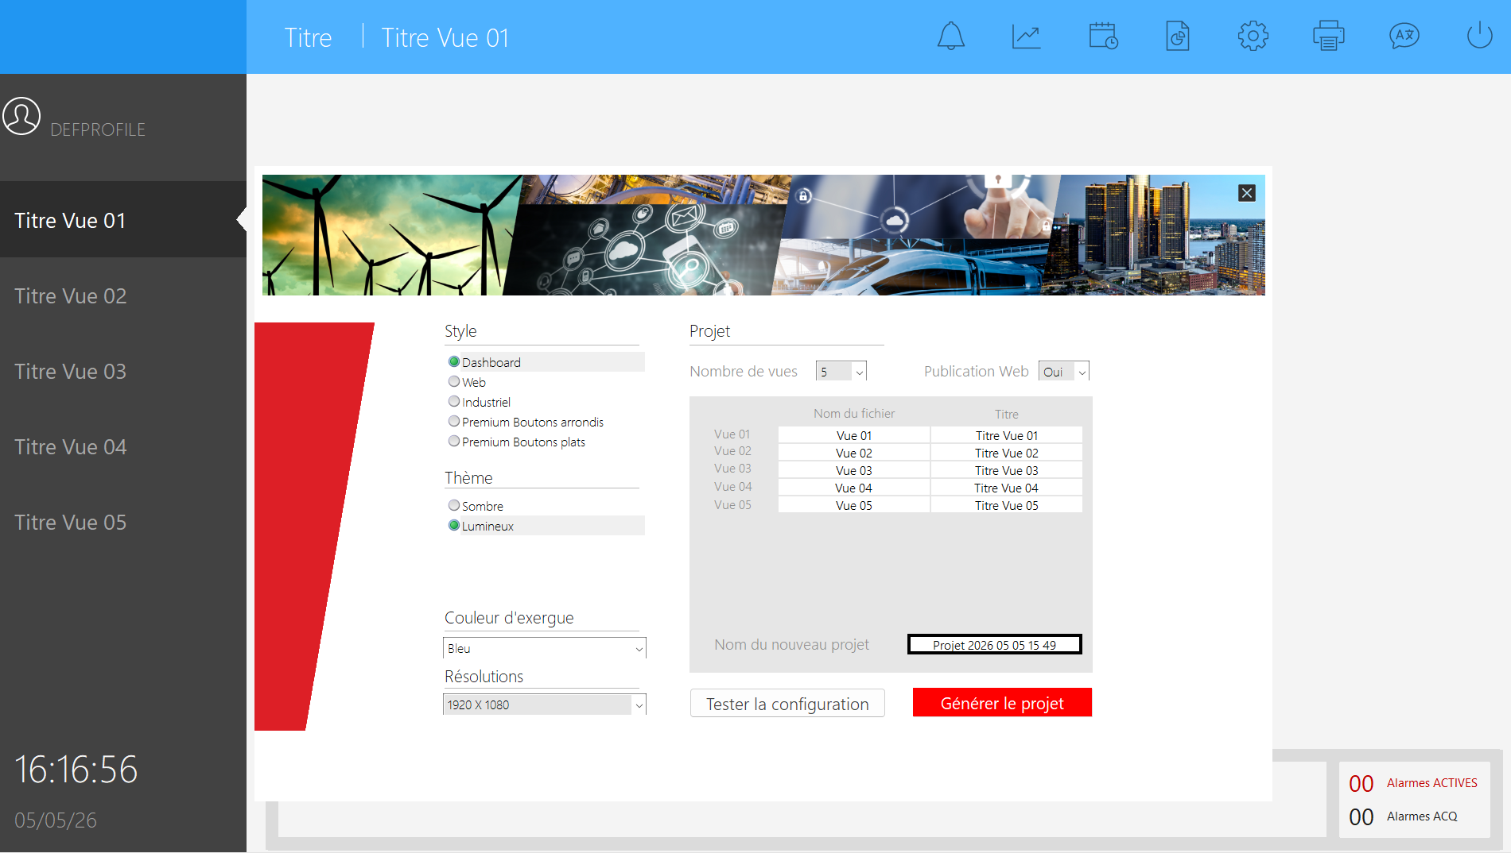

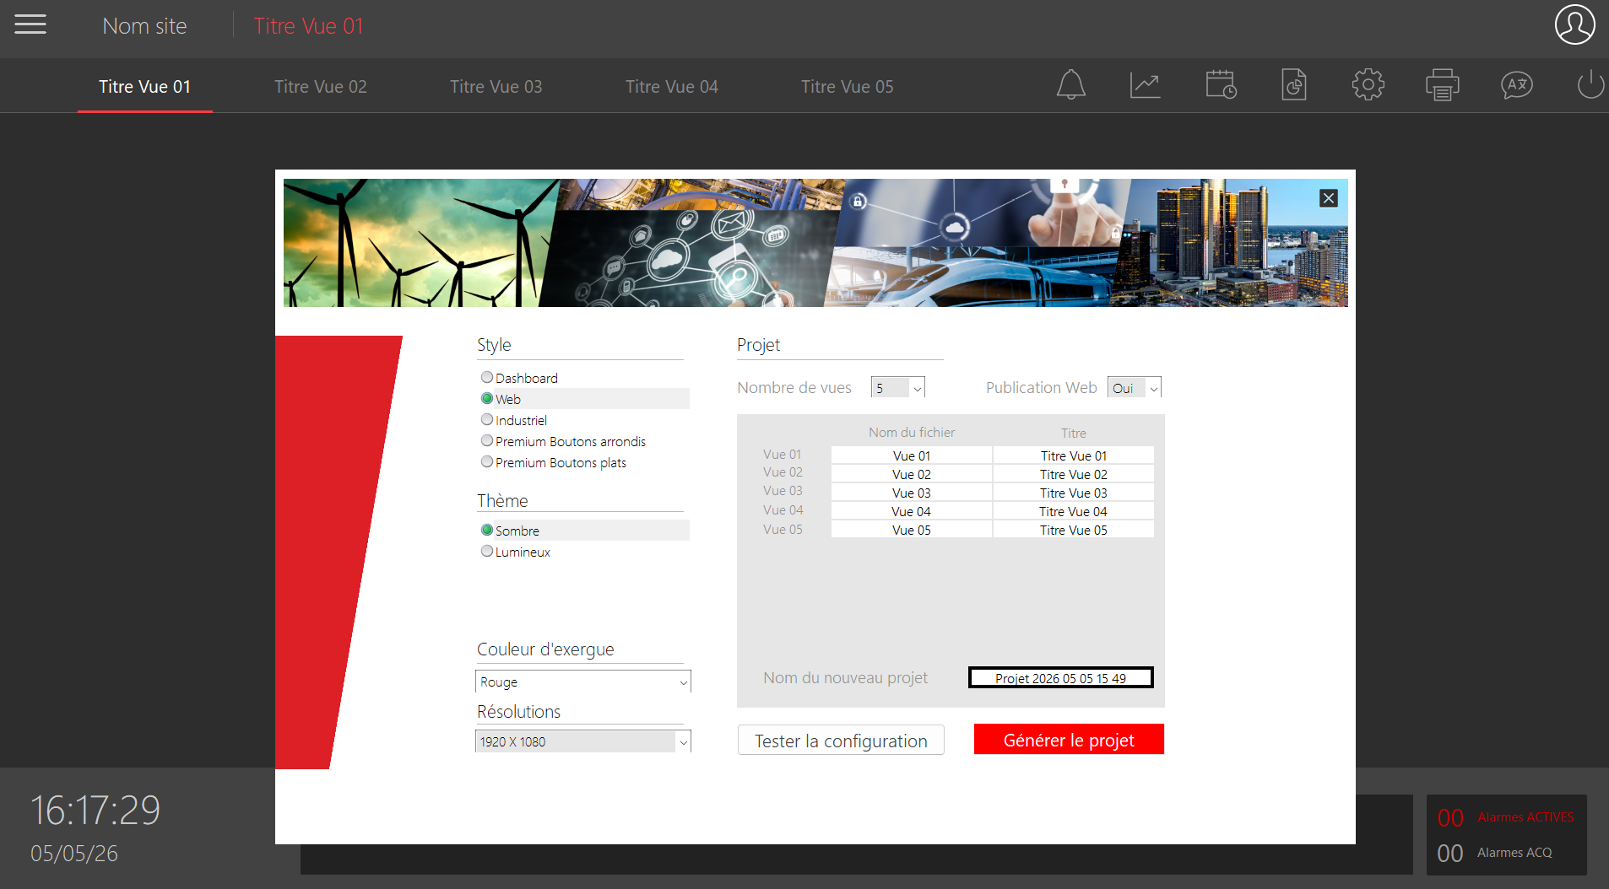
Figure 1 - Quickstart project

Advanced Configuration Environment - ACE

The Advanced Configuration Environment (ACE) of PcVue brings a consistent and innovative platform to develop your application. The PcVue ACE is designed to maximize productivity by providing components with similar user interfaces. It presents a single interface in which all developments are done. This ACE brings many features for creating object descriptions, mimics, communication frame with PLC, user rights, etc.. .
It also provides advanced tools for creating the client/server architecture and deploying the software throughout the network.
Dynamic, intuitive use of configuration boosts PcVue's ease of use.

PcVue ACE reduces configuration time and increases developer productivity.

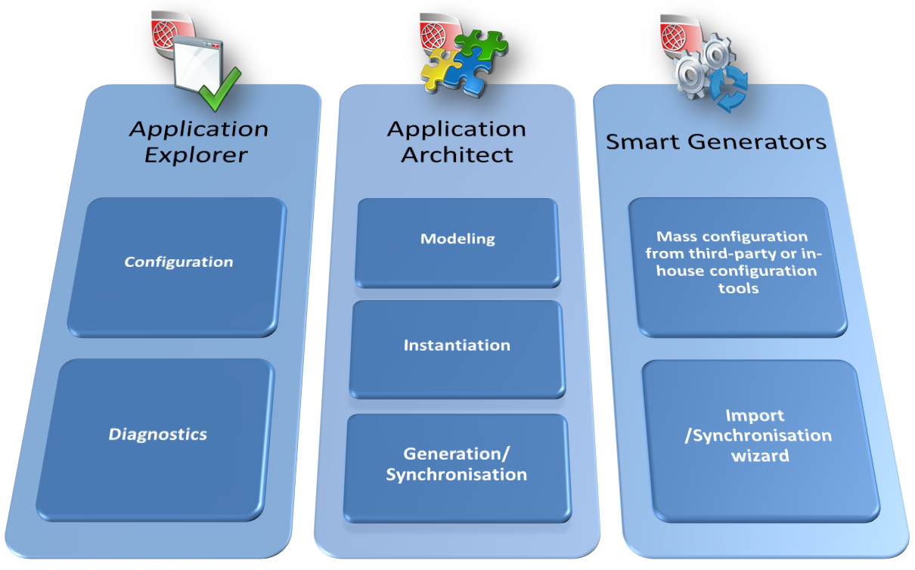

The ACE includes:
  - the “Application Explorer”, an “All in one” configuration tool for configuration and diagnosis,
  - the “Application Architect” to model objects and create applications,
  - the Smart Generators are a suite of import tools for mass configuration from third-party or in-house configuration tools (PLC programs, CAD drawings, user software and legacy SCADA/Building Management Systems).
These tools can be used independently or jointly as required.

Application Explorer

Configuration & Diagnostic

The Application Explorer is an “All in one” configuration tool, including the features for configuring all parts of supervisory project:
- Communication/Networking
- Variables
- Archives
- Data processing
- User management
- Libraries
A consistent and modern user-friendly interface based on the ergonomic rules for systems environments to make the design easier and faster:
- Based on a tree view structure with element lists
- Easy duplication of branches and sub elements
- Multiple document Interface
- Copy, cut & paste including sub-elements
- Intuitive navigation: previous & next
- Various display options: icons, list, details...
- Standard Windows’ keyboard shortcuts
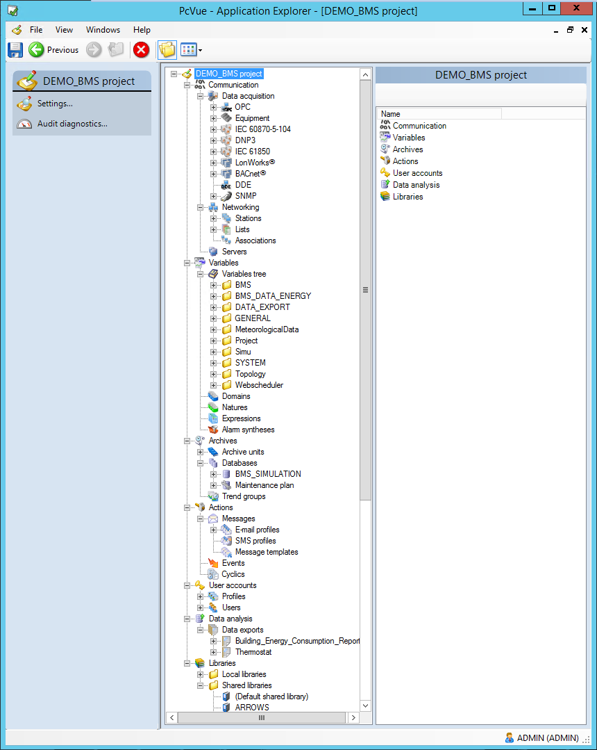
Figure 2 - Application Explorer

Configuration wizards

Several configuration wizards to guide you through the process of configuring:
- the network architecture
- the archiving database
- the redundancy process

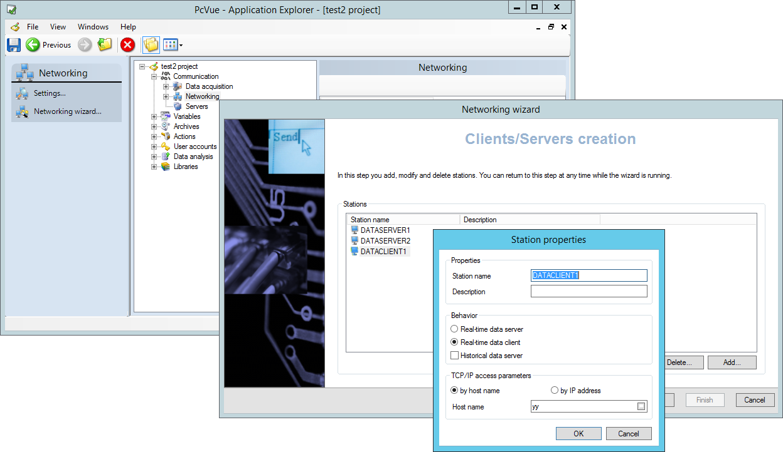
Figure 3 - Configuration wizards

Application Architect

Application modeling

The Application Architect lets you use high-level facilities to template and reuse of components.
It enables you to create reusable objects to integrate not only graphics, symbols and tables but also all the frequent configuration elements such as variables, alarms and their associated behaviors: events, archiving, thresholds, commands, scripts etc.
Benefits of the Application Architect
- Reduce development time
- Enhance application description reliability
- Reduce the risk of errors
- Does not require scripting
- A ground breaking tool to help applying existing good design practices
    - Branch and leaves
    - Generic graphic objects
Build the applications in 4 steps: templating, differentiation, instantiation, and customization.

Templating

- Identify the Inputs/Outputs
- Define the internal variables required
- Identify the behaviors (trending, archiving etc.)
- Specify the graphical appearance
You can also define higher-level models by inheritance and/or inclusion.
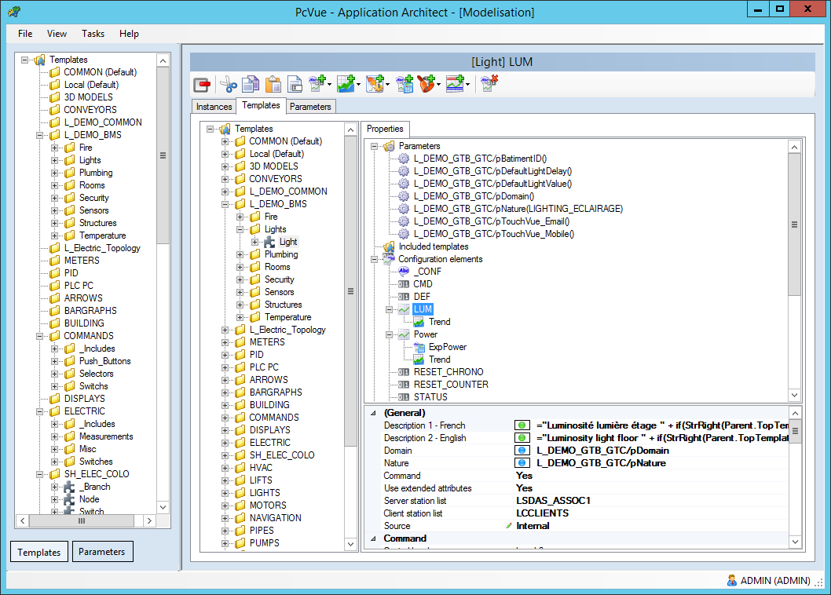
Figure 4 - Application Architect : templates

Differentiation
This step lets you identify and specify the differences between the processes of a model in three ways:
- Parameters
- Manual input
- Evaluated expression: by calculation
- Values of preset parameters
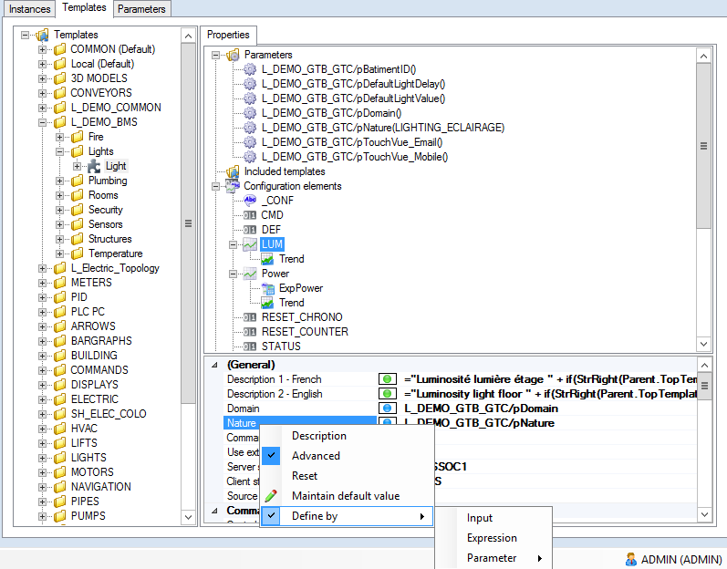
Figure 5 – Application Architect : differentiation menu
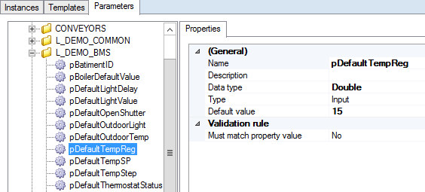
Figure 6 – Parameter example

Instantiation

- Specifying the process structure
- Representing physical objects as facilities (motor, conveyor, production line, fan, pump, air treatment centre, floor etc.)
- Input any value required to differentiate instances
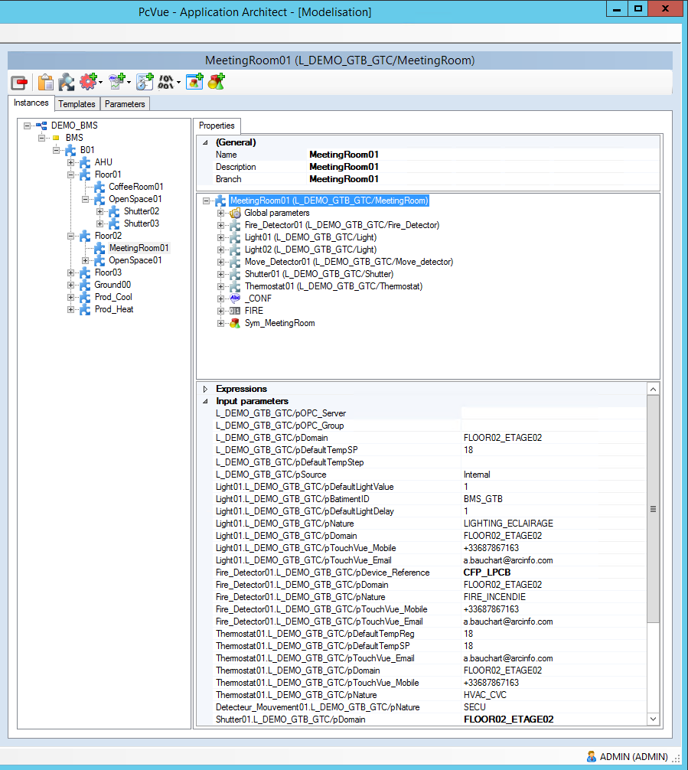
Figure 7 – Application Architect : Instantiation

Customization

- A component can be very similar to another without justifying a supplementary model, so the Application Architect enables you to customize processes to take account of their particular features.
- Unit modifications of instances :
  - Add or remove elements on a particular instance
  - Only if an additional template is not worthwhile
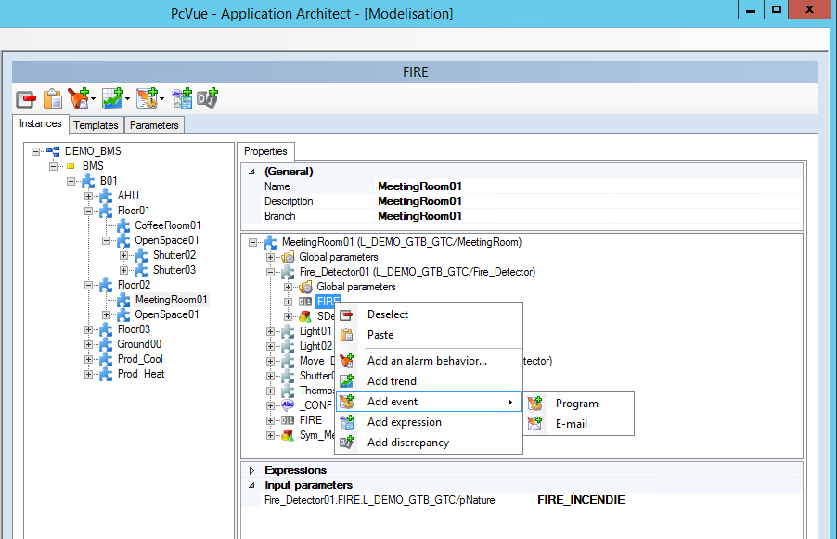
Figure 8 – Application Architect : Example of customization

- Templating is sometimes not applicable or not useful across the whole application, so the Application Explorer and the Smart Generators also be used on the same project.

Partial Generation

The Partial Generation mechanism allows only the necessary parts of an application to be generated, while preserving the overall integrity of the project and the dependencies between generated elements.
This feature is particularly useful when certain parts of the project have already been validated, or when only targeted modifications need to be taken into account. It avoids a full regeneration of the application when this is not required.
Partial Generation addresses several objectives:
- Reduce generation time by avoiding regeneration of the entire project when only specific parts have been modified.
- Preserve already validated and stable elements without unnecessary updates.
- Provide granular control over the elements to be generated through status-based management.
- Ensure consistency between generated elements while improving configuration workflow efficiency.

Generation Status Management

Partial Generation introduces a status management system used to define the behavior of each instance during the generation process.
This management applies within the project tree, at the level of instances and topological elements. It does not apply at the level of included models.
Three generation statuses are available:
- Generated: the element is considered ready to be generated. It corresponds to the standard behavior when the element is not deselected.
- Ignored: the element is not generated, but the corresponding PcVue objects, such as variables or other associated elements, are preserved.
- Excluded: the element is not generated and the corresponding PcVue objects are deleted.

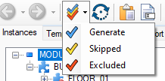

The Ignored status can be used to preserve elements that have already been generated, tested and considered finalized. It can also be used to temporarily set aside elements that are not yet ready to be processed, in order to focus generation on validated parts of the project.

Generation Modes

Two generation modes are available:
- Full Generation: runs the generation process on the entire project, while respecting the status defined for each instance.
- Partial Generation: launches a targeted generation from a specific part of the topology tree.
This approach provides finer control over generated content and adapts the generation process to the actual progress of the project.

Applicable Elements

Partial Generation can apply to different types of project elements, including:
- Standard elements: variables, trends, events, etc.
- Graphical elements: mimics.
- Application files.
By allowing only the necessary elements to be generated, this feature improves productivity during the development, validation and maintenance phases of a PcVue application.

Smart Generators

The Smart Generators enable you to generate an application automatically importing elements from external sources.
They facilitate and dramatically accelerate the development of a PcVue project avoiding the loss of time of a double configuration and risk of error. The wizards guide you through the process of extracting data from third party applications and using it to generate elements of PcVue’s configuration (variable database, communication configuration, mimics etc.).

Available Smart Generators

  - TIA portal
  - Unity pro®
  - WAGO®
  - MOXA®
  - OPC
  - ISaGRAF™
  - CAD (AutoCAD)
  - LNS®
  - FactoryLink®
  - STEP7®
  - DALI®/WAGO®
  - Stardom™
  - Harmonas®
  - SAIA PCD™
  - TwinCAT®
  - BACnet™
  - Générique XML

Real-time Data

The real-time data is the core of PcVue and it is composed of a set of tags called "variables" that contain the data to be supervised and displayed in mimics. Variables can also used to trigger actions, be recorded and for various other behaviors.

Structure

PcVue is designed to allow the creation of variables in a hierarchical manner, using a variable tree, allowing a structured organization of data and corresponding to the supervised physical process.
For example, a building may be modeled as follows:

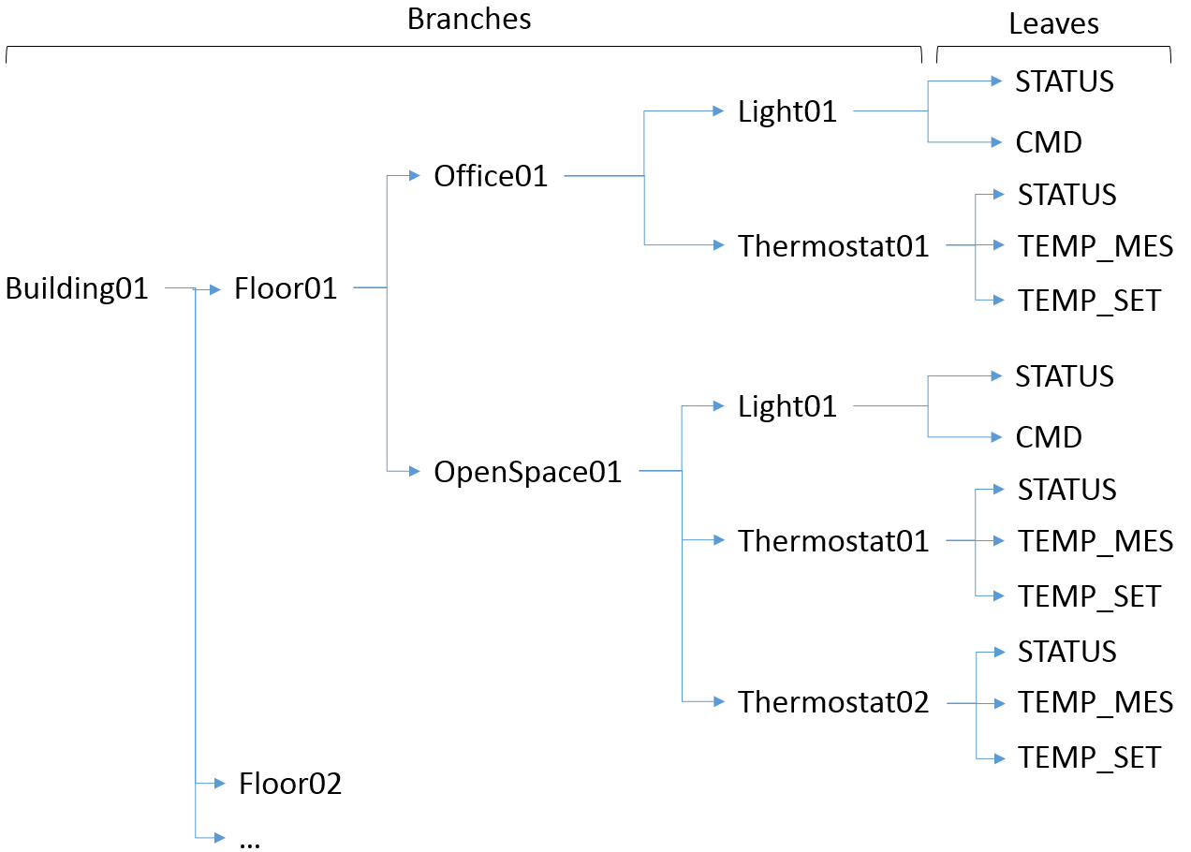

Each line defines a variable composed of several branch levels and one leaf. This variable tree is displayed in the Application Explorer as shown below:

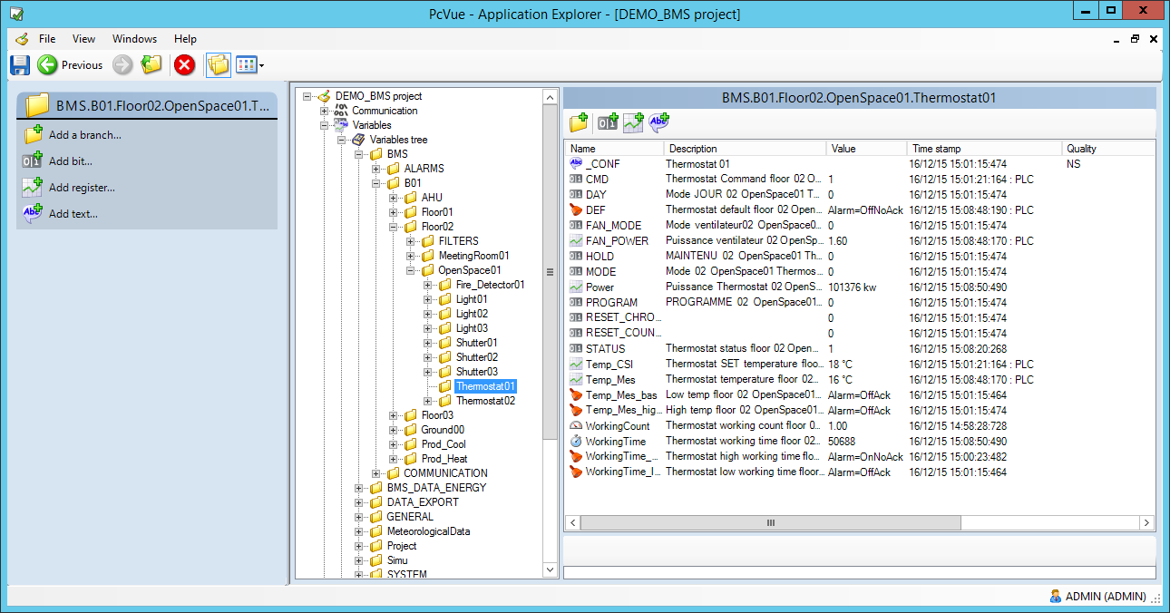

Figure 9 – Variable tree
The Variables Tree is designed so that variables are grouped together in a similar manner to the real world. The groups are similar in concept to a Windows' folder. The folders containing the variables are nested thereby generating the structure of the tree. The complete folder structure that contains a variable is known as its branch. In practice, the term branch can be used to refer to all or part of a branch structure (similar to a tree where a branch is made up of many smaller branches.)
This data structure helps to create projects that are both easy to design and maintain.

Generic Approach

The branch concept of the variables let the developer easily builds generic objects (graphical symbols, program or mimic) : the same generic object can be re-used in different variables contexts.
When a generic object is created only the leaf of variables names is used without any branch. The branch is supplied each time that the object is instantiated, to ‘connect’ each leaf of variables of the object to the branch, and animate the corresponding variables.
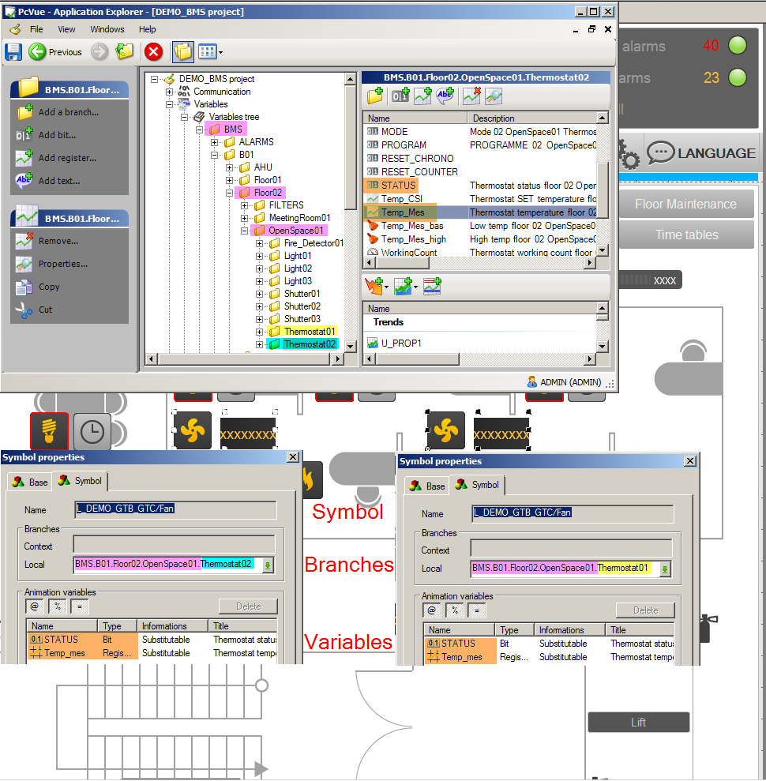

Figure 10 - Data structure and genericity

For example- A symbol represents an air conditioner. The symbol indicates if the air conditioner is on and the ambient temperature. When animating the symbol the variables names are used without a branch:
TEMP_MES
STATUS
The branch is supplied when symbol is inserted into a mimic to ‘connect‘ the variable leaves of the symbol to the branch and the animations to the corresponding variables (Branch+leaves).
The same symbol can be instantiated any number of times with different branches thereby displaying different variables.
This principle is extensively used in PcVue for all kinds of objects (mimics, symbols, programs, expressions) and dramatically reduces the development time particularly for installations composed of highly repetitive elements.

Data Types

The following variable types are supported.
- Bit - Logical or two state data
- Alarm - A sub-type of bit with modified behavior
- Register - Any analogue data (byte, word, double word, float etc.)
- Text - String data
A variable could be:
- An Internal variable – the data value is calculated in PcVue
- An Equipment variable - the data value is given by the communication layer

VTQ – Value Time Quality

Each variable has three real time properties, value, quality and timestamp - also known as VTQ. The timestamp has millisecond resolution and is the time that the value last changed.
Timestamp can also be provided directly by the PLC by using one of our timestamped protocols.
Any variable can be configured to be shared on multi-station architectures and/or made available for third party software through several interfaces (OPC, webservices,…). In such case the VTQ is broadcast.

Properties

Variable configuration is rich in properties with all variables having a Description, Source, filters criteria (Domain, Nature), and Command level plus properties specific to each variable type, Maximum, Minimum, Units, Associated Label etc.

Attributes and Filters

Extended attributes provide the opportunity to associate a number of binary and text attributes with each variable. The single binary attribute takes the form of a 32 bit integer than can be entered either as a number or as 32 individual bits. The text attributes are entered as a string or as the name of another variable. If you use the name of another variable, when that text attribute is referenced, the value of that variable is used.
Up to 16 free format extended text attributes can be configured for each variable.

Extended attributes have many uses such as:
  - Cataloguing data for better filtering particularly in the alarm viewer or logging :
  - Add details of specific characteristics to a variable. For example you might want to include the name of the equipment manufacturer or a reference that can be displayed on a mimic:
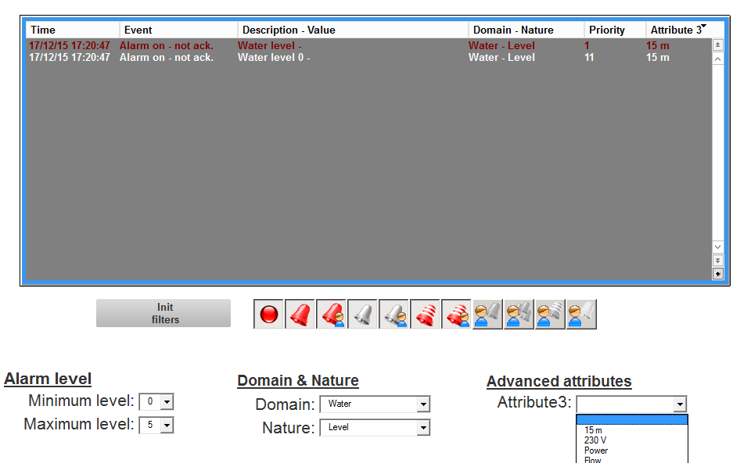

Figure 11 - Example of an alarms viewer with filters using extended attributes

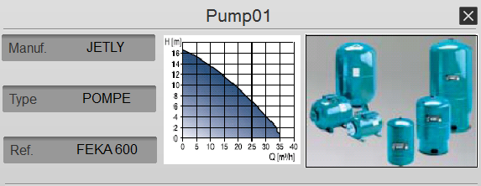

Figure 12 - Example of a detail popup with information displayed from the extended attributes

Associated labels

Associated Labels are sets of text strings which can be associated with a variable and as a result substituted for the variable's values when displayed. For example, instead of a bit variable displaying ANIMATION 0 or ANIMATION 1, it might display STOPPED and RUNNING.
The strings provided by associated labels are displayed in mimics in the alarm and log viewers, and by the Text-Label and the Send-Bit animations.

Bits and alarms associated labels

Each bit associated label comprises of the following strings.

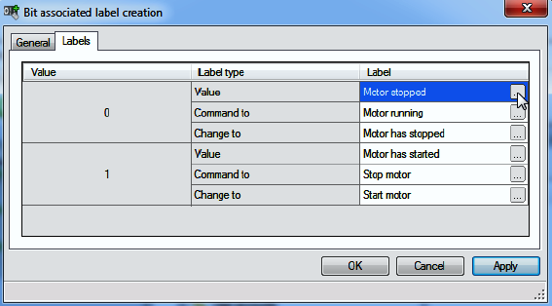

Figure 13 – Bit associated label creation

Each alarm associated label comprises of strings for each of the possible alarm states plus Acknowledgement, Command to 0 and Command to 1.

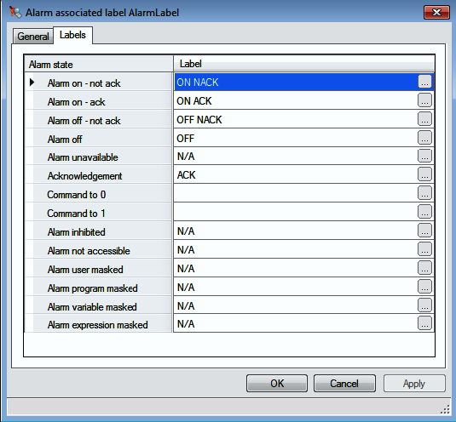

Figure 14 – Alarm associated label

Associated behaviors

Associated behavior adds features to a variable in addition to that provided by its main properties. The following is a summary of the main behaviors:
- Threshold - Set bits when the value rises above or falls below a value. Typically used to generate alarms from analog values
- Chronometer - Measure the period for which a bit has been set
- Counter - Count how many times a bit has been set
- Discrepancy – DCS style mechanism that checks that the value of one bit against another within a configurable period. An alarm is generated if the check fails
- Alarm – Acknowledge trace, Associated action (open a mimic or run a script), Masking by bit or expression
- Event - Run a program or send a message (SMS or email) on change of value
- Trend - Record the VTQ in an archive unit for replay through a Trend Viewer or export to a 3rd party application

Alarms

In PcVue an alarm is generated by a bit variable that has been configured with alarm behavior. This means that alarms have all the flexibility associated with a bit plus the characteristics required by an alarm. Changes in alarm value are time-stamped to millisecond resolution. The origin of the time-stamp can be PcVue itself or the source of the value (PLC, OPC etc.).
A real-time alarm list is provided by the Alarm Viewer. Alarms can also be used in the HMI’s animations the same as any other variable to produce color changes, change text strings, exchange symbols etc. Individual alarms can be accepted by an operator with the corresponding user rights. Advanced group alarm acceptance strategies can be configured using SCADA Basic.
In distributed applications alarms are broadcast to all nodes. Alarm acceptance (subject to user rights) can take place on any station.

Alarm levels

PcVue supports 30 alarm levels. Alarm display, acknowledgment and masking levels can be different. (For ease of configuration, by default, they are the same.) These levels are also defined in the user profiles. Depending on their profile settings the user may be able to display, acknowledge or mask an alarm with a given level.
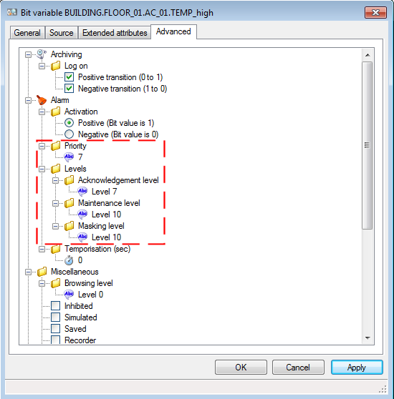
Figure 15 - Alarm levels settings

Temporization

A period in seconds between the source changing to the active state and the bit state following it (and hence the alarm activating). Should the source return to the inactive state before the temporization period is over the alarm will not activate. A value of 0 disables temporization and the alarm activates immediately the source changes to active

Thresholds

A threshold is one of the behaviors that can be attached to a register variable. A threshold sets and clears a bit depending on the rising or falling value of the register and a configurable hysteresis. Up to four thresholds can be specified per register and can be used to directly generate alarms.

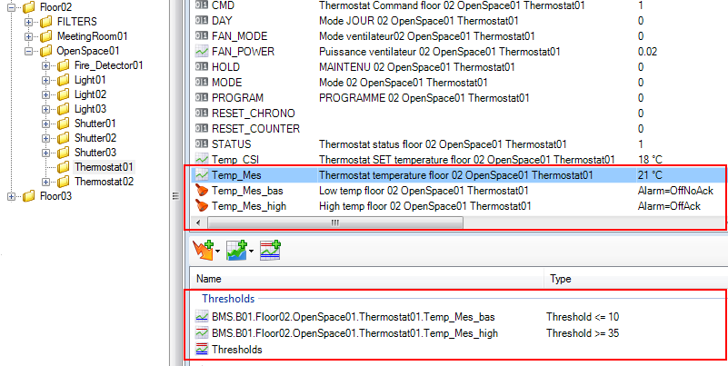
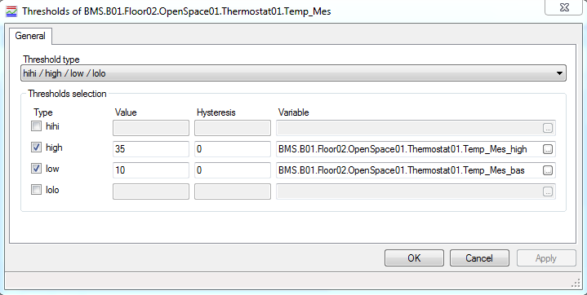
Figure 16 - Thresholds variables

Masking

To help prevent alarm cascades, an alarm can be masked by another alarm, a bit or an expression. Alarms can also be temporarily inhibited by the operator or taken out of service completely using maintenance mode.
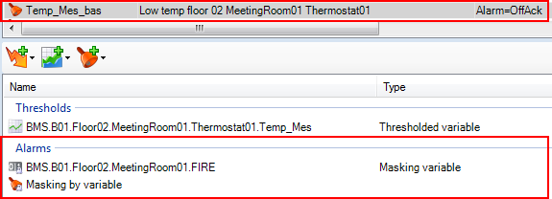
Figure 17 - Masking variable

Alarm counters

Alarm counters by level, status, Domain and Nature are easily configured using specially named register variables. These can be displayed in the HMI and trigger actions (such as sending an email or generating an audible alarm) in the same way as any other variable.
Advanced alarm counters using expressions and alarm properties can be configured using a technique called alarm synthesis

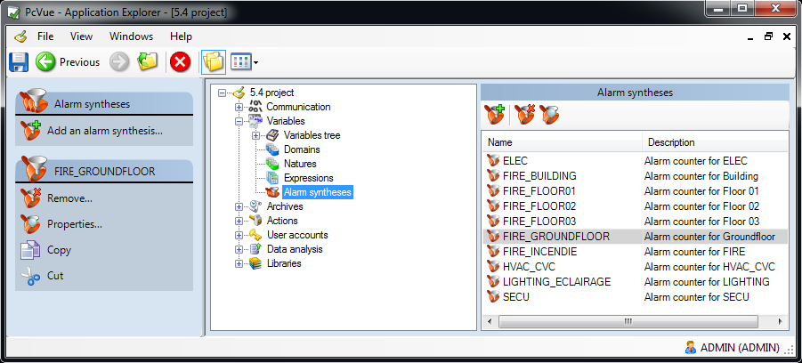

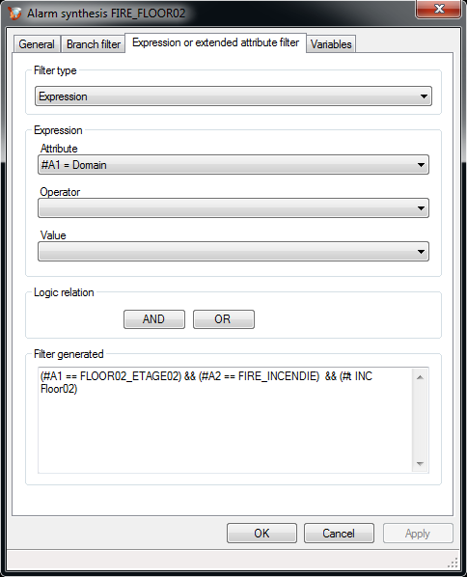

Figure 18 - Alarms synthesis configuration

Data Acquisition

PcVue includes many built-in serial and Ethernet drivers, from proprietary buses and legacy serial protocols to the latest TCP/IP, OPC, IoT standards. The communication manager CIMWAY allows the simultaneous management of several drivers to meet the requirement of installations dealing with different equipment manufacturers.
PcVue driver’s development is ongoing and new drivers are added all the time.

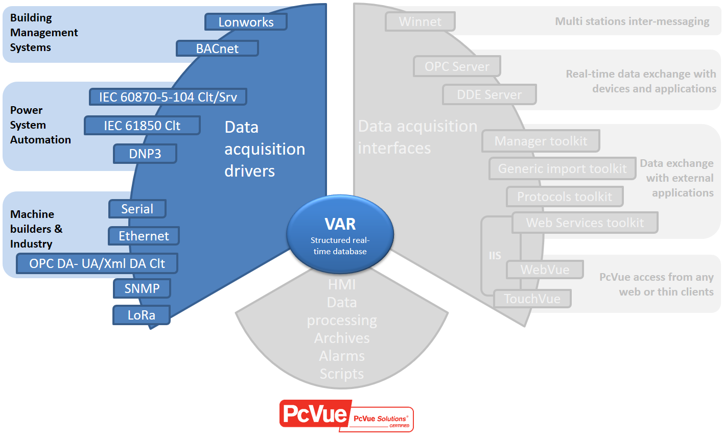

Drivers and communication interfaces
PcVue communicates with acquisition, control and automation systems (programmable logic controllers, remote input / output, regulators, etc.) and natively has a set of protocols, serial and TCP / IP, covering the main manufacturers of devices.
The full updated list is available on the website:
https://www.pcvuesolutions.com/driver-di-comunicazione/

BACnet IP/BACnet SC

BACnet IP

BACnet is a built-in protocol in PcVue.
PcVue is listed by the official testing laboratory of BACnet for the profils B-OWS and B-AWS.

All the services provided by the standard (BIBBs) are supported:

- Data Sharing,
- Network & Device management,
- Alarm & Event notification,
- Trending and event logging,
- Scheduling.

PcVue offers features for the configuration, the diagnostic and the commissioning necessary for BACnet including:
- Device and object discovery,
- Versatile support for BACnet automation objects: Notification Class, Trend Log, Trend Log Multiple, Event Log, Schedule, Calendar,
- Helpers to assist the application developer diagnose and troubleshoot automation objects’ behavior in a BACnet device,
- A comprehensive mapping editor
- An import configuration tool called “Smart Generator for BACnet”

Configuration interface

The interface allows the configuration of BACnet objects including schedules and calendars. It’s important to note that it’s also possible to configure the devices directly from the PcVue interface without the need of the device platform.
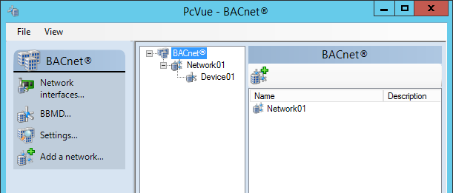
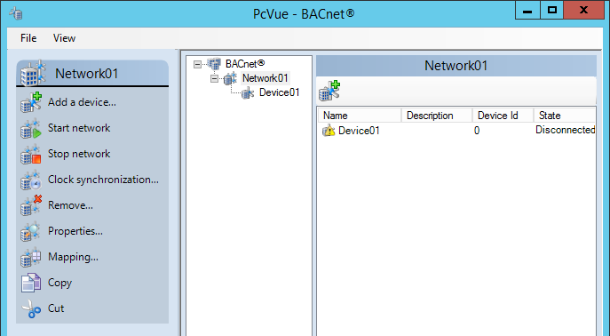
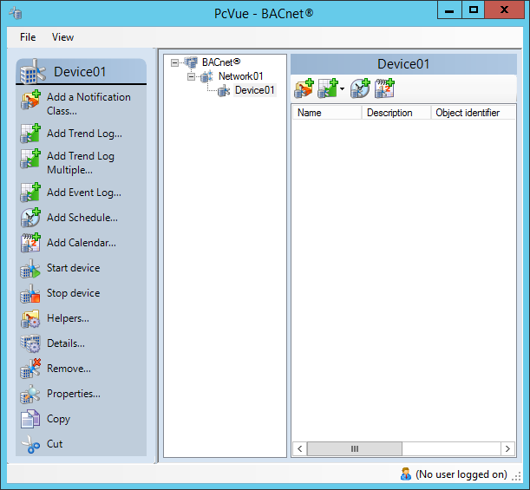

Figure 19 - BACnet : configuration interface
The configuration interface allows the configuration of the following features:
- Creation – Modification – Deletion of objects
From within PcVue configuration tools Including Calendars and Schedules
- Property values display
Based on a grid in Helpers
Based on the ePICS standard in the mapping editor
- Improved fallback
COV vs Polling
Segmentation and supported services (FDT,BBMD)
- Detection and tracing of device id conflicts

Browsing and mapping editor

The mapping editor allows the following features:
- Online & offline – Based on EDE files
- Display values
- Allow for single and multiple writes
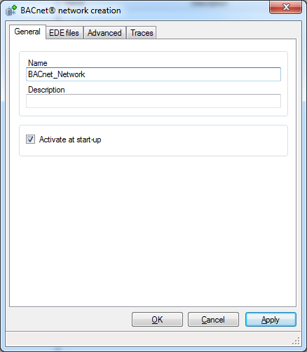
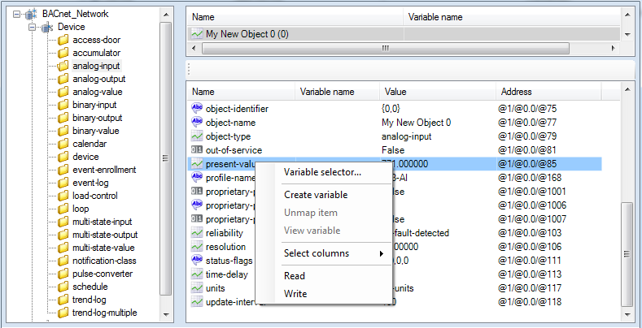
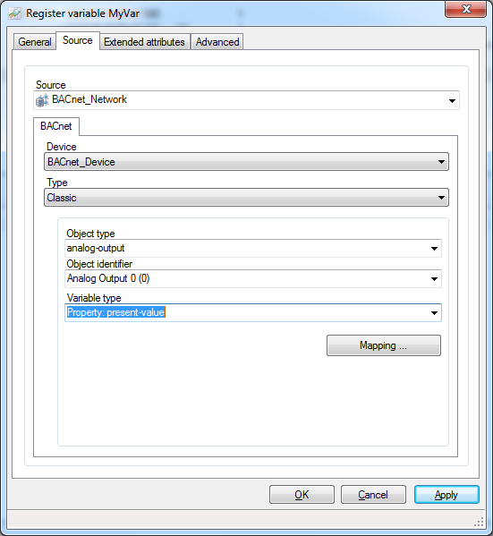
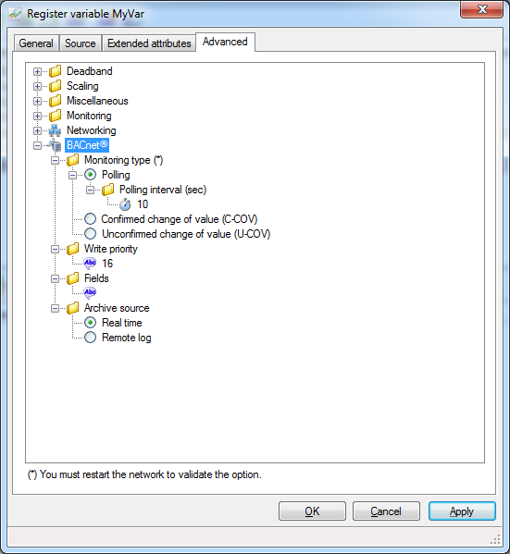
Figure 20 - BACnet : browsing and mapping editor

“Helpers”: help for diagnostic and commissioning

“Helpers” are built-in tools to help designer for commissioning.
It includes the following features:

- Object discovery
- Object creation, modification, deletion in devices
- Device configuration troubleshooting
- Property reading & writing
- Data retrieval: event log, trend log, alarms

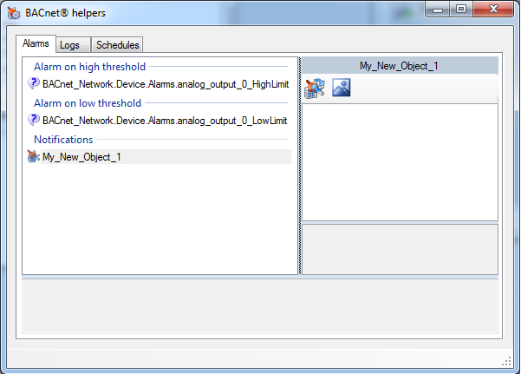
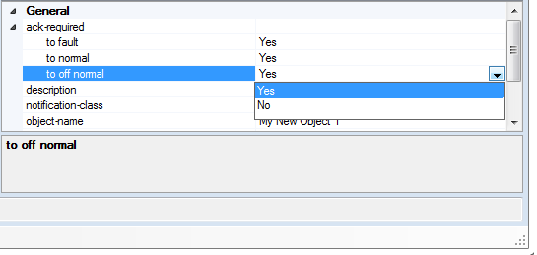
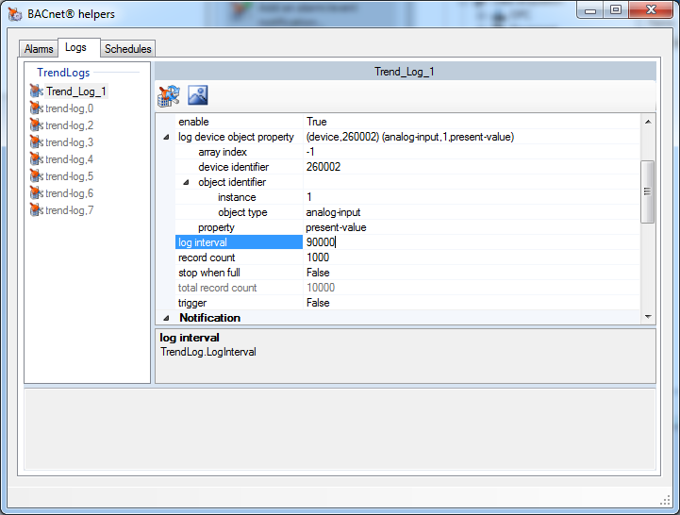
Figure 21 - BACnet : Helpers

Smart Generator BACnet

Smart Generator is a tool that allows to import a BACnet configuration and generate the configuration objects in PcVue such as:

- Variables
- BACnet networks and devices
- BACnet automation objects: notification class, schedules, Trend logs …
- Variables mapping to BACnet object properties

Import file supported are:
- EDE
- IEIEJ

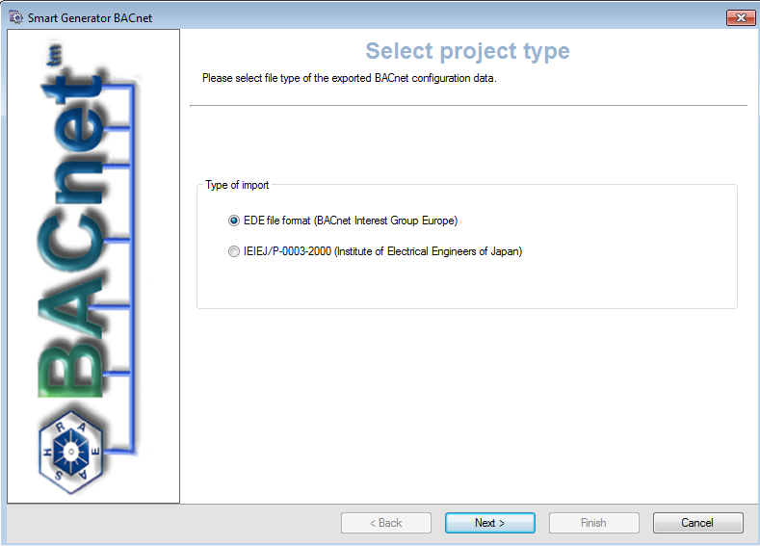
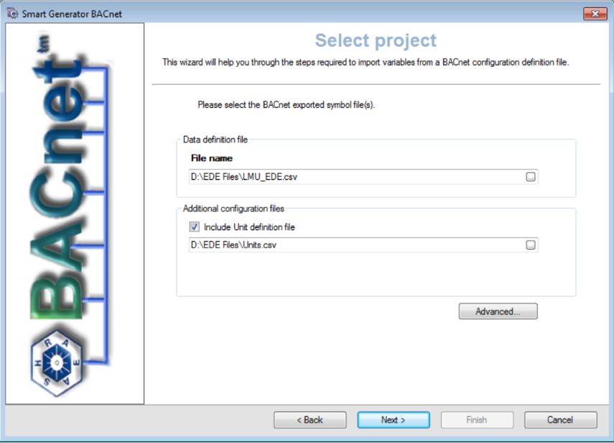
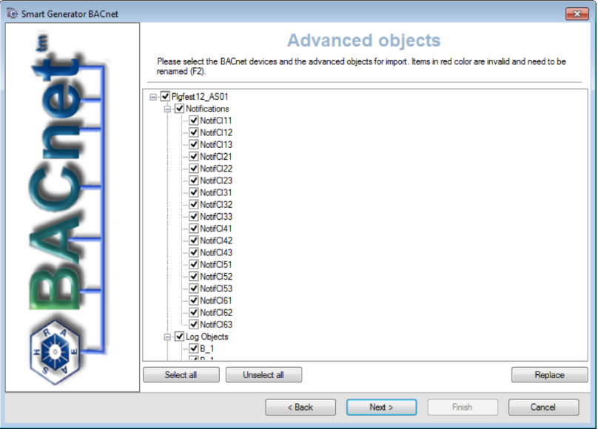
Figure 22 - BACnet : Smart Generator

BACNET SC

PcVue natively supports BACnet Secure Connect (BACnet/SC), the secure evolution of the BACnet standard defined by the ASHRAE SSPC 135 IT Working Group.

BACnet/SC replaces the traditional transport layer with a stack entirely based on IT standards: WebSockets over TLS 1.3, with support for elliptic curve cryptography (128 and 256 bits). This approach allows BMS infrastructures to be aligned with IT best practices, without compromising interoperability with existing BACnet installations.

The main benefits of BACnet/SC are:

- Native securing of communications without VPN, thanks to end-to-end TLS 1.3 encryption,
- Authentication and authorization of devices on the network,
- Elimination of static IP addresses and BBMD devices,
- Transparent traversal of firewalls and NAT architectures through outbound HTTPS connections,
- Compatibility with IPv4, IPv6, Wi-Fi and cellular networks,
- Full interoperability with existing BACnet/IP and MS/TP deployments through BACnet/SC routers.

PcVue supports the main BACnet/SC deployment topologies:

- Secure remote access from the Internet without opening any inbound port in the site firewall,
- Fully BACnet/SC network within a new building subject to strict IT policies,
- Mixed architecture integrating BACnet/SC devices and legacy BACnet/IP or MS/TP devices,
- Multi-site supervision through a BACnet/SC hub hosted in the cloud.

BACnet/SC does not replace BACnet/IP but complements it: PcVue supports the three deployment modes — BACnet/IP, BACnet/SC and mixed architecture — enabling a gradual migration of existing installations towards a secure model.

SNMP

PcVue is implemented as SNMP manager and agent.
V1, V2 and V3 are supported.

PcVue supports the following features:

- Off line/on line MIB browser
- Common MIB files installed
- Traps support with enhanced features
- Modeling for SNMP networks and devices
- PING management for unmanageable devices
- Optimisations and redundancy mechanisms
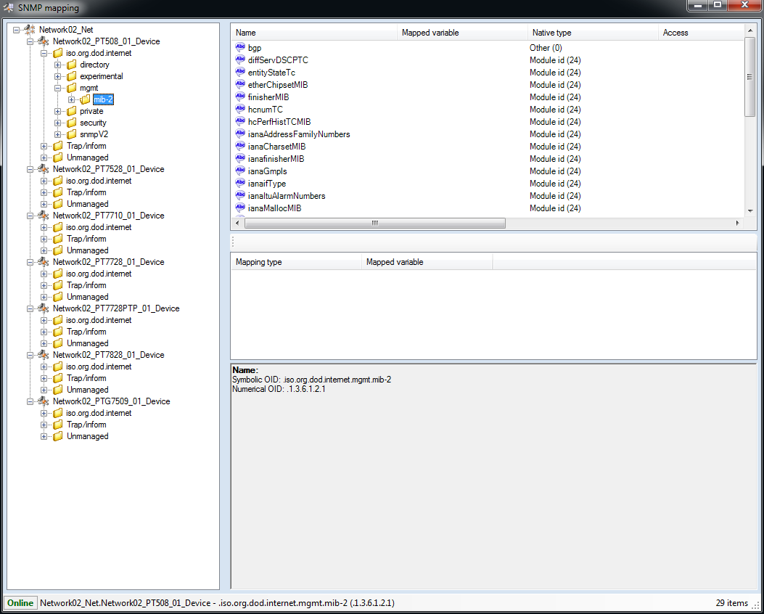
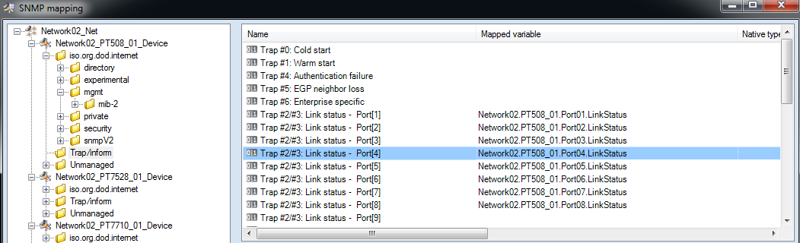
- SNMP agent
Figure 23 - SNMP : MIB browser

PcVue is designed for the deployment of large network using the following tools:
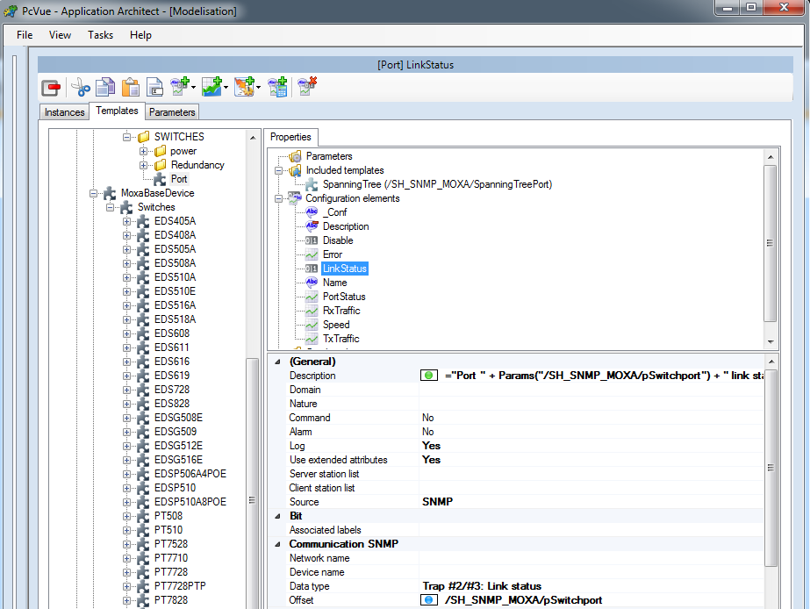
  - A tool for modeling a SNMP network and devices and generate the configuration
Figure 24 - SNMP : modeling tool

  - SNMP devices libraries
PcVue implements optimisations and can manage:
- Up to 1000 SNMP devices
- Up to 500 SNMP parallel requests
Built-in redundancy mechanismsare also implemented.

IoT – Internet Of Things

PcVue IoT HUB

PcVue has a set of components, functions and services grouped under the name of PcVue IoT HUB allowing to:
- Connect sensors or "objects" through IoT drivers
- Implement and create IoT elements in a project
- Operate and maintain an installation using connected objects by exploiting the data collected

IoT Connectivity

PcVue can connect “IoT” objects independently of manufacturers, on private or operated networks and is compatible with most networks (LoRa, sigfox), operators, protocols (LoRa, sigfox, MQTT,…) and sensors on the market.

PcVue is compatible with many gateways including the “Node-Red” gateways.

PcVue natively integrates the LoRA protocol and the MQTT driver.
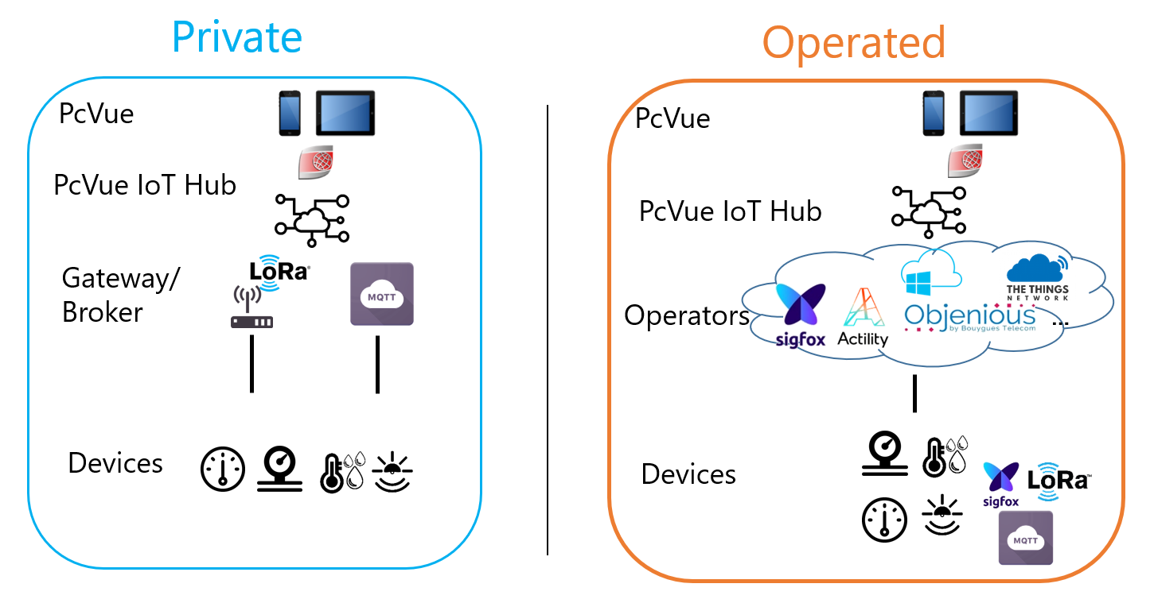

Time-stamped data

In some cases it is necessary to acquire time-stamped data provided by the source (such as equipment) instead of the Supervisor.
PcVue manages the time-stamped data for several drivers that support this mode.

Communication check

Communication control features are built-in in PcVue and a set of status concerning the quality of the exchanges are available. These statuses can be directly exploited through variables of the software real-time database (system variables).
They can therefore be used in all the functions of the supervisor: animations on synoptics, windows of alarms, histories, programs, on call...
In addition to the mechanisms of detection of communication anomalies (timeout of answer or absence of correspondent), PcVue manages natively without programming, a principle of watchdog in relation to the PLC program. Thus, it is possible to detect a possible freezing of PLC processor even if its communication board responds correctly to the communication requests.
Outre sa capacité d’acquisition de données terrain, PcVue est également très ouvert sur les systèmes tiers avec lesquels il est capable de s’interfacer grâce à différents kits de développement et autres standards.

Interoperability with 3rd party systems

Data exchange standards
PcVue has standards for interoperability with most software systems for the exchange or provision of data:

OPC

An OPC client / server interface is available built-in, supporting UA,DA and XML formats.

SNMP Agent

The optional SNMP Agent Module makes PcVue interoperable via Microsoft Windows SNMP Services. All PcVue variables are then "exposable", making them accessible to an SNMP Manager.This function includes the automatic generation of MIB to expose the OIDs.Thanks to this functionality it is possible, among other things, to monitor the proper functioning of the PcVue application through the IT monitoring tools.

Files import/export

A tool for importing / exporting text files (csv, XML, ...) allows to integrate in PcVue the data contained in this type of file.

FTP

It is possible to manage FTP transfers with PcVue, in particular to recover external files available on an FTP server and containing data useful for supervision.

Universal Data Connector – ADO.NET

PcVue features a SQL bridge based on ADO.NET allowing to interface with an infinity of data sources thus opening up to DBMS, ERP, MES, CMMS, Big data, RESTservices, social networks, files...

The Universal Data Connector includes the following features:

- Connect cloud or on premises data sources
- Handles all the connection, and redundancy mechanisms
- Support for SQL requests: SELECT, INSERT, UPDATE
- The result of the SQL request shall be map to a variable as for any other driver
- SQL request can be executed on event or cyclically
- Supported in web and mobile client
- Support for SCADA BASIC script and SV manager toolkit
- Support for displaying data with a grid

Software Development Kits

In addition to the built-in drivers PcVue, as an open SCADA Solution, offers a range of SDK’s that can help to develop an application and answer specific customer requirements.
It’s important to note that these SDKs all come with PcVue with no extra charge.

Generic Import Toolkit

Using the PcVue Smart Generator import tool (see Advanced Configuration Environment chapter) a well-constructed XML file can be analyzed to automatically generate a ready-to-use configuration database. This ability may well be of interest to persons wishing to use a descriptive format that is not specific to the PcVue software and which can therefore be read by other, mostly web-oriented, applications.
Why using Import Toolkit ?
- To externally develop PcVue configuration and automatically import it
- For OEM partners who needs to define a bigger configuration database which includes configuration items in addition to the PcVue configuration

Manager Toolkit

A manager is a part of PcVue. There are many managers like alarm manager, historical manager, real-time database manager.
The Manager Toolkit enables a programmer to interface with PcVue. This method is very helpful to make links between PcVue and others applications, or to have specific treatments on variables that are not available in PcVue.
The Manager Toolkit dynamically loads a user’s DLL to invoke specific functions.
Why using the Manager Toolkit?
- To reuse application-components: there are some features that may need to be done outside of PcVue (very specific calculation with advanced algorithm). The treatment can be done in a third part application by reading data in PcVue using the Manager Toolkit & the result can be calculated & written back to PcVue.
- To connect existing software: the manager toolkit can help to solve interoperability problems by allowing other applications to link their data.

Protocol Toolkit

The protocol toolkit is useful to develop master/slave protocols which are not implemented in PcVue. Using standard development tools, the protocol compiled as a DLL is easily integrated in PcVue.
CIMWAY, the PcVue communication kernel, provides a development environment in order to develop proprietary protocol. CIMWAY includes a generic interface to get or send data as required by the protocol. The code of the protocol is written in C++ and linked as a DLL file (Dynamic Link Library) which CIMWAY loads. In CIMWAY, protocols are modules totally independent from each other. If a protocol is added or modified only the protocol's DLL must be rebuilt.
This makes protocol evolution much easier to maintain.
Why using the Protocol Toolkit ?
- To develop a very specific driver integrated in PcVue
- To interface with other software or hardware

Web Services Toolkit

Web Services allows applications to communicate with each other without consideration of their hardware systems, operating systems and programming languages.
The PcVue WebServices Tool kit is targeted at developers willing to implement a Web Services client taking advantage of the PcVue Web Services Toolkit public interfaces.
The Web Services Toolkit is a set of XML SOAP and REST Web Services accessible over http.
PcVue is a web services server providing the following access:

- Session management
- Real time data access
- Real time alarm access
- Historical data access: Logged events and trends
Why using WebServices Toolkit ?
- To embed data from PcVue in an external Web portal
- To reuse application-components: There are some features that need to be done outside from PcVue (very specific calculation with advanced algorithm). The treatment can be done in a third part application by reading data in PcVue using the WebServices toolkit & the result calculated & written back to PcVue.
- To connect existing software: Web services can help to solve the interoperability problem by allowing different application to share their data. With Web services you can exchange data between different applications and different platforms.

Graphical Interface – HMI

PcVue has a powerful Graphical User Interface which provides everything needed to design and display comprehensive animated graphics of your process. PcVue applications are developed as one or more interactive windows linked together to provide menus, process mimics, status pages etc. Each window can contain ActiveX® Controls, dot NET controls embedded within an ActiveX, images and built-in PcVue drawing elements.
The user-friendly interface as well as the powerful graphics tools makes the design of screens fast and easy.
Integrated development and run-time environments allow changes to be made on-line without the need to compile or restart.
The same mimic can even be opened in design mode and in run time mode at the same time allowing to the modification done in real-time.

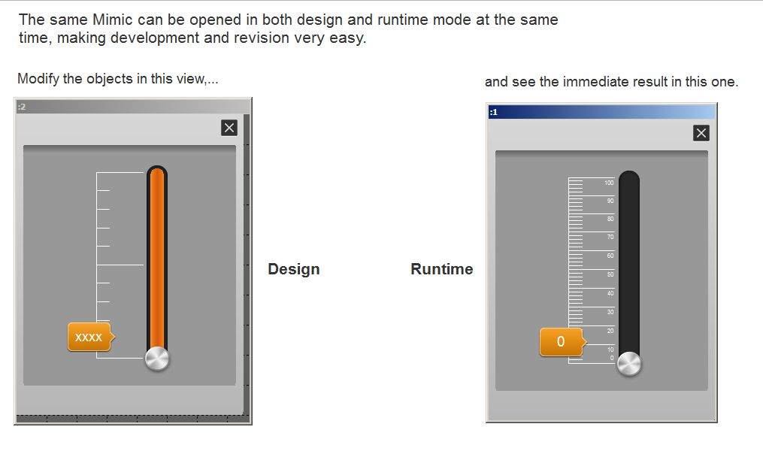

Figure 25 - Design and Run-time mode

Design and animations

PcVue has its own built-in window editor using the latest vector drawing technology for maximum productivity. The comprehensive animation range (more than 60) includes color change, variable filling, visibility, text display, exchange, movement, rotation and sizing. Some animations are not supported on web client or webapp.
Images including animated WMF, EMF, GIF (static, animated), BMP, JPEG, PNG files and AVIs may be imported and animated as well as 2D and 3D DirectX objects from CAD software.
It’s important to note that 3D graphics :
- can be animated in PcVue (they are not static 3D).
- are not supported on webclient or webapp.

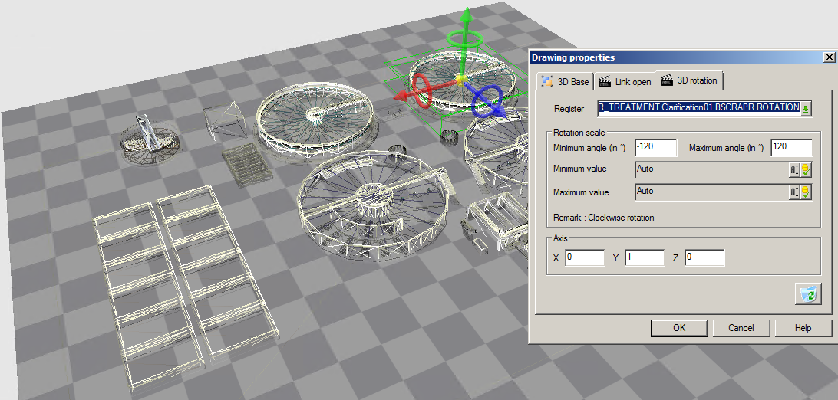

Figure 26 - Example of a 3D mimic

The drawing property manager enables you to define sets of properties that will be applied when creating or modifying objects and the graphic explorer shows any objects in a mimic at a glance allowing easy access and modifications of objects.

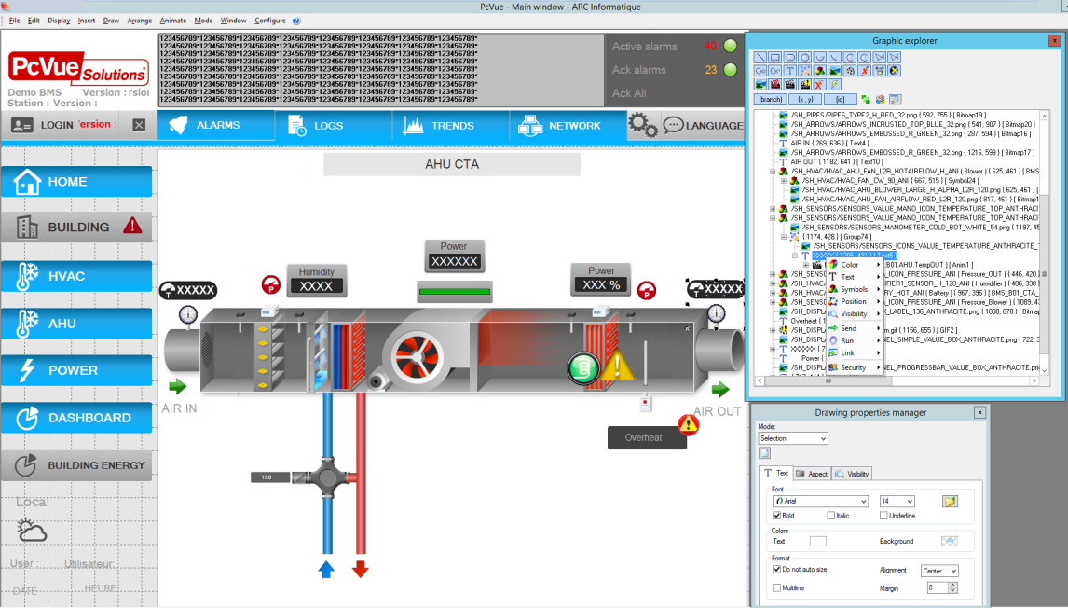

Figure 27 - Graphical design tools

Thanks to the Object Oriented technology re-usable graphic objects are easily created without the need for special tools. Modification of any object is propagated automatically wherever it is used. User configurable libraries allow you to organize and distribute objects specific to your industry sector.

Libraries

The PcVue libraries have been designed to facilitate the development of graphic projects using a modular approach. Basic objects are easy to combine and assemble infinitely according to customers’ needs like a puzzle. The delivered pre-defined objects cover the most common usage and are fully customizable.

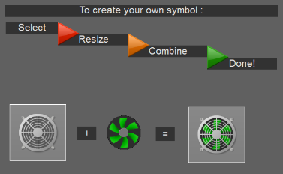

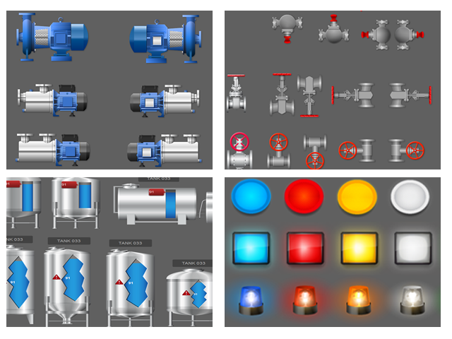
Figure 28 - Example of objects available in the libraries

Images and pre-defined symbols were developed to be close to the needs encountered in the various fields thanks to a thorough study of the application of our partners (pumps, valves, controls, displays ...), specific libraries (Process, BAS / BMS, Electrical Management).

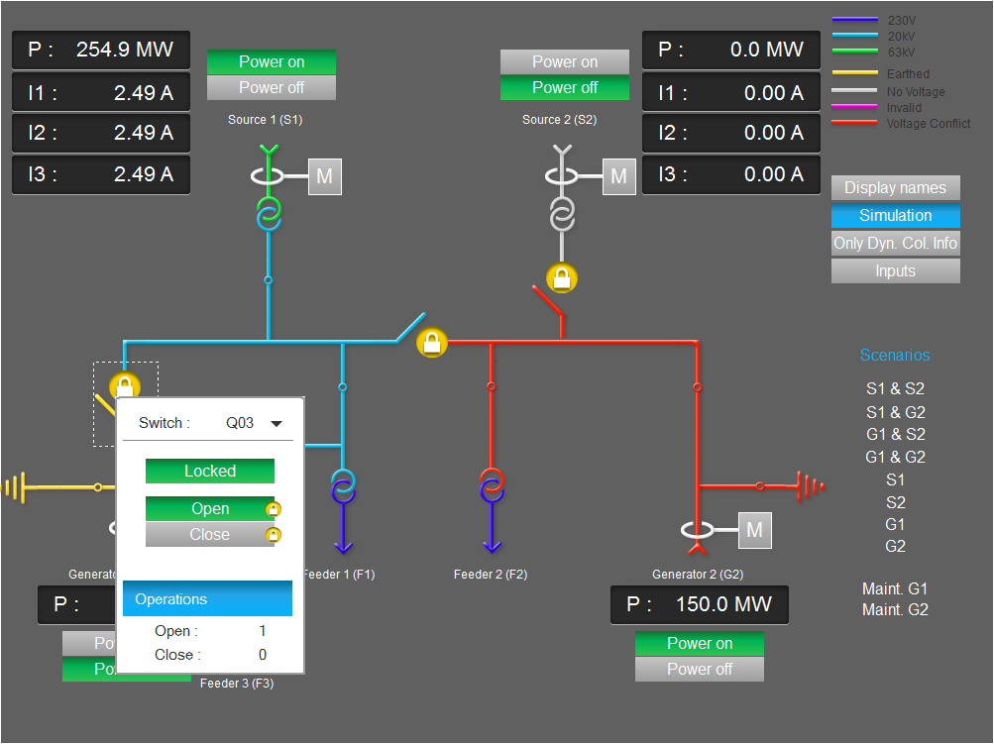

Figure 29 - Example of an electrical diagram using the libraries

All of these libraries are developed using modern graphic styles (shadows, 3D ...) without forgetting the functional aspect to ensure the best compromise of development time / graphic rendering.

PcVue libraries include thousand pictures in PNG format, hundred animated objects and more than 100 predefined templates containing instantiated variables, alarms, symbols etc. to aid a quick start to your project.

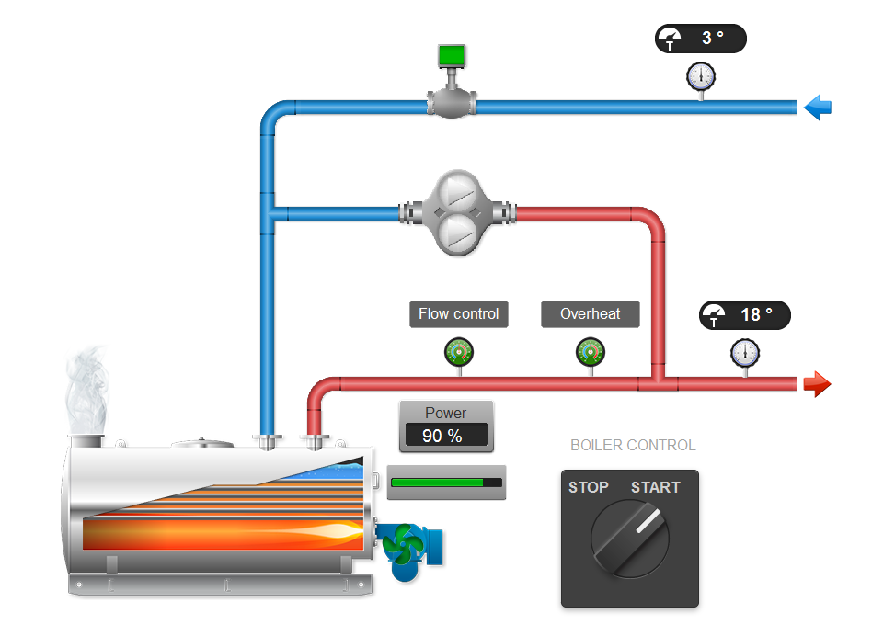
Figure 30 - Example of a mimic for BMS designed using the libraries

Multi-language HMI platform ready

PcVue is designed to handle multiple languages. Development menus and dialogs are bilingual. The two languages that are available are chosen, from a list of ten plus, as part of the project configuration .
Each text of any graphic objects (text strings used in mimics, mimic templates and symbols) can be entered in two languages.
The translation is made easy using the Translation Import/Export tool!
The translation Import/Export Tool allows you to easily export, modify (translate or check the spelling) and import back into the project each text of graphic objects.
In order to support the widest range of languages, the Import/Export tool supports both ANSI and Unicode encoding.

Multi-screen

PcVue provides built-in management of multi-screen displays and video walls. By having multi-screen, an operator can have access to several aspects of the process simultaneously (mimics, alarms, ...). Sharing or comparing data between different parts of a process is much smoother.

Run-Time

The HMI of PcVue offers many runtime features that enhances the user experience for monitoring and controlling the process.

Layers system
The HMI supports a CAD-like layer system for drawing. Any graphic objects can be allocated to one or more layers. Thus, in run time, the user can easily display or hide graphic objects by enabling or disabling layers on which they are allocated. The layers levels can also be associated with user profiles so the graphic objects are automatically displayed or hidden depending on the current user.

Zoom

The Standard zoom capabilities are supported (Zoom IN, Zoom OUT, Zoom Area) as well as de-cluttering which hides and displays graphic objects according to zoom level. It’s also possible to define de-cluttering templates which enable the display of layers according to zoom level.
This feature is very useful in run-time in order to automatically reduce the amount of information visible so that the most important information is readily seen.

The mimic tab control

The mimic tab control is a built-in feature which enables you to define multiple pages in a mimic which, at run time, are selected by tabs in a similar way to some configuration dialogs.
The look and feel of the tab control is inherited from the Windows appearance configuration.
The mimics displayed in a tab have the same properties as regular mimics.

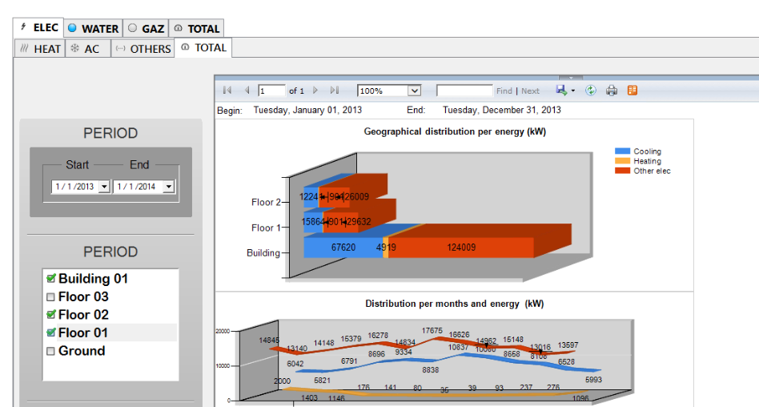

Figure 31 - Example of a mimic using tabs

The mimic Navigator

The Mimic Navigator is an alternative method of scrolling a mimic that is larger than its container window - when the mimic has been zoomed for example. It’s a built-in tool available at both design and run-time.

The Mimic Navigator is displayed as a thumbnail of the mimic with a black rectangle representing the current view. The rectangle can be dragged with the cursor changing the view of the mimic as it moves

This feature is very useful to help user to navigate through a very large process such as a building floor or a electrical busbar.
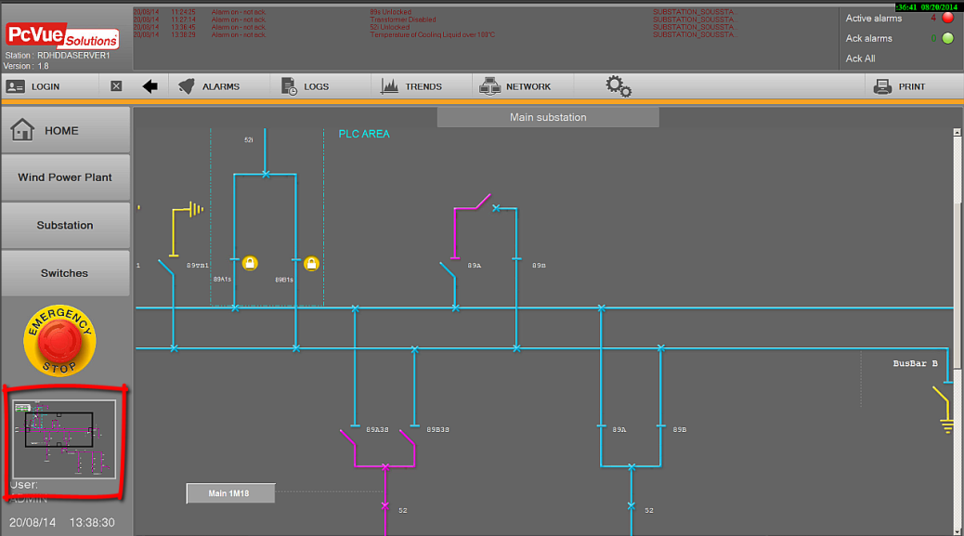

Figure 32 - Example of a mimic using a navigator panel

Contextual objects for easy access to data

The PcVue HMI implements the concept of contextual object which allows an object inherit contextual data from another object.
For example it’s possible to define a mother/child relationship between two mimics. In this case the child mimic inherits the context from the mother mimic.
This built-in feature, along with the generic object oriented variable tree, allows simple development of contextual popup mimics such as those used to display detailed information.
The same principle can be applied to other objects such as symbols, programs, tooltips,…
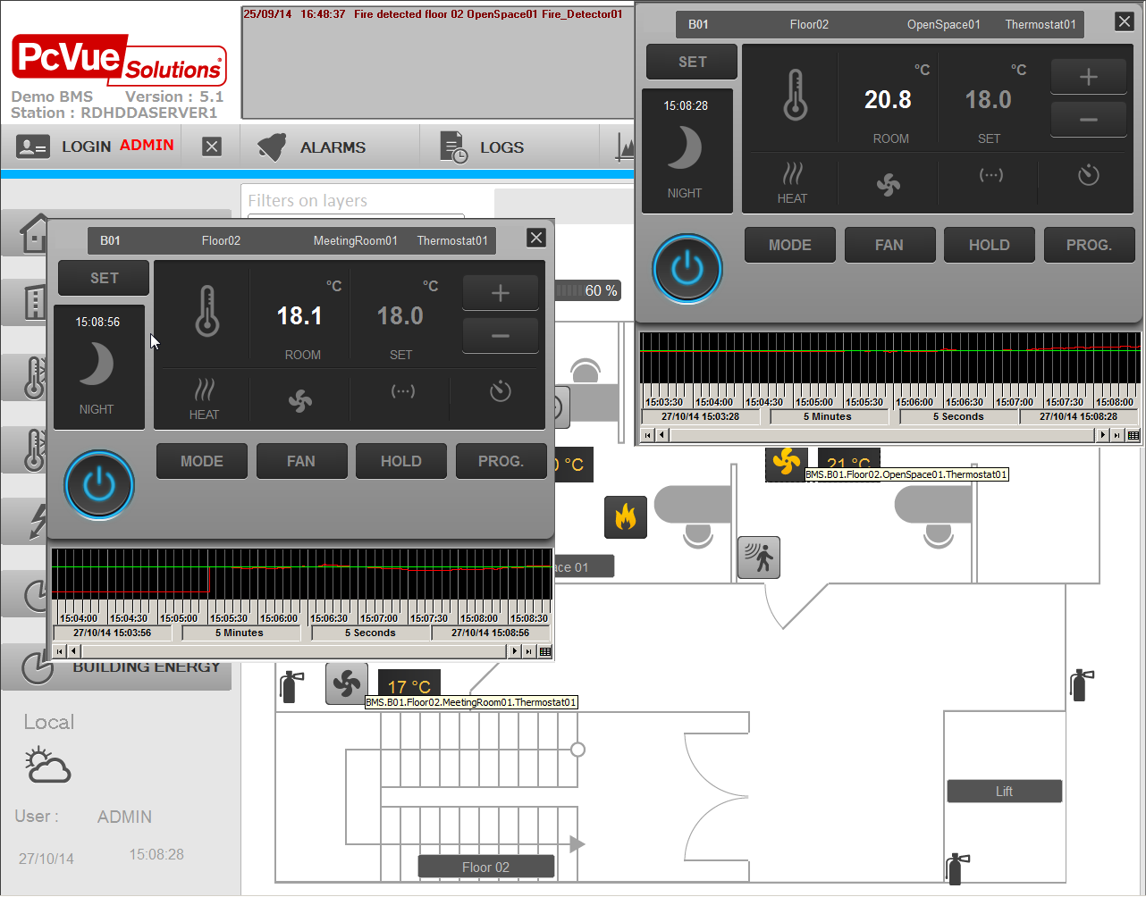

Figure 33 - Example of a mimic showing 2 generic pop-up mimic

In the above example, there is a single thermostat detail mimic used with different contextual data depending on the thermostat symbol from which it is opened. Also, the tooltip automatically gets the context of the associated symbol to display the device description.

In addition it’s possible to set up a specific contextual mimic for the Alarm Viewer (see alarms topic for more details)

The Alarm Viewer

The Alarm Viewer displays a real-time list of alarms and can be embedded in any mimic. Each instance of the Alarm Viewer that you use is individually configurable.
Each alarm is displayed on a single line in a color reflecting its status and level. The alarm list can be sorted in a number of ways including display priority to the oldest, newest at the top or newest at the bottom.
The information that is displayed for each alarm is configurable and includes the following:
- Alarm variable name, description, domain, nature, and level.
- Status including inhibited, masked and maintenance modes.
- On, acknowledge and off time stamps in a configurable format.
- The value and type (hihi, high, low, lolo) for alarms produced by from the threshold behavior of a register variable.
- Up to eight configurable extended attributes including the value of other variables.

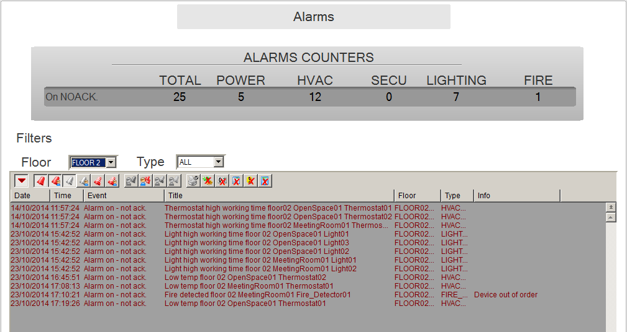

Figure 34 - Example of an Alarm viewer

It is also possible to display the timestamp at which an alarm came on, was acknowledged and went off, all on the same alarm line:

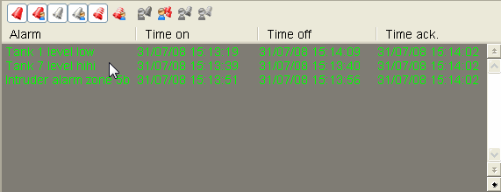

Figure 35 - Example of an alarm viewer using several timestamps

The alarm viewer can be configured to display a contextual popup open by a click on an alarm, allowing the display of any properties associated with the alarm. Also many contextual actions can be performed including but not limited to:
- Open a specific mimic associated with the alarm
- Add a pre-defined message or write a comment before acknowledgment
- A tracking file associated to the alarm can be open for editing and saved,
- A procedure or a technical note can also be open by the operator (pdf, word, Excel,…)
- In relation to a GIS, display the geographical location of the faulty equipment
- An action towards a third-party software (opening an intervention sheet in a CMMS, opening a hand-held form, etc.)
- ,…
This popup is fully customizable.
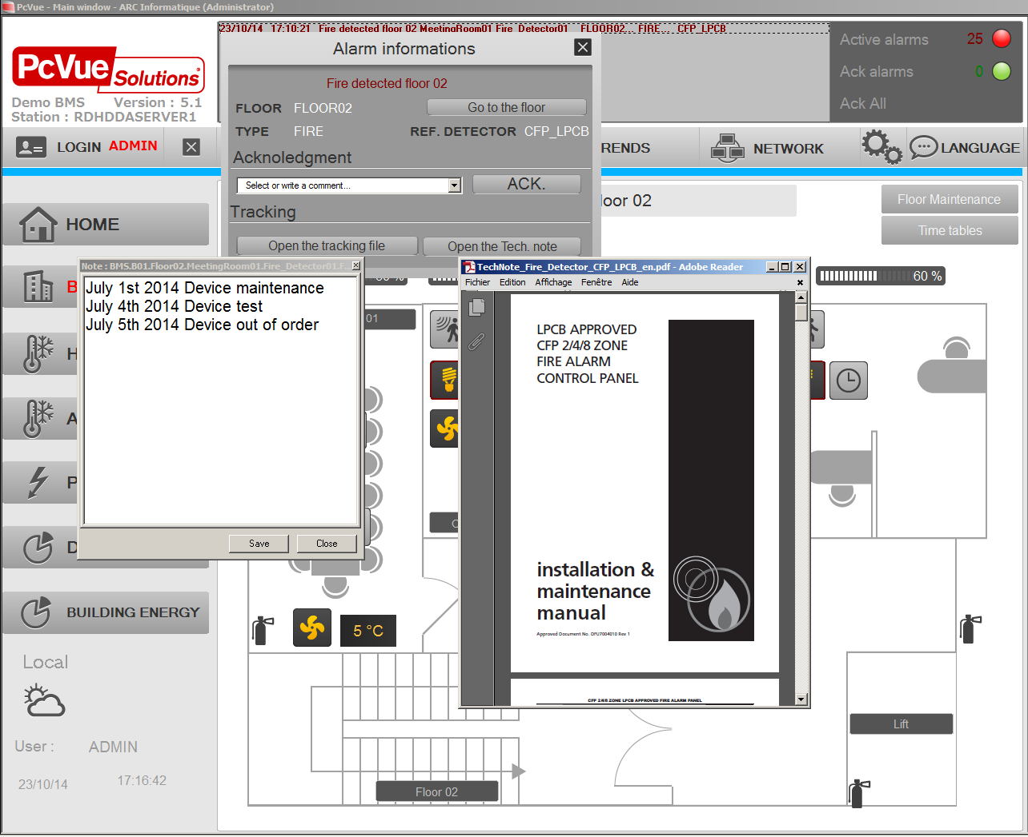

Figure 36 - Example of an alarm pop-up

Operator tools

Each Alarm Viewer includes a configurable toolbar from where the operator can display and change the Alarm Viewer filter, acknowledge, inhibit or switch alarms to maintenance mode, and execute an action associated with a particular alarm. (For example opening a mimic related to the alarm origin).
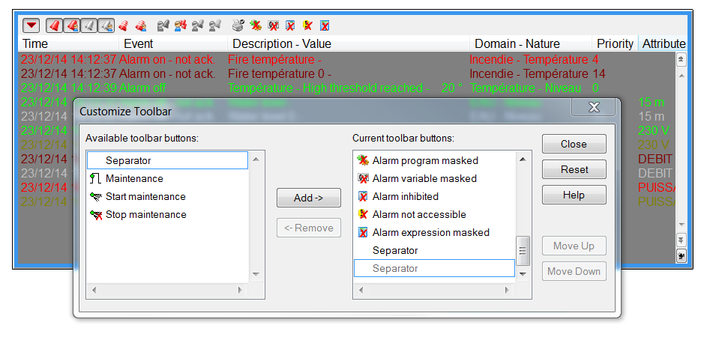

Figure 37 - Alarm viewer : customizable toolbar

Alarm filters

The alarms visible in each viewer can be selected at run-time using the optional domain and nature filter. Additional, more complex filters, using any of the alarm variable’s attributes, can be constructed using scripts.

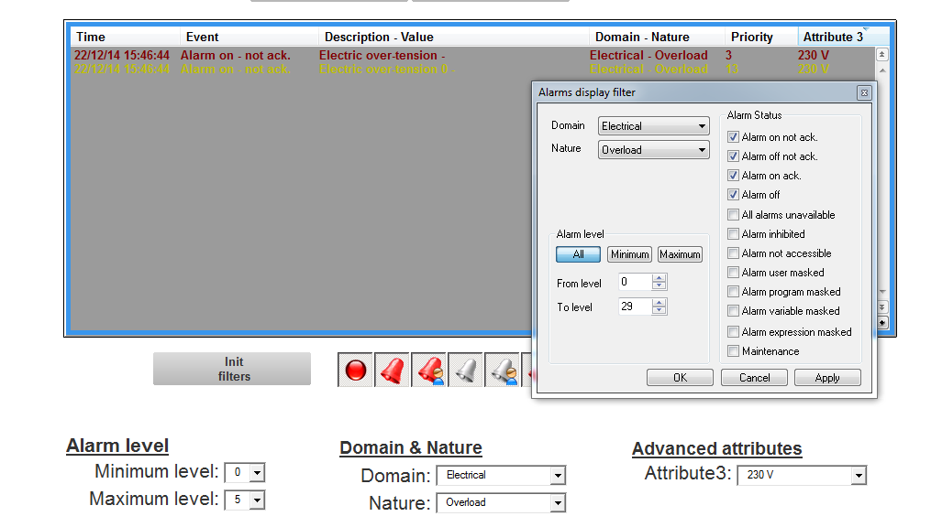
Figure 38 - Example of an alarm viewer with filters

Trending

PcVue has built-in components for displaying trends of real-time data or archived data

Trend viewer for Real-time and Historical Data Trends

- Built-in control that can be embedded in any mimic
- Up to 100 traces per viewer
- Same user interface for both real-time and historical trends which can be displayed simultaneously
- Highly customizable interface
- Fully customizable legend to display properties, and/or dynamically hide/show traces, scales, change color, set thresholds display,…in run time
- An easy to use calendar to search and display a specific period for a trend window.
- Multiple zoom capability
- A simple wizard to export trend data to Excel at run-time including statistics
- Thresholds display
- …

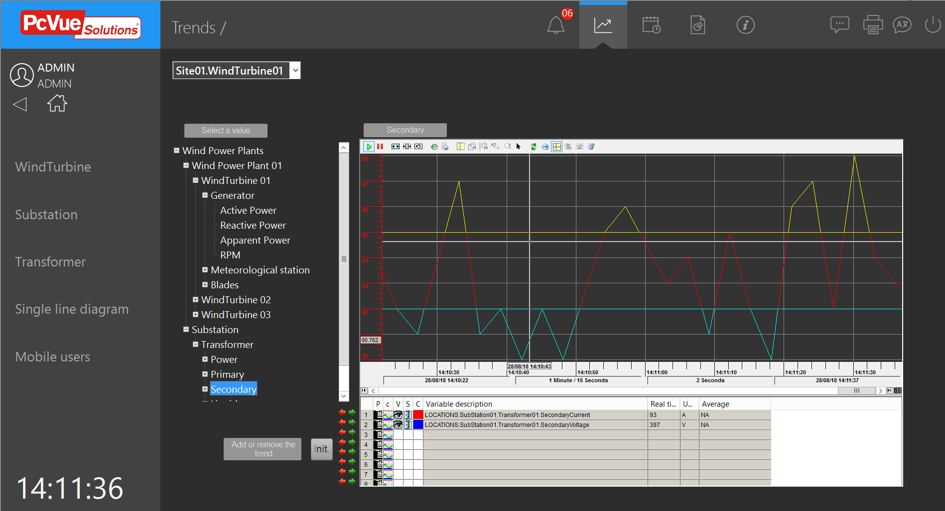
Figure 39 - Example of a Trend Viewer

Chart Control for Y=f(X) Trends

- Built-in control that can be embedded in any mimic
- Plots data series : values variables (Y-Axis) against one other (X-Axis)
- Up to 8 series each representing a register or a bit
- Draw types : lines, columns, cylinders, points,…
- Graphical features : Legend, zoom, cursor, tooltip ,print, popup on right-click,…
- Reference series (lines, or ranges) for comparison (business oriented series)
- Chart control is not supported on web client and web app
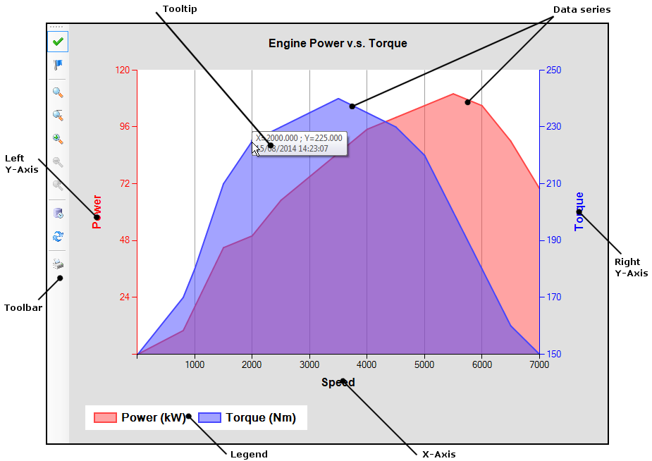
Figure 40 - Example of Y=f(X) chart

Charts

Supported charts
- Doughnut,
- Pie,
- Pyramid
Supported Run time features
- Value format,
- Collection,
- Explode,
- Skins,
- Colors,
- Populate,
- 2D/3D,
- Save,
- Print,…

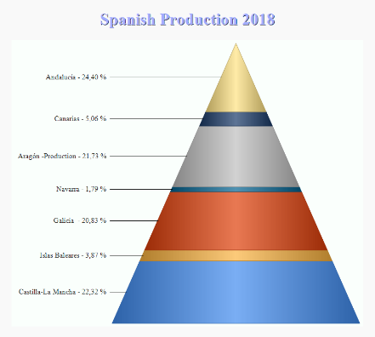
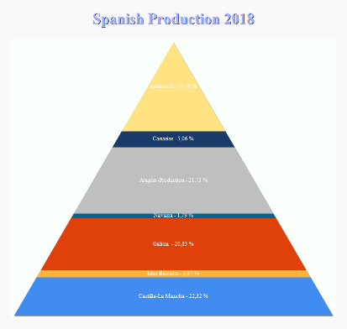
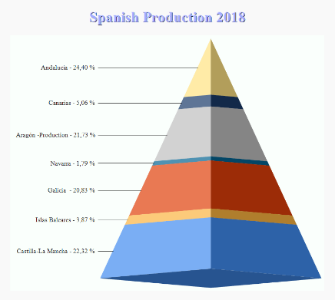

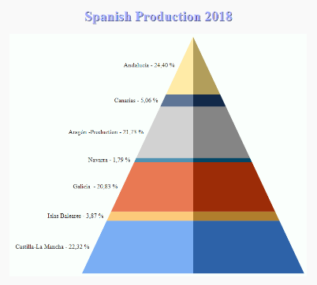
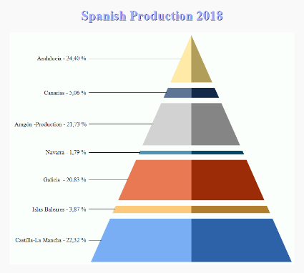

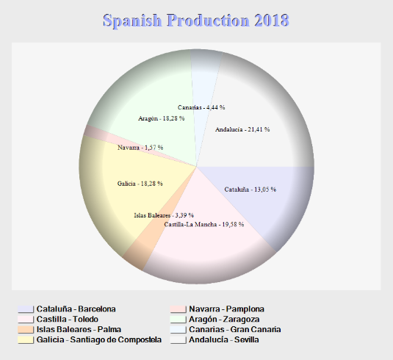
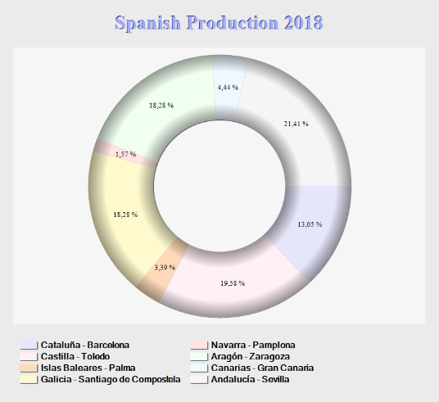
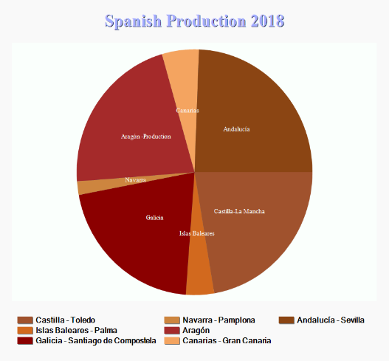
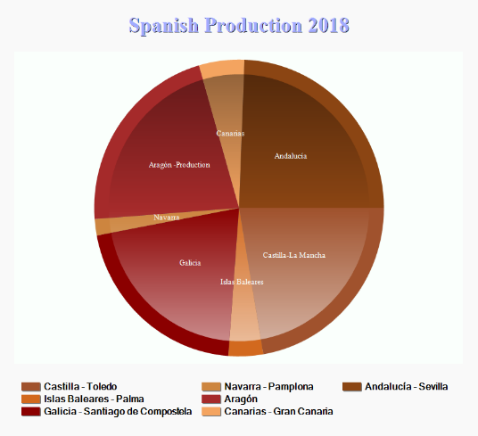
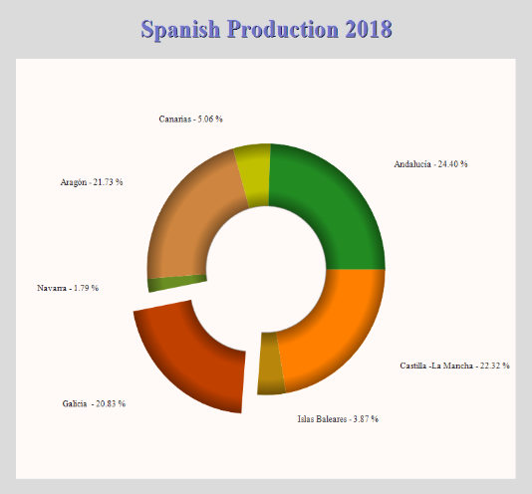
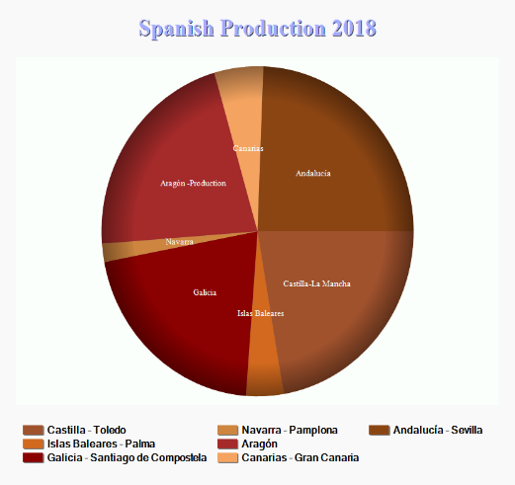

Figure 41 - Example of charts

The Events Log Viewer

A Log Viewer displays data that has been recorded through a particular Log List. The Log List is attached to the Log Viewer when the Log Viewer is configured. The types of data which may be displayed are as follows:

- Alarm changes of state.
  - On and not acknowledged.
  - On and acknowledged.
  - Off and not acknowledged.
  - Off.
  - Unavailable.
- Bit changes of state.
  - Change to zero.
  - Change to one.
  - Change to invalid.
- Operator actions.
  - Commands.
  - Logon and Logoff.
  - Alarm acknowledgement.
  - Alarm masking.
  - Program start.
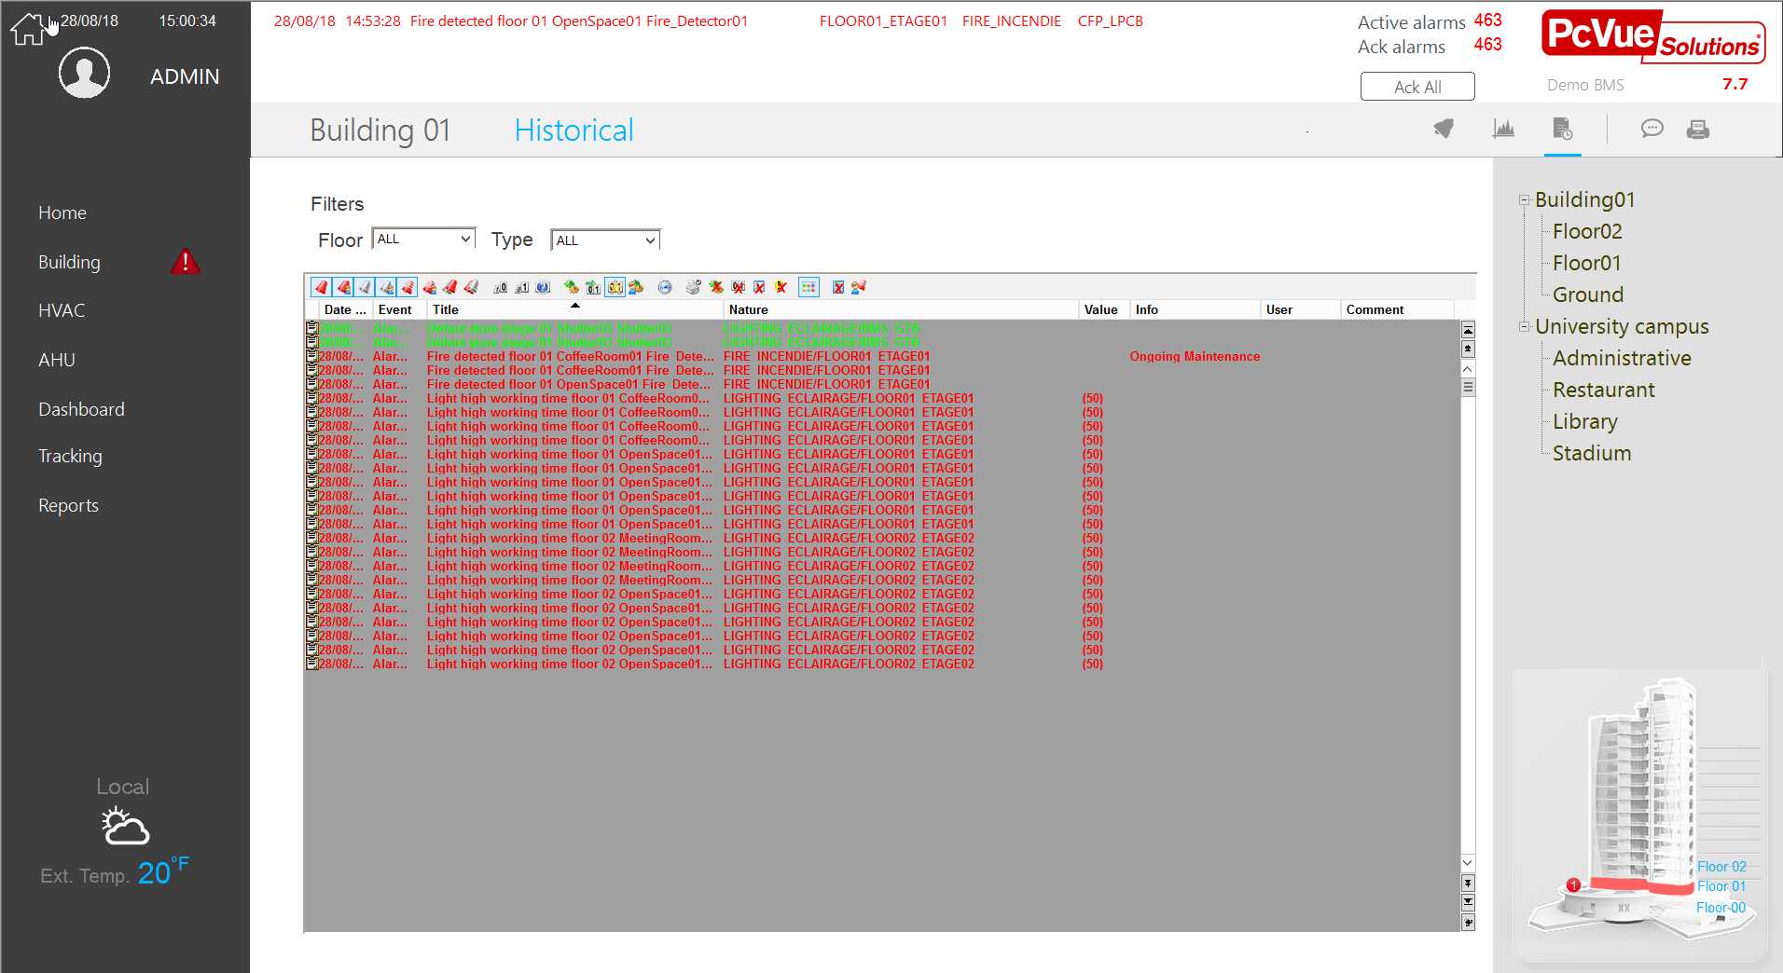
The Log Viewer is extremely flexible both in its appearance and operation and has many configurable options.

Figure 42 - An event viewer

Summary of the event Log Viewer features:

- Log Viewers can be embedded in any mimic.
- Unlimited number of Log Viewers in each project.
- The size of Log Viewer is configurable from 1 line to the maximum allowed by the screen resolution.
- Data can be filtered by Domain and Nature and/or by time filter to search for records from a particular time (from date and time and a search direction).
- Optional toolbar and scrollbar.
- The format of the log lines in the display list is 100% configurable.
- Comment modification - the User is allowed to add a comment of up to 40 characters to each log entry.
- Sort modification - the User can change the sort column and direction.
- Can be configured so that the newest logs appear at the bottom or the top.
- Can be accessed by SCADA BASIC and VBA to customize features.
- Can have a context mimic.

Controls

PcVue provides built-in controls for selecting data in different ways.These controls can be set by a simple configuration and/or with scripts.
Supported in web or mobile clients.
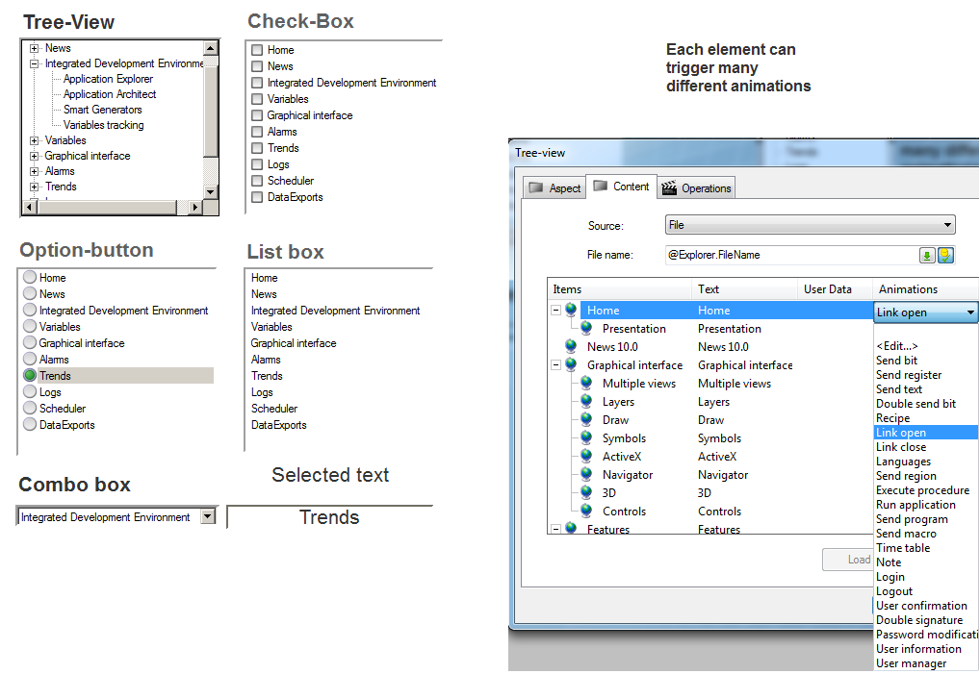
Figure 43 - The built-in controls

GEO Map Control

The PcVue map control is a built-in PcVue component client for a GIS mapping service which:

  - Displays an interactive map provided by map providers. Online & offline both supported
  - Allows an easy map manipulation with integrated functions such as panning and zooming
  - Displays overlays with custom dynamic objects (Markers) including PcVue animated symbols
  - Supported on web or mobile clients

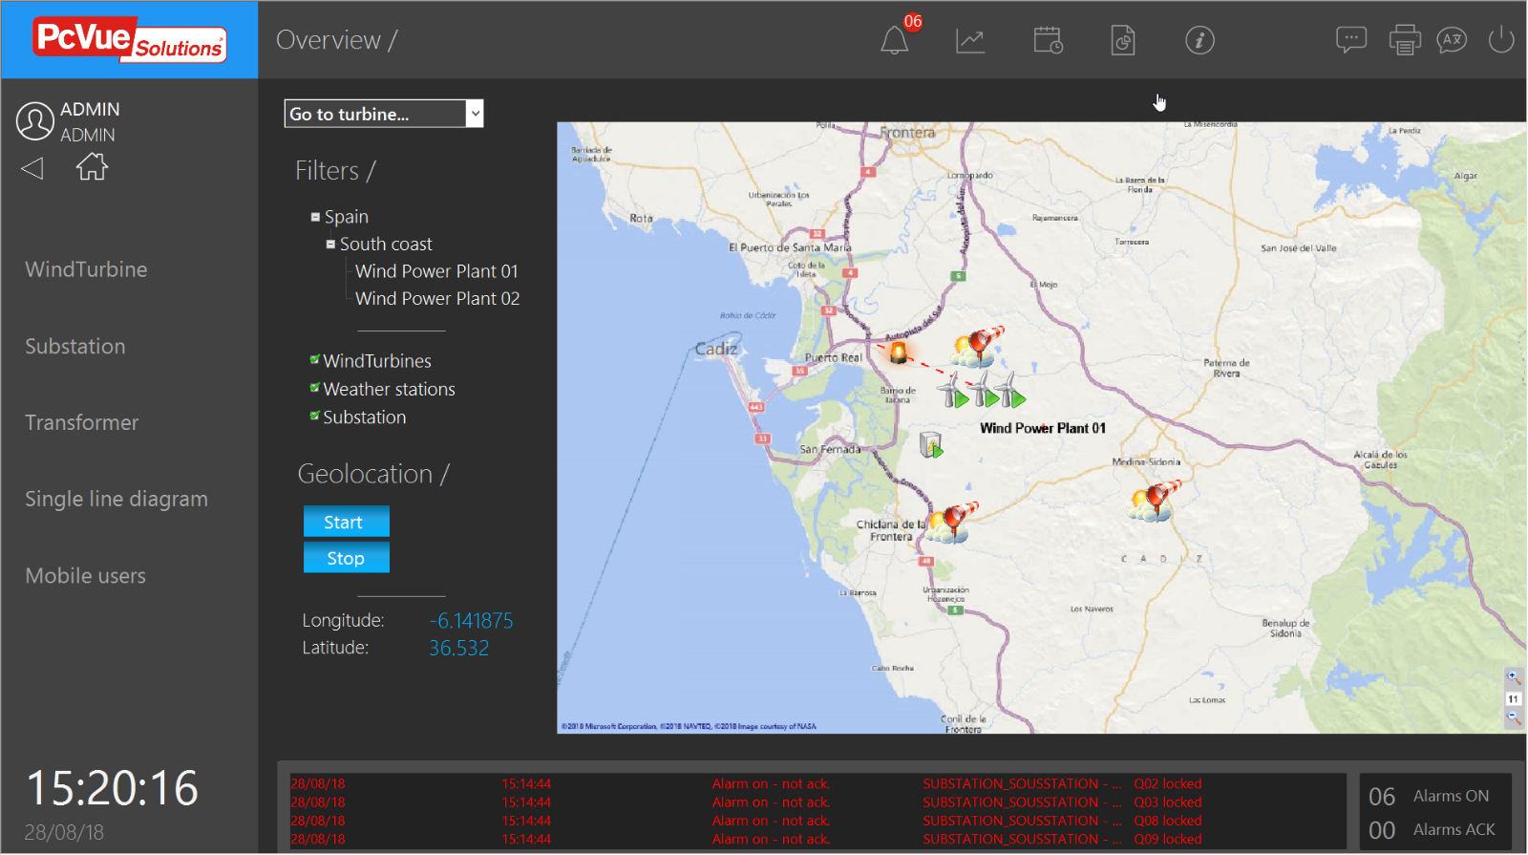

Figure 44 - Mimic embedding a Map Control

Geographical data sources

GEO Map control retrieves 2 types data:
- The backgrounds of cards in the form of tiles
Tiles can be retrieved by queries from a map provider or from a database
- Points of interest

These can be retrieved by reading a GPX file or dynamically by external web services.
GEO map control is based on the GMap.net engine and supports Web Feature Service (WFS) and Web Map Service (WMS).
The following table shows a list of external card providers supported by GEO Map control – This list may changes. Other card providers (possibly dynamic or internal) can be implemented on demand.
 | Name | Guid | DbID
ESRI ArcGIS | ©2013 ESRI - Map data ©2013 ArcGIS
ESRI ArcGIS | ArcGIS_Imagery_World_2D_Map | ff7addad-f155-41db-bc42-cc6fd97c8b9d | 2013713480
ESRI ArcGIS | ArcGIS_ShadedRelief_World_2D_Map | a8995fa4-d9d8-415b-87d0-51a7e53a90d4 | 331635354
ESRI ArcGIS | ArcGIS_Topo_US_2D_Map | 7652cc72-5c92-40f5-b572-b8feaa728f6d | 1717823861
ESRI ArcGIS | ArcGIS_World_Physical_Map | 0c0e73e3-5ea6-4f08-901c-ae85bcb1bfc8 | 966328060
ESRI ArcGIS | ArcGIS_World_Shaded_Relief_Map | 2e821fef-8ea1-458a-bc82-4f699f4dee79 | 548500796
ESRI ArcGIS | ArcGIS_World_Street_Map | e1facdf6-e535-4d69-a49f-12b623a467a9 | 147401035
ESRI ArcGIS | ArcGIS_World_Terrain_Base_Map | 927f175b-5200-4d95-a99b-1c87c93099da | 33405937
ESRI ArcGIS | ArcGIS_World_Topo_Map | e0354a49-7447-4c9a-814f-a68565ed834b | 1296763954
Bing | http://www.bing.com/maps/  ©2013 Microsoft Corporation, ©2013 NAVTEQ, ©2013 Image courtesy of NASA
Bing | BingMap | d0ceb371-f10a-4e12-a2c1-df617d6674a8 | 2144088369
Bing | BingSatelliteMap | 3ac742dd-966b-4cfb-b67d-33e7f82f2d37 | 783085212
Bing | BingHybridMap | 94e2fcb4-caac-45ea-a1f9-8147c4b14970 | 1949545009
Wiki | http://wikimapia.org/  © WikiMapia.org - Map data ©2013 WikiMapia
Wiki | WikiMapiaMap | 7974022b-1aa6-41f1-8d01-f49940e4b48c | 1876805230
OpenStreetMap | http://www.openstreetmap.org/  © MapQuest - Map data ©2013 MapQuest, OpenStreetMap
OpenStreetMap | OpenStreetMapQuestSattelite | e590d3b1-37f4-442b-9395-adb035627f67 | 883468586
OpenStreetMap | OpenStreetMapQuestHybrid | 95e05027-f846-4429-ab7a-9445abeefa2a | 1276062033
OpenStreetMap | OpenStreetMapQuest | d0a12840-973a-448b-b9c2-89b8a07dff0f | 63558647
OpenStreetMap | http://www.opencyclemap.org/  © OpenStreetMap - Map data ©2013 OpenStreetMap
OpenStreetMap | OpenCycleTransportMap | af66df88-ad25-43a9-8f82-56fca49a748a | 1675354978
OpenStreetMap | OpenCycleLandscapeMap | bdbaa939-6597-4d87-8f4f-261c49e35f56 | 1581784214
OpenStreetMap | OpenCycleMap | d7e1826e-ee1e-4441-9f15-7c2de0fe0b0a | 1404362775
OpenStreetMap | http://openseamap.org/  © OpenStreetMap - Map data ©2013 OpenStreetMap
OpenStreetMap | OpenSeaMapHybrid | faacde73-4b90-4ae6-bb4a-ade4f3545592 | 1134614052
OpenStreetMap | http://www.openstreetmap.org/  © OpenStreetMap - Map data ©2013 OpenStreetMap
OpenStreetMap | OpenStreetMap | 0521335c-92ec-47a8-98a5-6fd333dda9c0 | 1492776782
Yandex | http://maps.yandex.com/
Yandex | YandexMap | 82dc969d-0491-40f3-8c21-4d90b67f47eb | 2056733135
Yandex | YandexHybridMap | 78a3830f-5ee3-432c-a32e-91b7af6bbcb9 | 1435206852
Yandex | YandexSatelliteMap | 2d4ce763-0f91-40b2-a511-13ef428237ad | 431368446
OVI Nokia | http://maps.ovi.com/  ©2013 OVI Nokia - Map data ©2013 NAVTEQ, Imagery ©2013 DigitalGlobe
OVI Nokia | OviHybridMap | b85a8fd2-40f4-40ee-9b45-491aa45d86c1 | 1548269087
OVI Nokia | OviTerrainMap | 7267339c-445e-4e61-b8b8-82d0b7aaacc5 | 957412045
OVI Nokia | OviSatelliteMap | 6696ce12-7694-4073-bc48-79ee849f2563 | 1557910217
OVI Nokia | OviMap | 30dc1083-ac4d-4471-a232-d8a67ac9373a | 1651677878
Google | http://maps.google.com/  ©2013 Google - Map data ©2013 Tele Atlas, Imagery ©2013 TerraMetrics
Google | GoogleTerrainMap | a42edf2e-63c5-4967-9dbf-4efb3af7bc11 | 1222160303
Google | GoogleHybridMap | b076c255-6d12-4466-aae0-4a73d20a7e6a | 395208045
Google | GoogleSatelliteMap | 9cb89d76-67e9-47cf-8137-b9ee9fc46388 | 253259331
Google | GoogleMap | d7287da0-a7ff-405f-8166-b6baf26d066c | 1407893838
Google | http://ditu.google.cn/  ©2013 Google - Map data ©2013 Tele Atlas, Imagery ©2013 TerraMetrics
Google | GoogleChinaTerrainMap | 831ec3cc-b044-4097-b4b7-fc9d9f6d2cfc | 370833361
Google | GoogleChinaHybridMap | b8a2a78d-1c49-45d0-8f03-9b95c83116b7 | 1024577166
Google | GoogleChinaSatelliteMap | 543009ac-3379-4893-b580-dbe6372b1753 | 47626774
Google | GoogleChinaMap | 1213f763-64ee-4ab6-a14a-d84d6bcc3426 | 1818940751
Yahoo! Inc. | http://maps.yahoo.com/  © Yahoo! Inc. - Map data & Imagery ©2013 NAVTEQ
Yahoo! Inc. | YahooHybridMap | a084e0db-f9a6-45c1-bc2f-791e1f4e958e | 90900415
Yahoo! Inc. | YahooSatelliteMap | 55d71878-913f-4320-b5b6-b4167a3f148f | 921433430
Yahoo! Inc. | YahooMap | 65db032c-6869-49b0-a7fc-3ae41a26af4d | 729174836
Other | Others
Other | Empty map | 00000000-0000-0000-0000-000000000000 | 2096245217

Markers

- Turn any PcVue symbol into a marker on a map
- Basic markers, such as shapes, images or texts
- Display/control of variables value or attributes
- Popup and mimic open on markers
- Markers and layers are stored in a standard GPX file loaded and rendered by the map control

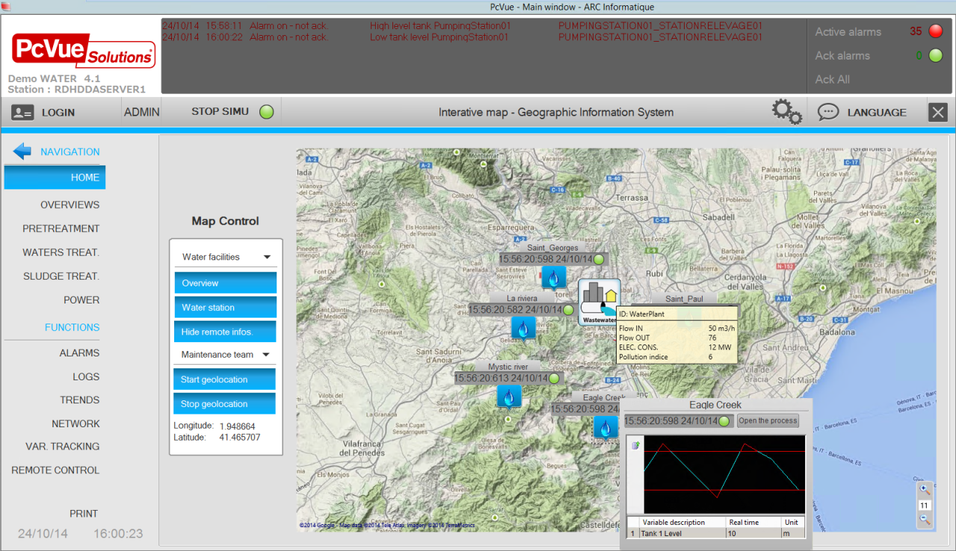

Figure 45 - Markers displayed on a Map Control

GEO Map Control tools

PcVue is delivered with tools to easily generate map and associated markers

The Map Markers Editor, to create and to edit GPX files:

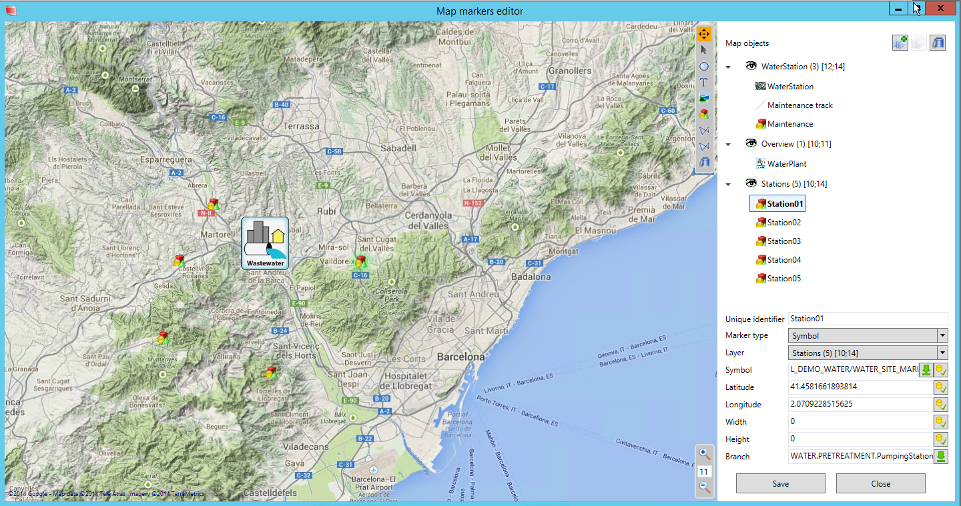

Figure 46 - The marker editor

The Map Cache Creator :
  - Retrieves map data online
  - Prepares the map cache for offline run-time use

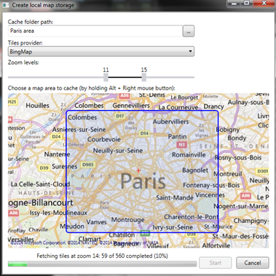

Figure 47 - The map cache creator

Keyboard configuration

The action produced by many of the non-QWERTY keyboard keys may be programmed by the developer. In this ways keys may be allocated to perform commonly used operations such as displaying a particular window. This is particularly useful if, in run time, the host PC has to operate without a mouse.
The keyboard may be configured either using the Function Key settings interface.
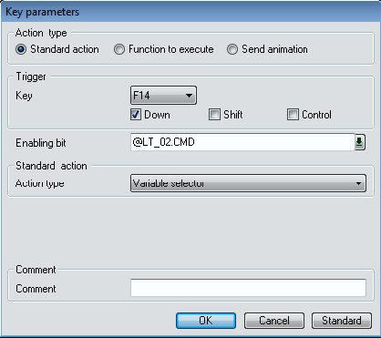

Figure 48 – Key parameters

A key action may be one of three types.
• Standard action. An internal action such as to display the on-line Help or show the Configuration Menu.
• Execute a function. A function from a SCADA BASIC program may be executed. The possibilities in this case are endless, but a typical use would be to open a window.
• Send an animation. Reproduce the action of an operator clicking on a Send type animation in a window.

There are over 30 keys which are user configurable. Most of these keys can be given more than one action by using them in conjunction with the shift and control keys. In addition an action may be triggered when a key is pressed and when it is released. The function of some of the keys is pre-defined by the Supervisor when it starts. These are known as the Standard Actions.
The detail can be found in the online help.

BIM operations

PcVue allows designing a PcVue BIM-based project for BIM-driven building and facility management system.
It supports for BIM operations features such as a BIM animated 3D viewer.

BIM animated 3D viewer

The BIM animated 3D viewer is a built-in PcVue control allowing visualizing the BIM geometric model. It supports the following features:

- Animated BIM 3D viewer based on IFC files
  - Displaying a 3D model and navigate in 3D space
- Animating objects according to PcVue variables, using animations or scripts
  - Advanced animations features: presets, color, zoom, callbacks,...
  - Automatic navigation in the model on an alarm raise
- Accessing properties of every object in the model
- Support for .xbim files

BIM configuration

The BIM control can be configured with no code.
It includes the following features:
- Browse in the model
- Create groups of objects
- Select animations on objects or groups

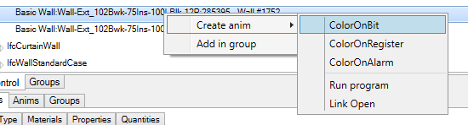
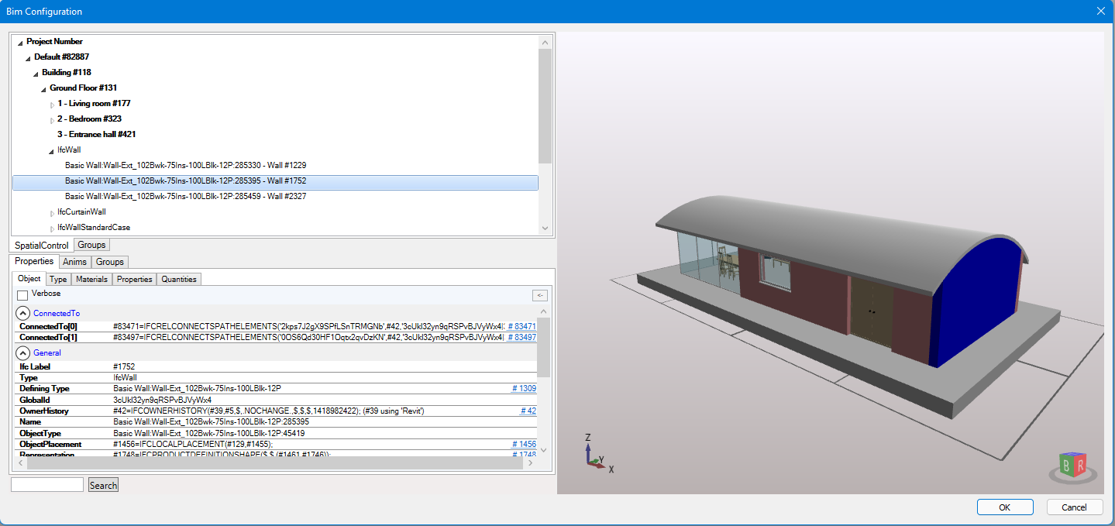
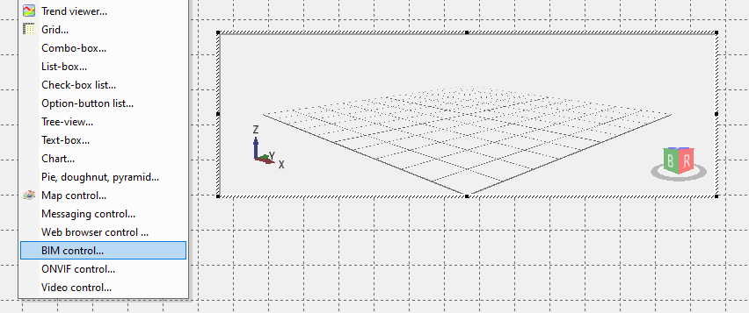
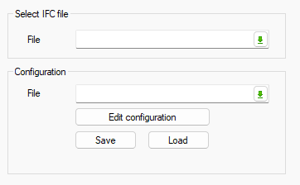
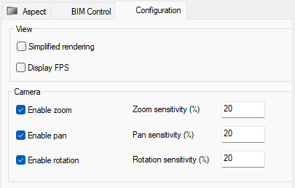

Figure 49 – BIM viewer configuration

BIM run-time
Animations
- Colorize an object with plain or blinking colors
- Zoom on an object
- Show or hide an object
- Add a callback on an object, to open a mimic or execute a program
Presets
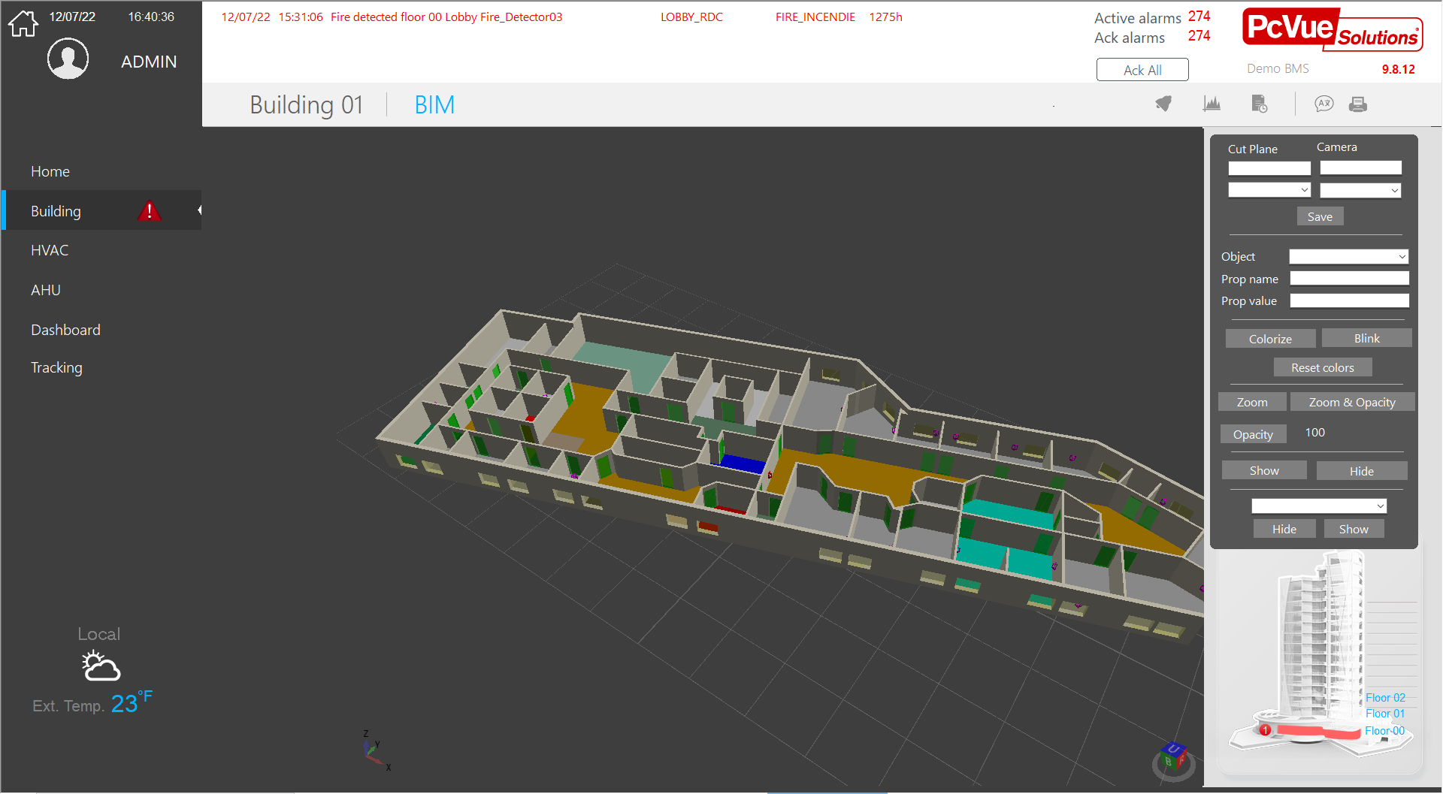
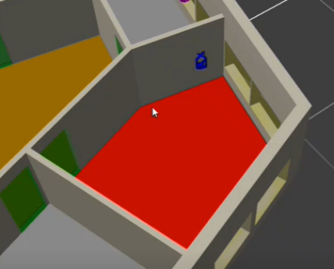
Presets are a camera position and a cut plan position that can be saved and called back at runtime

Figure 50 – BIM viewer run-time

Video Integration

PcVue makes it possible to integrate video equipment and to restore video streams in mimics via native ONVIF interface.

ONVIF

Video equipments compatible with profile S of the ONVIF standard are supported. They can be integrated into a PcVue project, and have the following characteristics and functions:

- ONVIF Profile S
  - For IP-based video systems
  - Video streaming and configuration
- Control of cameras
  - PTZ control
  - Audio-in
  - Multicast
- Guard tour
  - Rounds of camera presets in sequence
- Presets
  - Predefined Camera position + Zoom level
  - Load & save presets
  - Go to preset
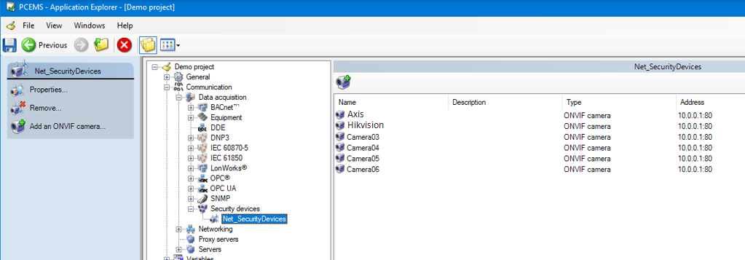

Figure 51 – ONVIF Video equipements - configuration

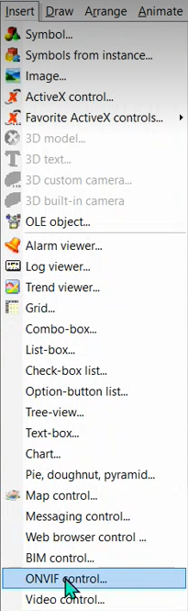
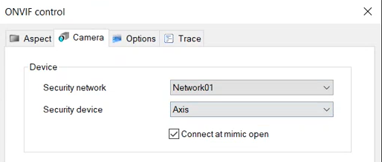

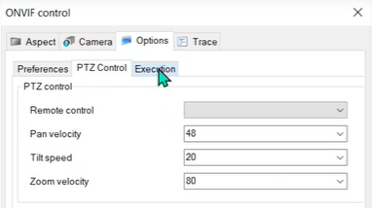

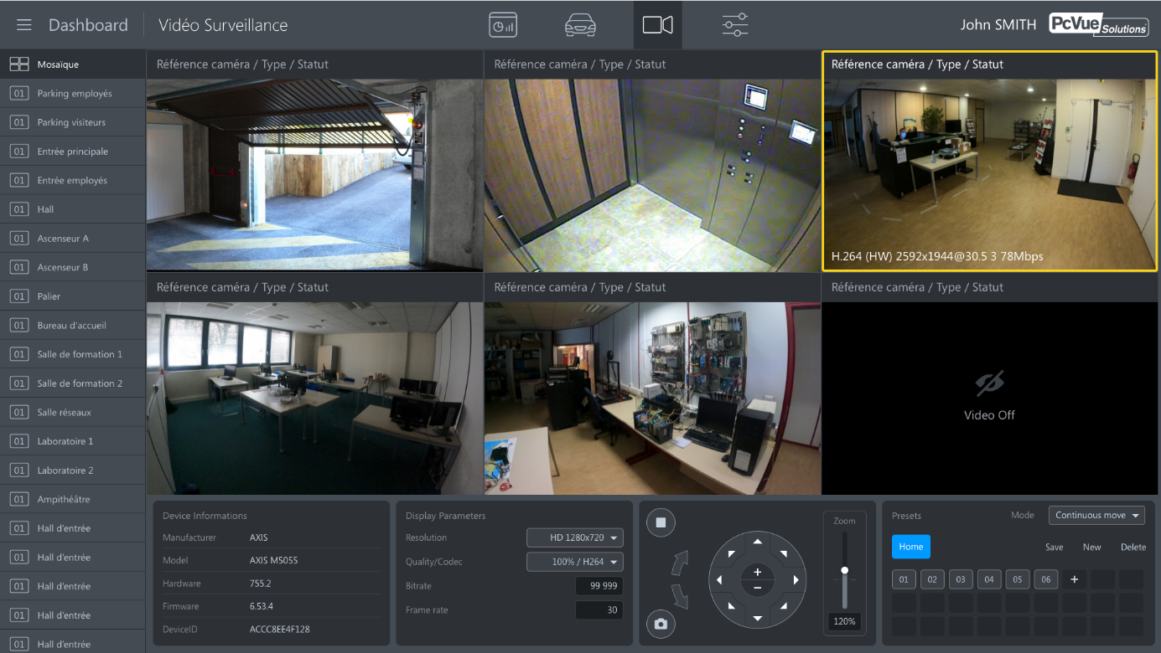
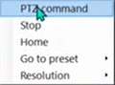

Figure 52 – ONVIF video equipements - Run-Time

RSTP flow

PcVue integrates a native video player allowing the control of video streams and live broadcasting.
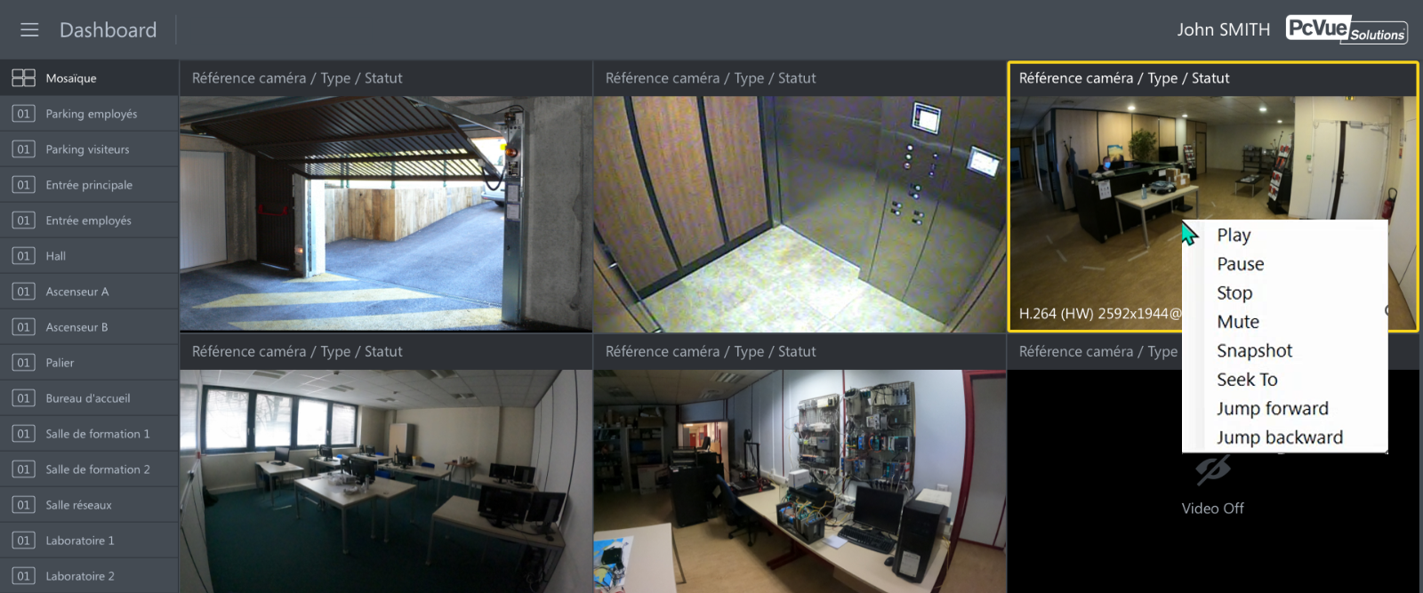
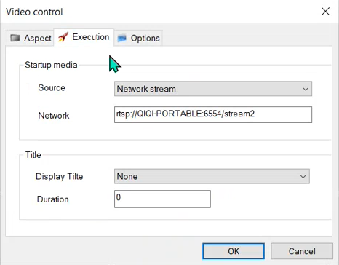
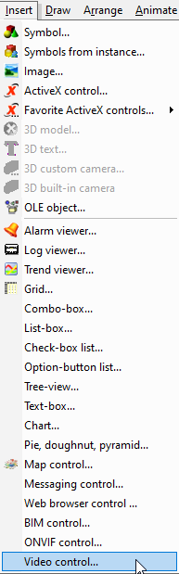

Figure 53 – Built-in RSTP flow player

Instant messaging

PcVue comes with a messaging control that allows a user to communicate, by sending and receiving text messages, to one or more other users on another PcVue station and / or one of the mobile applications.
Instant messaging uses a conversation known as a chat (or chat room) that are created, and owned, by a specific user. Once a chat has been created, the owner can invite other users and change user permissions.
The instant messaging control includes but it is not limited to the following features:
- One or several instances of a messaging control can be inserted in any mimic
- Several chat can be created with different members
- Several chat user access levels giving permissions
- Several medias can be sent
  - Text
  - Record voice
  - Attached file
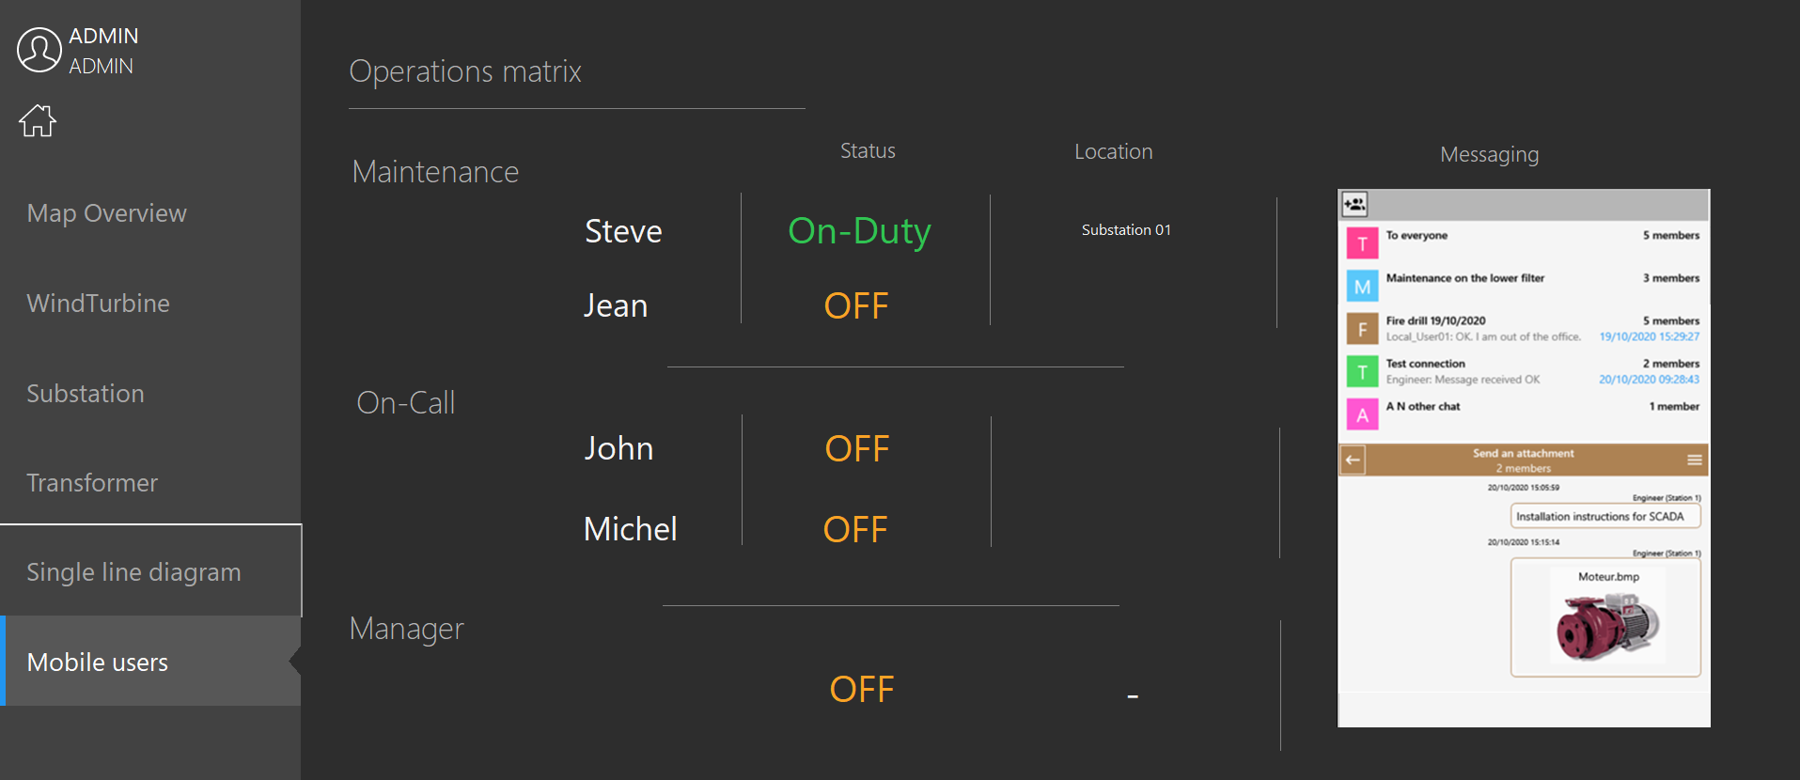
Figure 54 – Mimic with instant messaging control

Data processing

Archiving

Recording a history of process data is essential to many SCADA applications for many reasons: fault diagnosis, quality assurance, regulatory compliance, analysis of process trends, fiscal demands etc. It is a standard feature of PcVue with no additional components required or extra costs involved.

PcVue uses a data archiving engine to record values (events, trends) using various mechanisms and formats:
- Data recorded in a proprietary manner to a text file
- Data recorded to a DBMS such as SQL Server using a built-in component (Historical Data Server).
- Data recorded to a DBMS using an ODBC connector
- Data recorded in a specific format allowing to replay the recorded data through mimics

You can choose the one (or more) method best suited to your application during configuration.

In addition, PcVue has built-in multi-station and redundancy mechanisms for archives.

SQLServer archiving using Historical Data Server (HDS)

Many systems need to record data in a DBMS to centralize data used by several third-party software.
The HDS records in an industry standard database. The database can be located anywhere that the PC hosting PcVue has permanent access. Connection to the database utilizes Microsoft’s ADO technology. Qualified databases include SQL Server and Access. Microsoft's freely distributable SQL Express is delivered with PcVue. The recording capacity is limited only by the selected database and the performance of the host PC.
As well as making Microsoft SQL Server available to handle historical data in database format, PcVue offers a tool called DBImport which enables you to import data for the HDS tables from CSV formatted files. The recording of third party data in PcVue’s relational database assists the centralization and exploitation of data. The Reporting Services tool included with SQL Server allows you to organize the data and to publish it in a wide range of formats: PDF, XLSX, HTML etc.

HDS features

- Records in an industry standard database
- Easy access to data by 3rd party applications
- Qualified with Access and SQL server
- Capacity limited only by selected database
- Includes a scheduler to run database maintenance tasks
- System variables to provide status information for each database used

Event log and Sequence Of Events (SOE)

PcVue features Sequence of Events recording for events including alarm status, user actions, and value change.

In the data archiving engine one or more Log Lists, which filter the events to be recorded, are defined. These events are recorded in an archive unit (proprietary files, or DBMS) .The record of an event can be done with time stamps of 1 ms resolution.
Recorded events can be displayed using a Log Viewer.

VCR Replay feature

For security reasons operators shall be able to replay. The VCR replay feature shall enable to record changes in value (events) of variables on one Supervisor station and to play them back through mimics on another.
Main VCR features shall be :
- Replay mimics at a different rate to the events, associated with a set of variables
- Facility for data recording for several weeks
- Replay information event by event to analyze incident sequences

VCR replay feature is not supported on web or mobile clients.

Data processing and Reporting

PcVue offers all the necessary tools for data exchange, extraction, stats and reporting to cover your information needs.
PcVue records real-time data to a SQLServer database with its built-in Historical Data Server.
Pcvue can also connect any ADO.net based data source for exchanging data. Using the Universal Data Connector.
PcVue viewers can be used to display logged events and alarms, and historical trends, for short term analysis.
For long term analysis, comparisons, statistics and regulatory compliance, detailed Excel reports are often required. The built-in Data Export of PcVue is able to export statistical data from the archives to an Excel or csv format file.
For advanced reporting, features including data retrieval, graphic report design, advanced report generation and publication features, with a user friendly no-scripts interface, PcVue offers a built-in connection to the reporting software Dream Report.
In addition, for maximum flexibility and high-level of customization the reporting platform SQLServer Reporting Services (SSRS) can be used with PcVue. | 

Data Export – Data Statistics from PcVue to Microsoft Excel®

Users want to visualize and analyze PcVue data using the familiar features available in Microsoft’s Office® suite of applications, including Microsoft® Excel®. Analytics must be reliable, secure and able to calculate Key Performance Indicators.
Thanks to the PcVue built-in Data Export features, users with little or no development experience are able to configure and deploy analytics. The Data Export features combined with Microsoft technologies provide powerful new ways for PcVue users to build sophisticated data exportation.

Principles

Extract Export data tracked according to criteria defined by the user (dates, event types, properties of the variables...). Setting up Data export, assessments, and data is directly realized from PcVue®. Ergonomics allows global visualization of the different elements that constitute the balance sheets. Data Export can automate extraction and export tasks to Excel® from the archives of a set of variables.

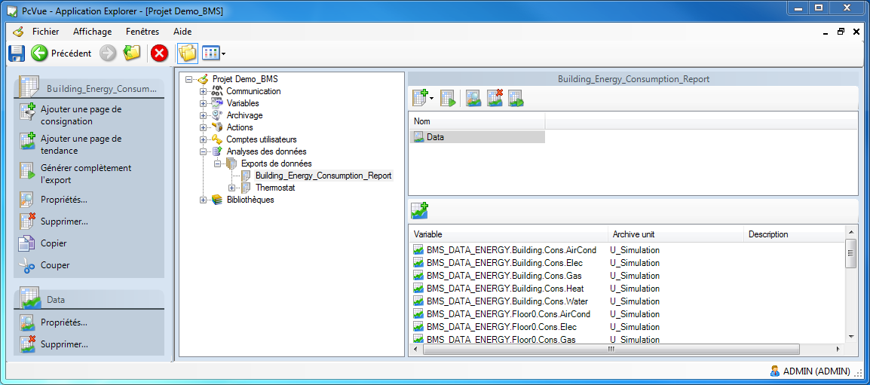

Statistics page

Data Export allows to perform statistical calculations on the data. It calculates different indicators from archived data in the proprietary archives and/or PcVue® database.

• Number of occurrences of State
• Number of occurrences of alarm
• Duration of State
• Duration of alarm
• Sum
• Average
• Minimum
• Maximum
• Standard deviation
• …

Formatting of statements

Data Export allows different modes of data extraction to balance sheets.

• Extraction of raw data

In this mode of operation, Data Export populates the worksheet with values and timestamps stored in storage units. Data Export produces an assessment that the number of samples depends on the number of changes values recorded by PcVue®.

• Retrieving data with sampling

In this mode of operation, Data Export populates the worksheet with values according to the second in several months configurable sampling rate. Thus, the balance sheet will always contain the same number of values for a given period.
• Retrieving data with sampling and synchronization

In this mode of operation, in addition to sampling, Data Export determines when each sample is taken. Synchronization allows selecting the values of various data to specific common stamps.

Balance sheets generated by Data Export are directly exploitable under Excel® without the need to install Excel on the computer. For custom formatting of balance sheets, workbooks models can be defined. These models will be powered by Data Export during the generation of balance sheets. This approach allows to have full power of Excel® to present the data through different tabs, charts and tables.

Generation of assessments

Data Export allows the generation mode RunTime, automatically and manual assessments. Automatic generation This generation mode allows to get balance sheets at the onset of an event in oversight (evolution of a State, an alarm, a tendency, planning,...). Generated assessments may use either:
• The default settings for balance sheets
• Specific timestamps start and end
• A reference time and a specific time period

Dream Report

For advanced reporting needs, PcVue offers an integrated connection to the Dream Report® reporting software.
Dream Report® allows you to acquire data from a variety of sources, set up reports through an intuitive programming-free interface, and manually or automatically generate reports in a variety of formats and media, including a web portal.

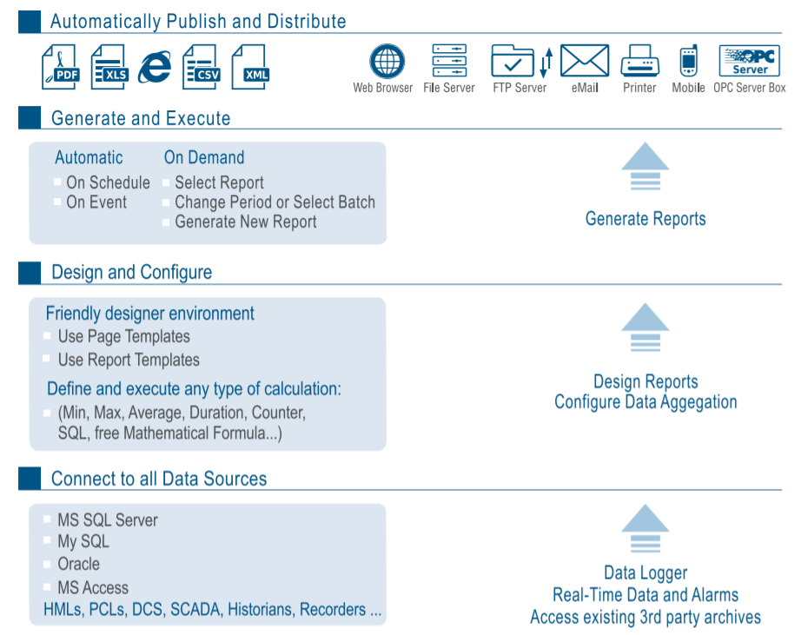

Reporting design platform
- Intuitive environment based on pre-defined animations - without programming
- Built-in calculation functions
- Built-in statistics objects
- Report templates for various trades (Buildings, industry, water, pharmaceutical, ...)
- Widgets, tables

Runtime engine
- Run as a service or application
- Local or remote connection
- Password protection
- Command line reporting
- Dynamic report generation
- Support for embedded in Active X and .net

Security
- Integrated user management
- Active Directory Support
- Version Management
- Complies with the requirements 21cfr11

Web Portal
- Access existing reports and generate new reports
- Creation of zones of seizures: choice of dates, texts, lists of data, ...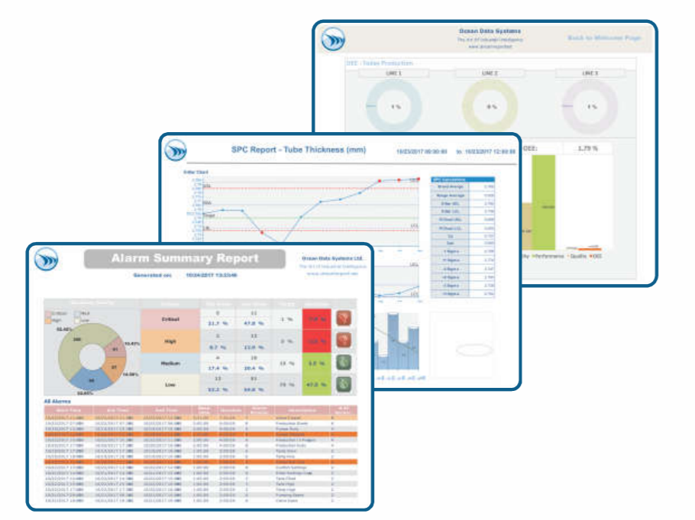

SQL Server Reporting Services (SSRS)
SQL Server Reporting Services (SSRS) is a server-based report generation software system from Microsoft. It is part of suite of Microsoft SQL Server services. SSRS enables users to quickly and easily generate reports from Microsoft SQL Server databases.
SSRS provides a full range of services and tools ready to use to create, deploy, and manage reports. They are fully integrated with SQL Server tools and components.
SSRS can be executed (or solicited) directly in a browser from a Microsoft Office application or even from a third-party application like PcVue.

SSRS reports integrate seamlessly within a PcVue application, with the ability to display them in mimic and filter the data displayed (see examples below).

SSRS offers among others the following features:
- Catalog Management for access to data stored in SQL Server
- A report generator that allows:
-The identification of the data sources (including non-Microsoft databases like Oracle)
- Querying data through SQL queries, programming languages C #, ...
- The output file format and the publication of media (email, ...)
- The creation and publication of reports

Reports type :
- Interactive,
- Tabular,
- Graphic
- Free from XML data sources, relational and multidimensional

Examples of balances energy consumption designed with SSRS and embedded into PcVue

One of the common applications of the use of SSRS reports within PcVue is displaying energy consumption of a building.
The following examples show different views of reports generated by SSRS and integrated into a PcVue mimic. The data comes from a database in which are recorded the building consumption values. Integration with PcVue can easily apply filters to display data of SSRS reports based on areas for example.
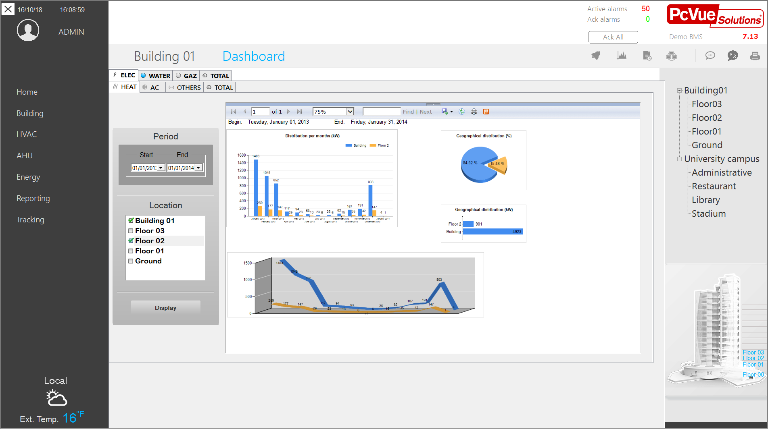
Figure 55 – Mimic showing the time distribution and geographical electrical consumption of heating for several floors

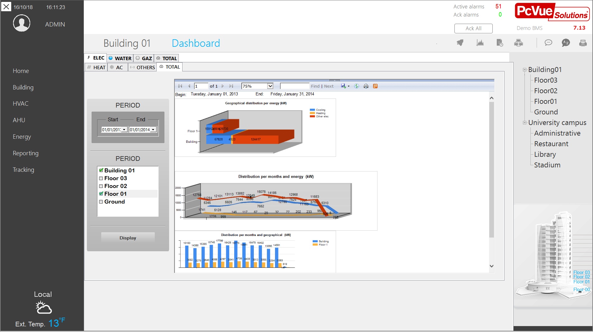

Figure 56 - Total balance electrical consumption of the building compared to floor 1

Example of Time Diagram and Distribution of Production Machines States

Using SSRS reports is particularly suited to visualize the production machines states.
From the real-time values reported by the machines, and archived in a SQL Server database by PcVue, it is possible to visualize in PcVue of status reports generated by SSRS like those shown below.

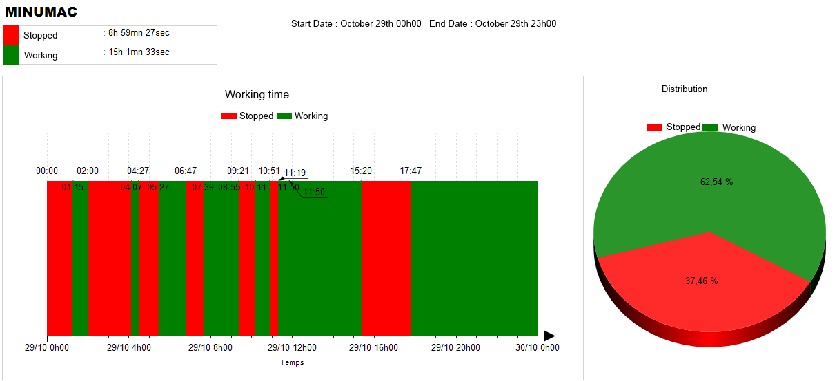
Working time of a machine
- Stopped
- Running

Figure 57 – Machine working time report

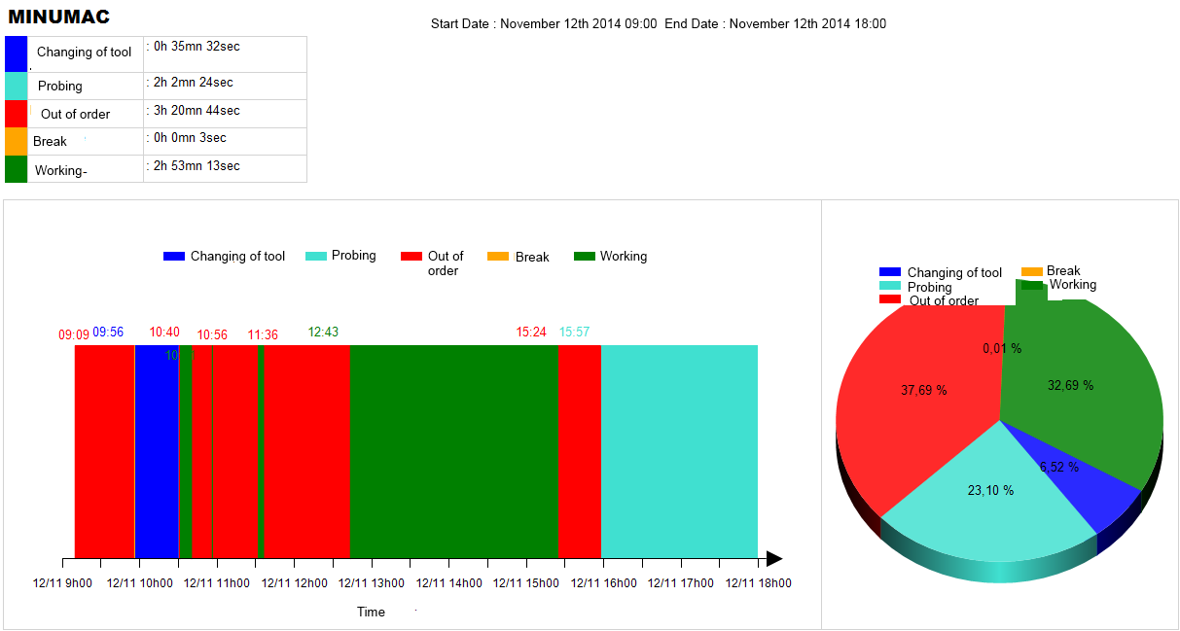
Machines states
- Working
- Changing of tool
- Probing
- Break
- Out of order

Figure 58 – Machine states report

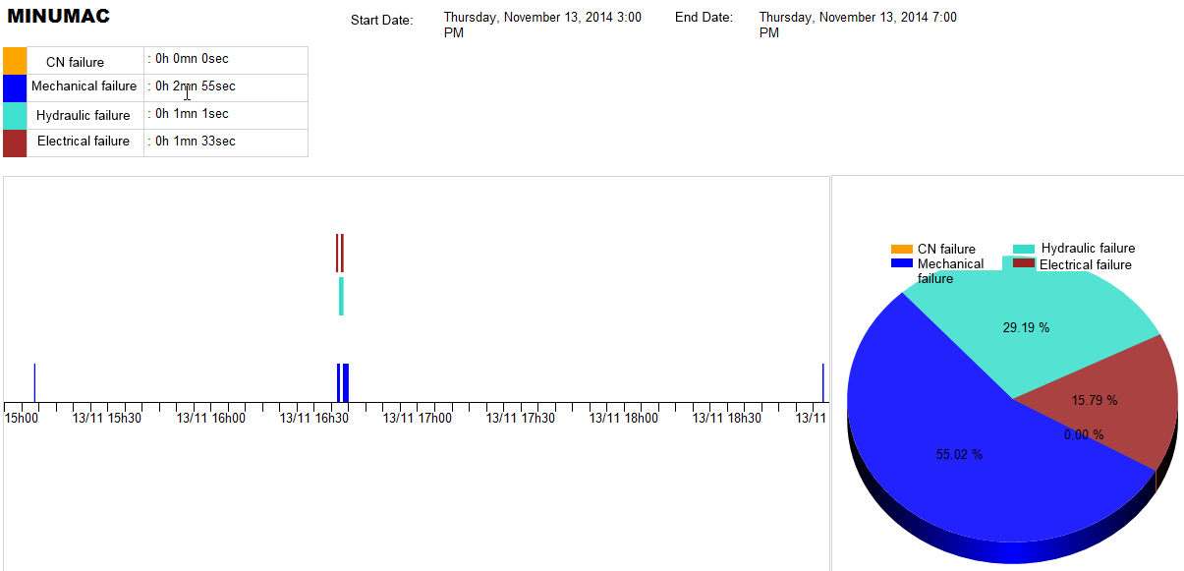
Type of failures :
- Mechanical failure
- Hydraulic failure
- Electrical failure
- CN failure

Figure 59 – Failures report

AI, Optimization and Intelligent Control

Intelligent Assistance for Efficient Operation

The Intelligent Assistant is a functional solution dedicated to the automation of operational tasks and data analysis. It combines automation mechanisms and Artificial Intelligence (AI) to process supervision data and execute corrective or informative actions.
This feature is designed to streamline operations by automating repetitive processes and providing decision-support tools for technical and business teams.
The system is based on two interdependent components: Bots (execution agents) and Jobs (orchestrators).

Bots: Processing Agents

Bots are logical units designed to perform specific unitary tasks. They can be used through standard templates or developed on demand.
- Functions: They handle data analysis (statistical calculations, predictive algorithms) and the execution of actions (sending notifications, generating reports, system commands).
- Triggering: Bot activation is conditioned by configurable triggers: time cycles, variable state changes or specific system events.

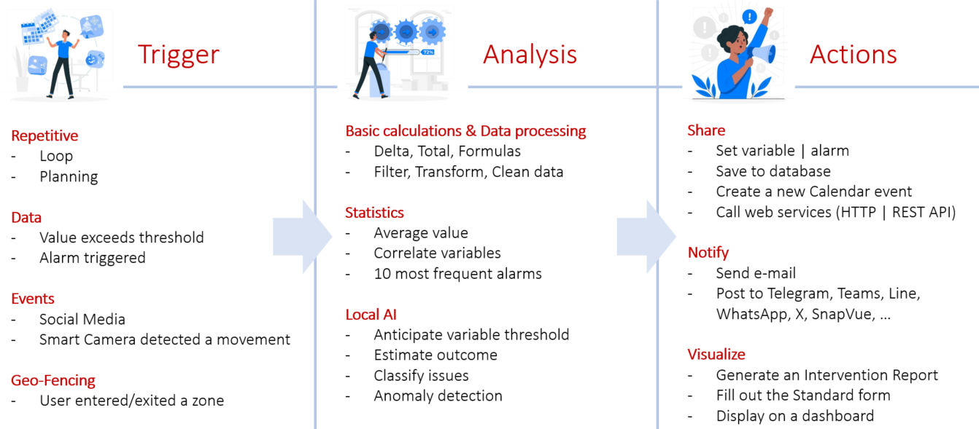

Jobs: Orchestration and Distributed Execution

Jobs handle the instantiation and coordination of Bots within structured workflows. They manage the task sequencing logic.

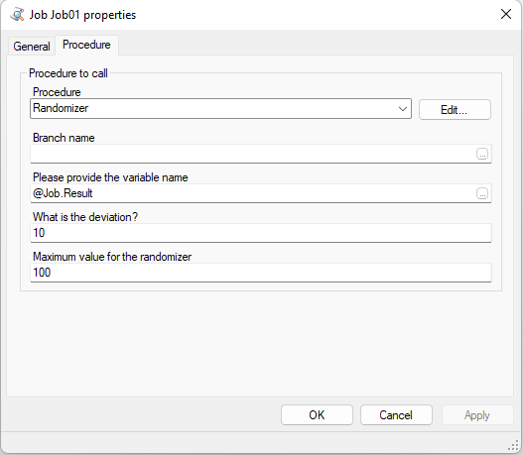

- Multi-server Architecture and Redundancy: Job execution supports distributed architectures. Jobs can be assigned to multipost lists, thereby ensuring:
  - Processing redundancy in the event of a server failure.
  - Load balancing to optimize machine resources.

- Centralized Management: Job administration is performed entirely through the Application Explorer interface. This environment allows:
  - Manual activation or deactivation of processes.
  - Dynamic modification of execution parameters without service interruption.

Configuration Environment

The implementation of the Intelligent Assistant favors a graphical configuration approach (No-code), while maintaining compatibility with existing scripting tools.

- Configuration interface: Scenarios are created through a dedicated interface, allowing the logical assembly of functional blocks without writing complex code.

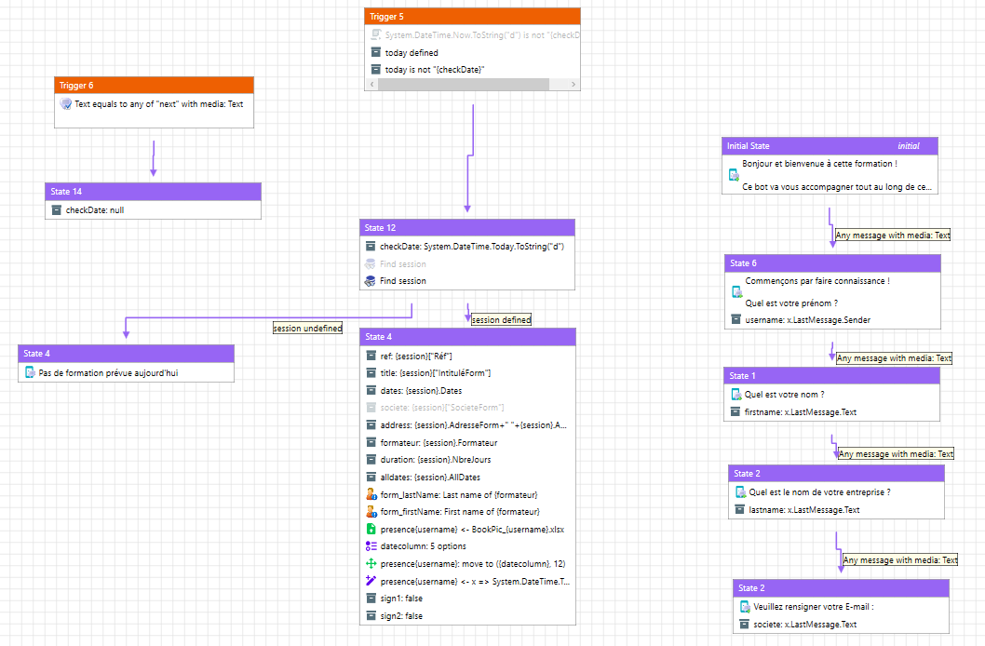

- SCADA integration: The module integrates into the existing environment and can operate in conjunction with SCADA Basic or VBA scripts to address specific needs not covered by standard templates.

Fields of Application

The integration of the Intelligent Assistant extends the functional scope of supervision towards autonomous action. This advanced processing capability provides a concrete response to critical operational challenges, such as:

- Resource management: By ensuring automated planning and dynamic task allocation to technical teams, the system adapts in real time to operational data.
- Energy optimization: Equipment setpoint control no longer relies solely on fixed thresholds, but on predictive and real-time analysis of consumption.

By transforming supervision data into automated decision-making processes, this module directly contributes to more reliable operations and to the overall performance of installations.

Energy Monitoring and Analysis – EmVue

Overview

EmVue is a software application dedicated to the collection, monitoring, and analysis of energy consumption data. Developed by ARC Informatique, it integrates natively with the PcVue platform to leverage data from meters and field devices.

It provides a complete multi-energy monitoring environment with automatic dashboard generation and advanced analysis tools.

With zero-code configuration, EmVue delivers information tailored to the needs of energy performance specialists while remaining simple to deploy and operate.



Main Features

Data Collection and Processing
• Automatic acquisition from PcVue and CSV sources
• Collection of metering data for more than 20 types of commodities (electricity, water, gas, etc.) via PcVue
• Unit conversion and data aggregation
• Automatic import of up to one year of historical data

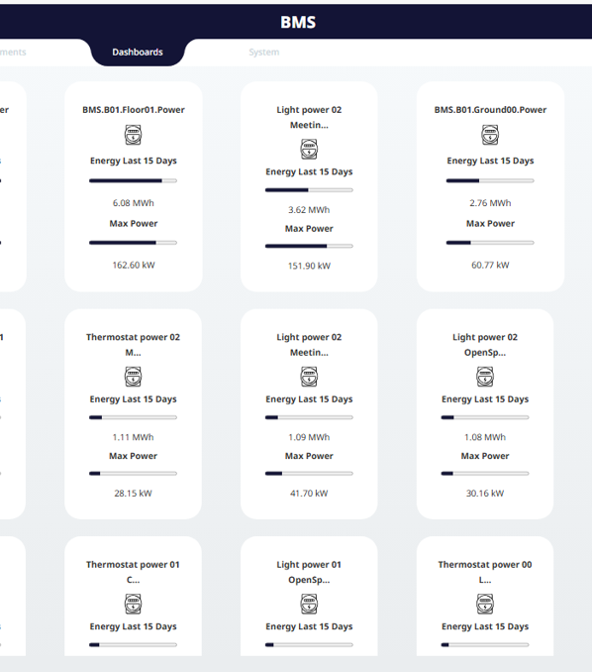
Figure 60 : Example of meter view

Advanced Energy Analysis
- Baseline management (reference consumption models)
- Unified Heating and Cooling Degree Days calculation
- Detection of consumption anomalies
- Multi-granular comparison (power, hourly, daily, monthly)

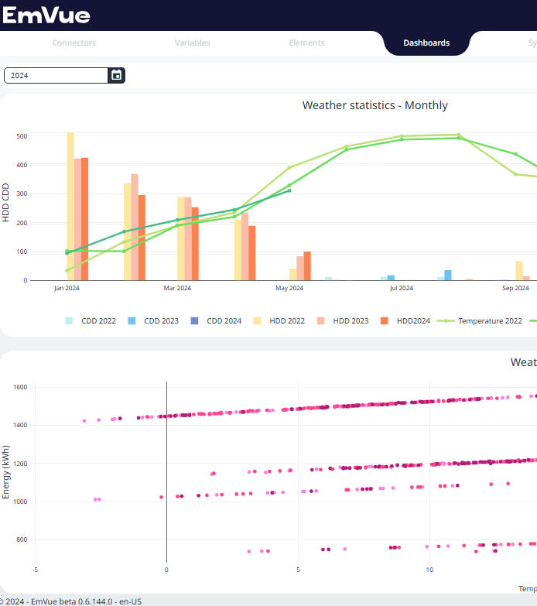
Figure 61 : Example of weather view

Visualization and Reporting
- Preconfigured and customizable dashboards
- Automatic generation of charts and widgets with zero code
- Consolidated monitoring of energy consumption and performance

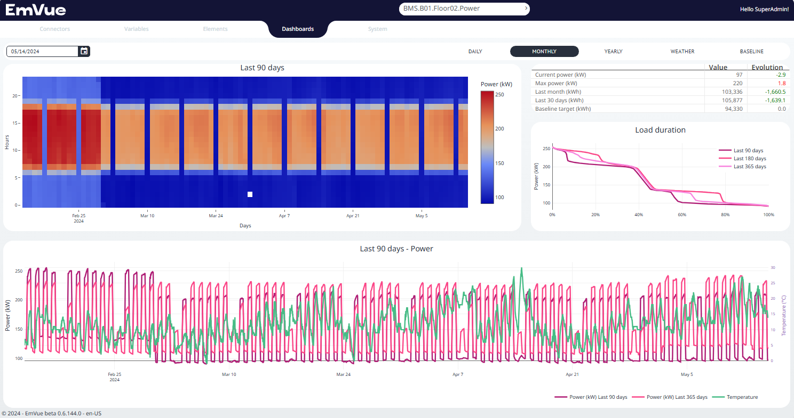
Figure 62 : Example dashboard view

Technical advantages

- Zero-code configuration for fast deployment
- Quick commissioning: first results available within a few hours
- Multi-language interface available in English, German, and French
- Compatible with PcVue and CSV data sources

Architecture and Integration

- Native integration with PcVue: communication through PcVue web services for data acquisition and automatic import of historical data
- Independent database: PostgreSQL storage separating configuration, history, and aggregations
- Web-based deployment: accessible from a browser with multi-user access and no local installation required
- Interoperability with more than 20 types of meters and energy quantities (index, power, active/reactive energy, etc.)

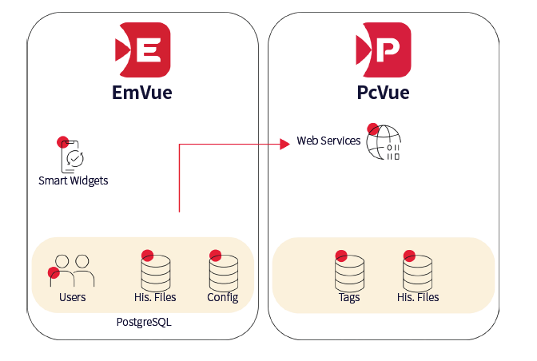
Figure 63 : Architecture

Summary

EmVue is a complete and integrated solution for technical energy management.
Combined with the PcVue platform, it provides energy analysis tools adapted to the needs of operators, engineers, and energy managers to monitor consumption and improve the energy performance of their facilities.

On Call management

PcVue offers built-in features for on call management, and can also connect to third party products for advanced on call management.

SMS et Emails

The broadcast of events notifications such as alarms, or real time data from the process is possible using SMS or Email directly sent from PcVue.

- Built-in device configuration
- Priority levels definition
- Possibility to define message templates including static or dynamic parameters as well as substitution characters associated with the context (value of a tag at the time of the message delivery)
- Automatic delivery of messages on alarm, event or any action

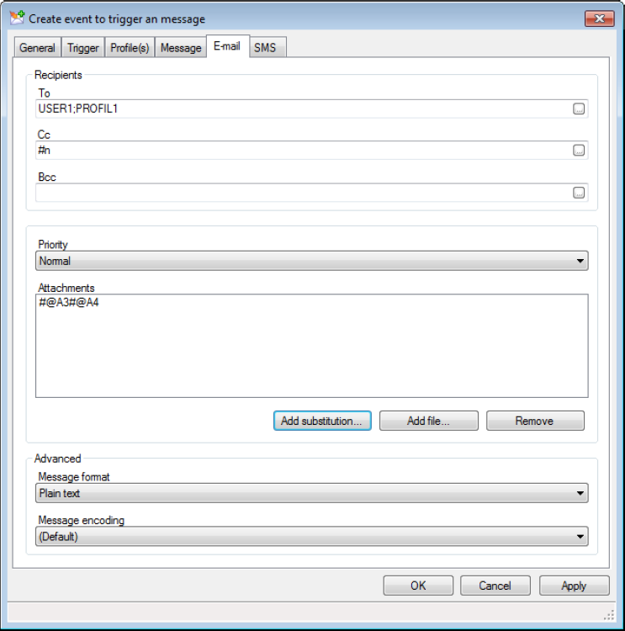

Figure 64 - Message profile

Advanced On Call Management
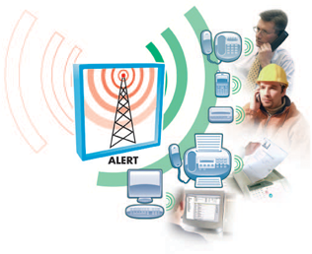
As a part of the PcVue Solutions suite, Alert™ easily connects with PcVue through a dedicated interface (Mediator) as well as with other industrial SCADA systems, using DDE or the OPC protocol.

Alert™ issues information through various media:

• Telephone (landline or mobile): operators are called by telephone, listen to alarms and acknowledge them through the integrated voice server.
• Short messages (SMS) to alert operators working offsite via mobile phone or pager.
• Dedicated paging systems to quickly alert maintenance operators working on site.
• Fax, teleprinter and email to receive written reports of the alarms detected and their contexts.
• Internet browser or WAP-enabled mobile phone.
The calls are also logged by Alert™, together with the operators’ acknowledgements of them. Each acknowledgement of an alarm is automatically forwarded to PcVue.

Scheduling

The scheduler engine included in PcVue allows you to automatically send commands and recipes, and to execute programs, according to a schedule. One or more fully configurable tasks can be assigned to a certain time on a certain day while exception periods for special days and other calendar events can be taken into account. Tasks can also appear in a recurrent scheme. Depending on the user-rights the parameters of a task could be modified during runtime.

WebScheduler

The WebScheduler is a tool delivered with PcVue that allows visualizing, and controlling all the tasks and events scheduled and stored in the system, from any device that is able to run a web-browser.
It gives the possibility to plan process-cycles, recipes and program routines over the Inter/Intranet and it allows you to integrate completely new, even more dynamic scheduling scenarios.
It’s also a HMI for BACnet calendar objects.

The WebScheduler can also be included in any PcVue mimic by using a web browser ActiveX®.

The WebScheduler is designed not only for maintenance team but also for any users with a handy interface.

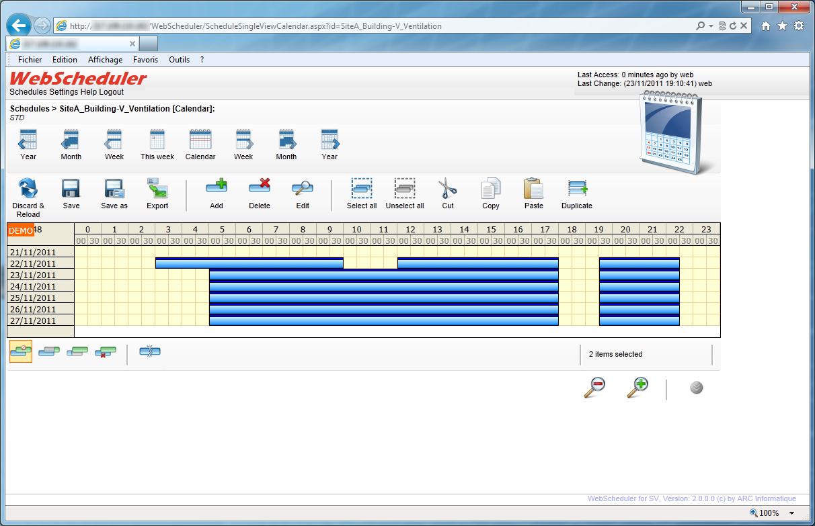

Figure 65 – Webscheduler

Recipes

PcVue features a recipes management.
A Recipe is a list of variables each with a desired value. When a Recipe is sent the values are copied into the corresponding variables in the variables tree.
The most common use of Recipes is in a batch process where a production plant is being used to produce batches of different products. The instructions to the control device on how a product is to be made is sent to it as a list of values from a supervisory computer. The list is known as a Recipe. Recipes can also be used in conjunction with the Scheduler for simple time based control, such as that required in a building management system.
Recipes are normally created by the developer using the Recipes command on the sub-menu Configure.Station. When each recipe is created it is given a unique numeric reference and title to identify it when sending it or displaying its configuration. Recipes can optionally be allocated to a group known as a family, which can be then used as a criteria when selecting a recipe for modification or sending.
Recipes can also be created at run-time if the user has the necessary access rights.
In addition Recipes can be created from files downloaded by a host computer, or to provide other special options.Access to recipes is controlled by a user's access rights. A user can be given rights to change, send or create recipes.

Expressions

PcVue has an expression engine for calculating a value using one or more operators (logical or mathematical functions) and variables.
Expressions are calculated automatically when the value of any element changes.
Expressions can be configured in various ways:
- Entering an expression directly in an animation
- Definition of expression model
- Definition of variables whose value is the result of an expression

Examples of expressions:
Motor01.Stop & Motor01.Start | Motor01.Fault
(Valve.Flow01+ Valve.Flow02) / 100
Tank01.Temp & 65520 (mask the first 4 states of value)
EXP (LOG (Valve.Pressure.Value) / 2) (Calculates the square root)

Events actions
PcVue features event action that can run the following :
- send a message via an e-mail
- send a message via a short message service (text/texto/SMS/TMS - here called SMS)
- a script (SCADA Basic program)
Event actions includes the following properties :
- Event actions are attached to a variable and are triggered when the value of the variable changes. The trigger condition is defined by a configurable expression, for example, when a register exceeds a pre-defined value. Events may be triggered on Bit, Alarm, Register or Text variables. For Bits and Alarms, the expression may include one or more conditions, for Registers and Text variables, only one condition is allowed
- Any number of events may be attached to each variable with a maximum total of 32000
- Event actions may also be configured using a script. These are known as temporary actions as they can be created and deleted under program control.
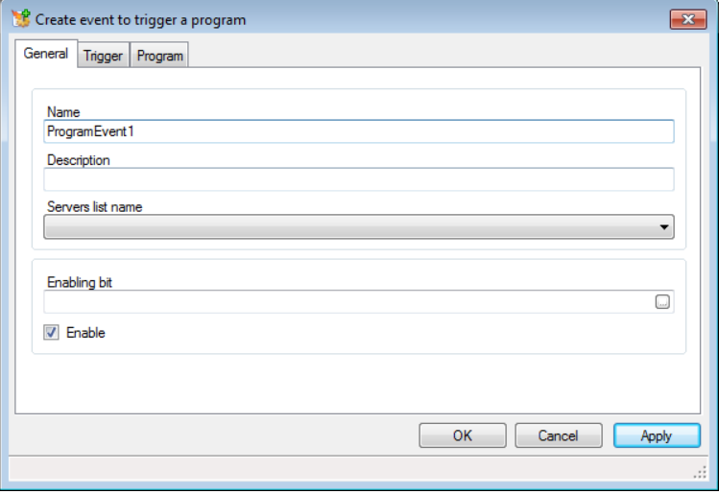
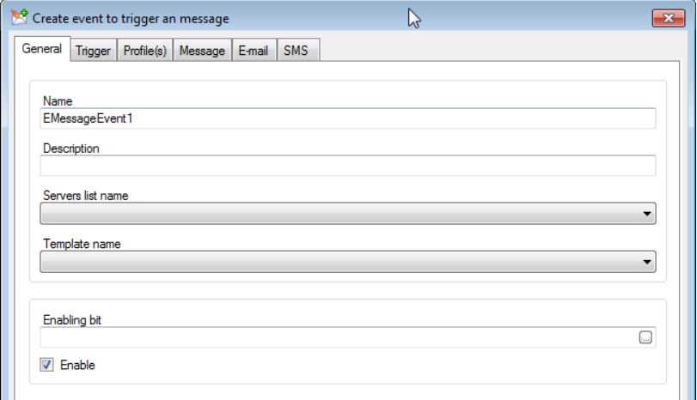
Figure 66 – Event action settings

Cyclics actions

PcVue features a Cyclic action mechanism. A cyclic action repeatedly runs a SCADA Basic program at a configurable period. Up to 512 Cyclic actions may be configured. The minimum period is 1 second. Cyclic actions are different to Scheduler actions where an action is triggered at a specific time.
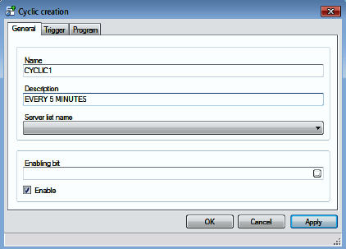

Figure 67 – Cyclic action settings

Scripts Editors
PcVue offers many tools to perform the best SCADA application without any programming knowledge. However, for maximum flexibility PcVue also includes two comprehensive scripting languages the SCADA Basic and the Microsoft™ VBA Scripting.

SCADA Basic
SCADA Basic functions are able to manage all the PcVue functionalities (HMI, drivers, alarms, historical data, user rights…) allowing you to interact programmatically with most of PcVue features using a high level scripting language. The syntax is very similar to several high level languages making the transition easy for anyone with any programming experience.
A powerful editor is available with syntax highlighting, auto-completion and code snippet insertion. To ease your development contextual help for the language is provided and code snippets can automate insertion of frequently used pieces of code.
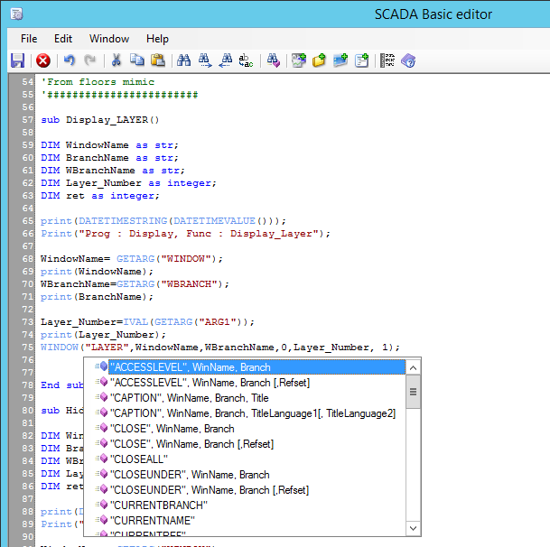
Figure 68 - SCADA BASIC Script Editor

Microsoft™ VBA Script Editor
The Microsoft™ VBA Scripting, which can interact with PcVue Trends, alarms, mimics etc. Microsoft™ Visual Basic as an integral part of PcVue provides programmatic access to the properties, methods and events of all built-in drawing elements, the project environment, variables and any ActiveX® components used in the project. Using VBA you can adapt PcVue to the special needs of the user and easily integrate third party software such as spread-sheets, databases and reporting tools.

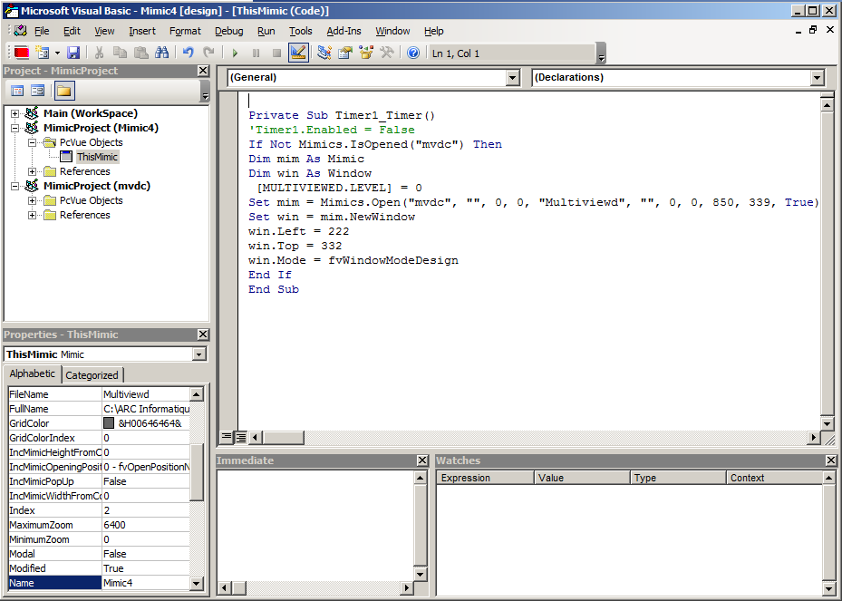

Figure 69 – VBA Script Editor

Architectures & deployment

Supported platforms

Ressource requirements

For more information about resources required for your architecture please see the document « PcVueSolutions Resources EN.pdf ».

Operating Systems

ARC Informatique has been a Microsoft Certified Partner for many years and has built PcVue Solutions on the Microsoft platform.

The lastest PcVue version runs on the following OS:

- Client stations: Windows® 10, 11

- Server stations: Windows Server® 2019, 2022 & 2025

- PcVue is developed using the Visual Studio .NET Integrated Development Environment.

- PcVue Historical Database is supports the latest versions of Microsoft® SQL Server™ : Microsoft® SQL Server™ 2017, 2019 , 2022 & 2025
All operational versions of Windows Server shall be installed with Desktop Experience installation option.
For all operational versions Windows, only the x64 processor architecture is supported.
For all platforms, it is recommend that you apply any critical updates available from the Windows Update website to ensure the best compatibility and security. Installation of the latest Windows Service Pack may be required on some operating systems.
For any other Microsoft® operating system, please contact your Technical Support.

Virtual Environments

PcVue supports virtual environments such as vmware® or Hyper-V™.

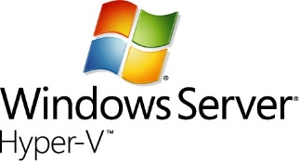
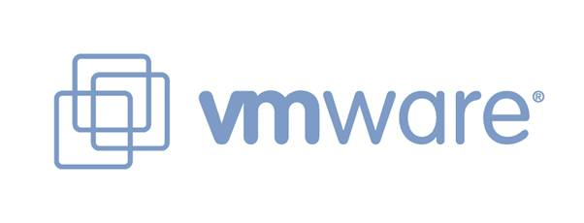

Multi Station Architectures

PcVue offers an extendable and flexible control system of high performance with a modular system architecture that consists of largely standardized component.
Client-Server architectures and inter-station messaging are built-in to PcVue and are available within the Windows environment.
The system is also easy to configure and operate thanks to wizards.
For more information please see the document “PcVueSolutions_WP_Architectures&deployment_en.pdf”

Central Project management

To make the maintenance and the deployment of a project easier and faster, PcVue is delivered with a built-in central project management tool.

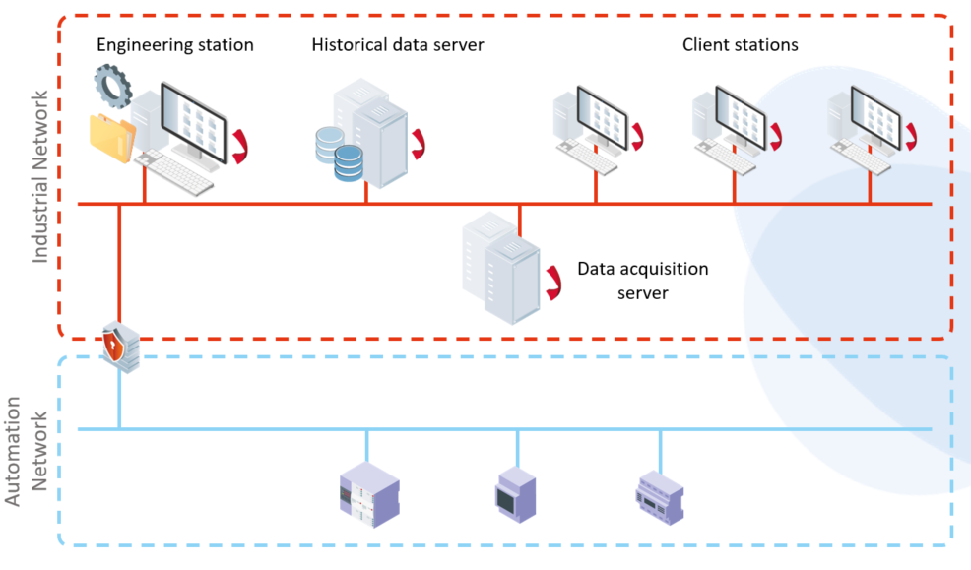
Figure 70 - Central version management

Different versions of a project and/or libraries are centralized in a shared directory on the network. The centralized project and/or libraries can be modified from any station on the network.
Usually a dedicated PcVue development station is used to host the central project versions directory and to make the change for a project.
Any station can manually load and run any type or version, or automatically run the reference version of a project and/or libraries from the central project directory. This feature can also be used for stand-alone architecture.

Supported features are:
- 4 version types : development, operational, pre-reference and reference
- Configurable content of a version
- Track modification for each version
- Automatic version numbering system
- Unlimited number of versions (vs media free space)
- Tags can now be associated to versions of your project and libraries, and you can start your project based on a tag instead of a version identifier or state
This device allows to trace the evolution of the project and if necessary be able to return to an earlier version.
In the event, or you want to work in "parallel", the platform allows PcVue through its separate application components (synoptic, communication, BDTR, historical, Scripts, ...) to configure each separately. This requires the establishment of good practices and a coordinator for the aggregation of components before generating a reference version.

Web & Mobility

EasyMobileTechnology

Web and mobile solutions of PcVue lean on an exclusive technology EasyMobileTechnology allowing to setup mobile architecture with no gateway/plug-in, embedding all the necessary security features (https, Oauth, certificates) and the HTML5 technology as well as maintenance tools.

This technology fits the following criteria:
- No gateway, no extra plugin
- No installation on client side
- Easy settings – no scripts – Wizard only
- Open to third-party application
- Adapted to any users: end-user, SI, IT
- Secure scalable architectures and communication
- Easy Diagnostic

Web deployment console

The web deployment console is a component for setting, deploying and maintaining a web or mobile architecture.
It supports the following features:
- Deployment of web services and web apps on IIS
- PcVue Web Back-end endpoint management
- Data protection management
- Certificate management
- User access logging & OAuth Server management
- IIS auditing / diagnosis
The web deployment console runs on a server hosting a web server IIS.
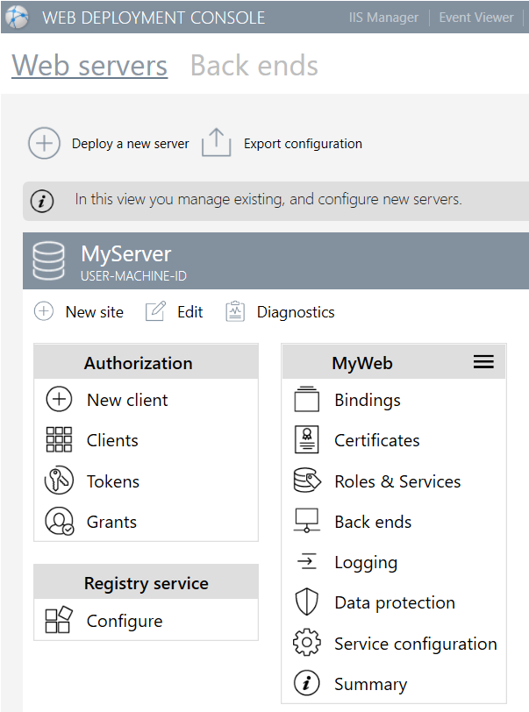

Figure 71 - Web deployment console interface

WebVue - HTML5 Web client

WebVue uses an ordinary web browser and an internet or intranet connection to provide remote display and control of your processes. A user with appropriate user rights (user name and password) is able to access the PcVue SCADA application from anywhere on the network. WebVue is independent of the operating system as it runs in a web browser and it displays PcVue mimics directly without requiring any modification.
Communication between the PcVue Web Server and the WebVue client uses Microsoft IIS technology and the enterprise firewall jointly to manage security. The WebVue client is continually refreshed and data exchanged using HTTP, or HTTPS if encryption is required (SSL V2).
WebVue is compatible with the main web browsers. Using PcVue’s public Web Services you can also create a custom web portal to access the real-time and historical data of PcVue on mobile phones, tablet PCs etc. via standard web pages.

WebVue Features

- HTML5 technology
- Real time monitoring and control and access to historical data, trends
and events are possible from the web client interface for an operator with appropriate user rights.
- The mimics displayed on the web client look the same as the mimic visible from the SCADA stations clients or servers.
- It is not necessary to develop specific mimics and views for the web client capability. Meaning the mimics develop for the SCADA application are automatically compatible with the Web Client. This in order to avoid extra engineering and to allow operator users to be immediately familiar with the Web SCADA interface.
- It’s possible for a user with appropriate user rights to log in to the web client application through intranet or internet using a standard web browser from the market.
- Auto log off feature to automatically log off a user connected to the web client after a determined inactivity period.
- Facilities for remote commands and acknowledgement of alarms
- (according to user rights)
- No software installation necessary on the remote station
- Optimized data exchange for mimic updates
- Encrypted data exchange to prevent problems of hacking
- Access to PcVue data server via IIS in XML SOAP
- Station for production maintenance staff, or for all occasional users
- Several users may be connected simultaneously to the supervisory application managed by the web server station
- Several connections are possible on the same webbrowser using several tabs
- No license required on the client station
- An operator with Web Client access has the same rights from the Web Client interface as on the SCADA application itself.
- Up to 50 web client connections shall be able to access the supervisor concurrently
- There’s no limitation to the total number of potential web user.

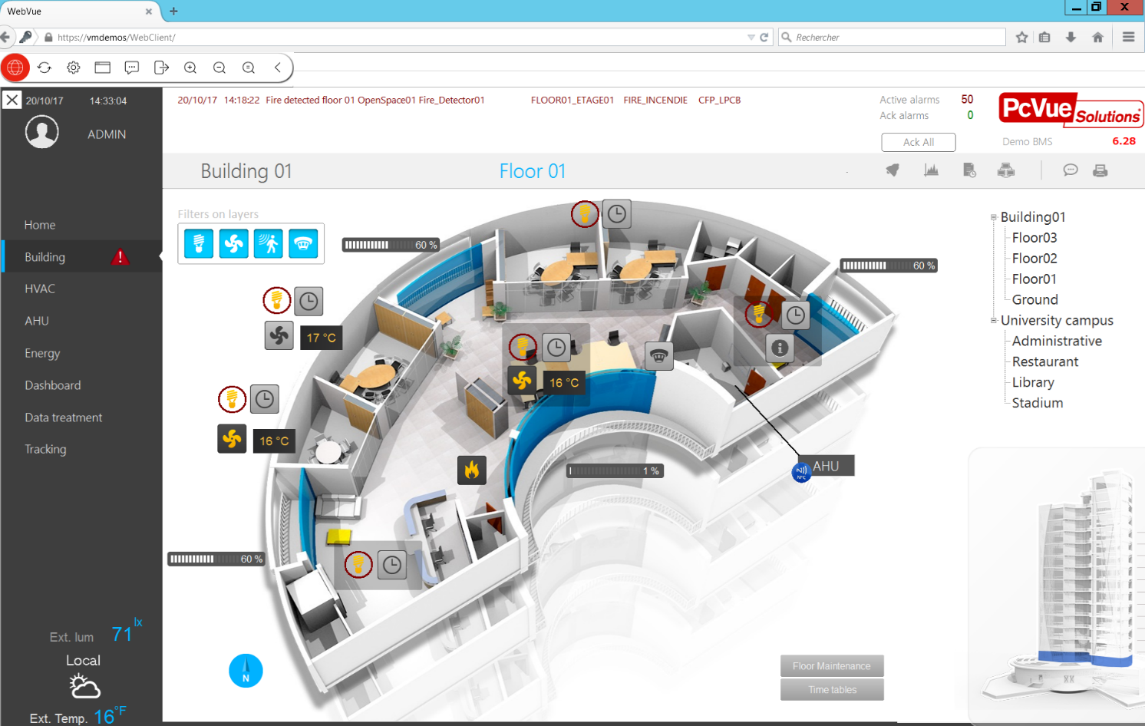
Figure 72 - Mimic displayed in WebVue

Some restriction may apply when using a WebVue client :

The following animation types are not supported: Grid Control, Recipe, Region
• The use of substitution strings for opening mimics is not supported (#I, #P, #U, #M11 to #M20).
• The form controls are supported but their appearance is slightly. The intermediate state of a check box or radio button form control is not available. You cannot use variables with Form Controls for mimics displayed in WebVue.
• The Trend, Alarm and Log Viewers have some limitations on their functionality.
• AVI (multimedia) files are not supported.
• If a mimic is repeated in the Supervisor's Workspace, only the first instance appears in the WebVue Client.
• The options available when entering a text string or register value are limited.
• There is limited support of pop-up (child) mimics.
• Limited use of function keys.
• The Zoom feature is not available.
• There is limited support of fonts and styles. Fonts will generally be supported if they are installed both on the Supervisor's station and on the browser of the WebVue Client's station. The fonts Arial, Courier, Times New Roman, and System are widely supported. Regular, italic and bold styles are supported; underline styles are not.
• Control zone animation accelerator keys are not supported.
• ActiveX controls in mimics are not supported.
• OLE objects in mimics are not supported.
• VBA and Enable scripts not supported.
• Limited support for SCADA Basic instructions and modes.
• 3D mimics not supported.

Remote access

PcVue supports the feature « Remote Desktop Services » which allows instances of PcVue to run remotely using any devices that supports Remote Desktop, including HTML5 compatible devices.
This allows a user to access the PcVue application remotely with exactly the same features as a local client station.
This solution offers a high level of security since only the keyboard and mouse activities transit over the network reducing the risk of data corruption.

TouchVue - Mobile application with alarms & events notification services

It is possible to access data from a PcVue project from a tablet or smartphone using the TouchVue mobile application for PcVue.
TouchVue is an application displaying information and enabling actions on variables provided by the mobile server of PcVue ,. The variables displayed are those whose level of navigation corresponds to the configuration of the TouchVue user profile.
TouchVue runs on the Android operating system (5.0 or higher), it also works in a web browser on any SmartPhone.
This application offers the following notification and control services:
• Notifications of alarms in real-time
• Access to real-time alarm list
• Alarm acknowledgment
• Access to the list of archived events
• View real-time data trending and archived
• View real-time values
• Sending commands and instructions
The implementation of this solution is done simply and without specific development. A simple setting made via check boxes in the PcVue project allows to define what type of data will be available on mobile. In addition, access to data and the level of visibility and control of these depend on the user profile and the rights associated with it in the PcVue project.

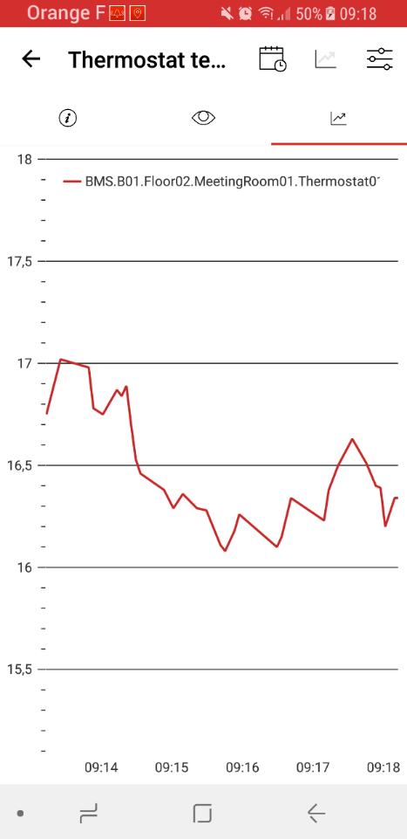
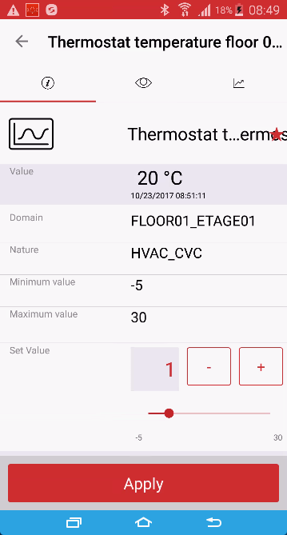
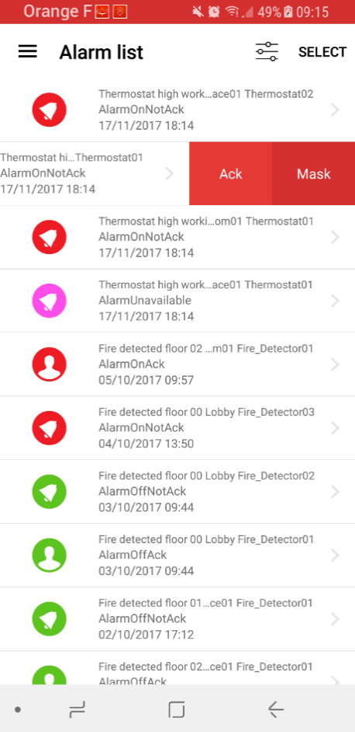
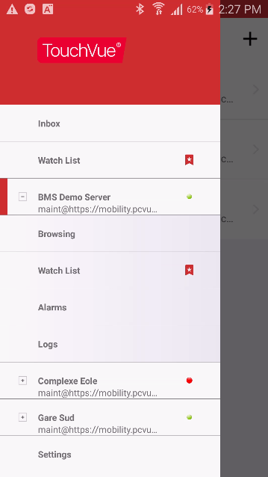
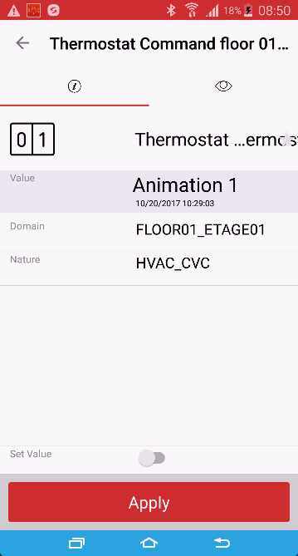

Figure 73 -TouchVue screenshots

SnapVue - Geolocation and contextual mobile app
A mobile application will allow a user, depending on his / her profile, to automatically obtain the contextual information related to his / her area of ​​responsibility (maintenance, operation, etc.) in the zone where he / she is and to have access to the actions he/she can undertake, directly from his mobile. It will be able to control the set points, analyze trends, consult a data sheet or exchange instant messages with other stakeholders.

This mobile application will be based on the existing internal / external geolocation technologies (bluetooth tags, NFC chips, QRCodes, GPS, WiFi, ...) and will allow in particular the following functionalities:
- Automatic display of contextual information according to the geographical area in which the user is located and his profile
- Visualization and control of equipment in the vicinity
- Instant messaging with text, audio or video messages, and images
- Localization of mobile devices from a server visible on the synoptics through animations or on an interactive map (Google map, ...)
This application should facilitate the interventions of nomadic users who do not necessarily know the site well by presenting the relevant information concerning the tasks to be accomplished without having to navigate through a multitude of menus.

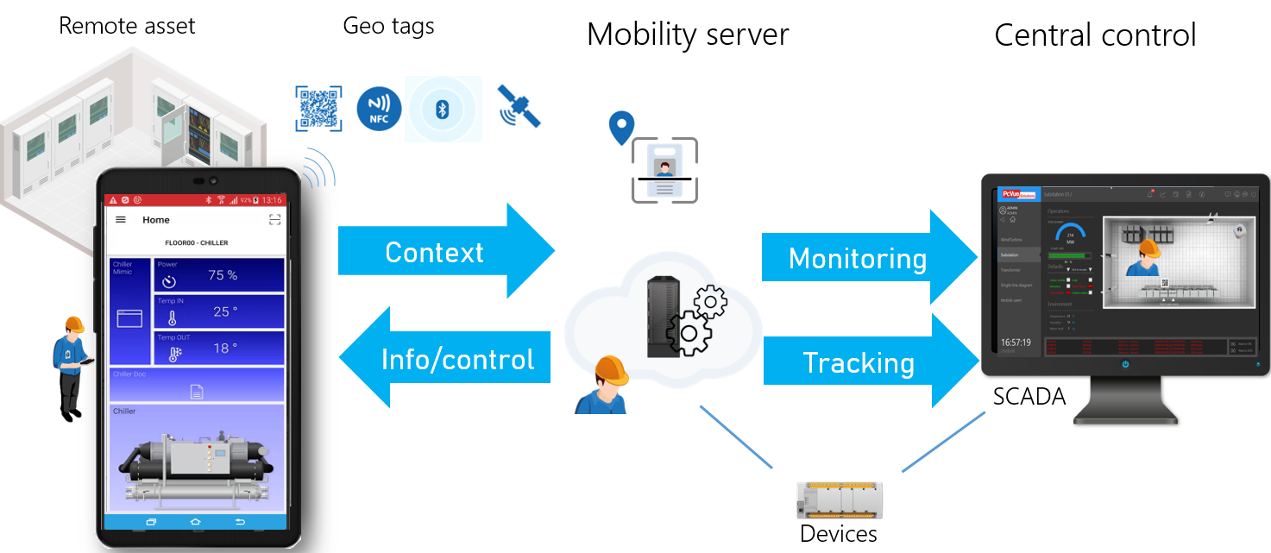
Figure 74 – SnapVue : concept

SnapVue uses geolocation technologies and services as shown below:
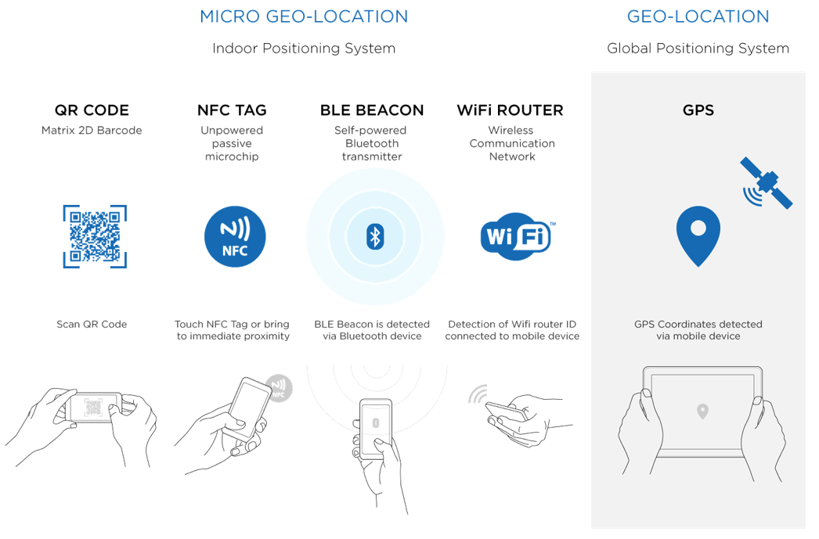
Figure 75 – SnapVue : technologies

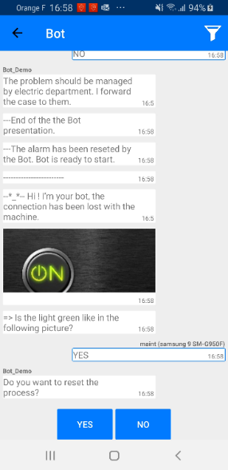
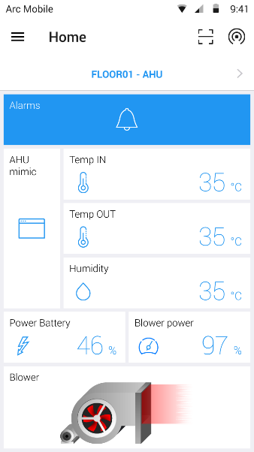
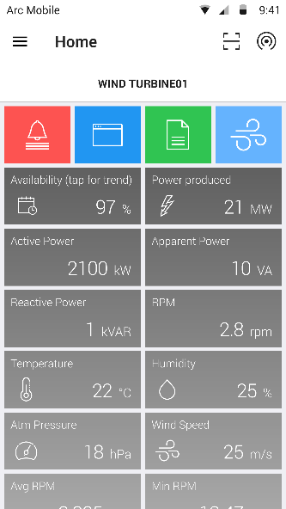
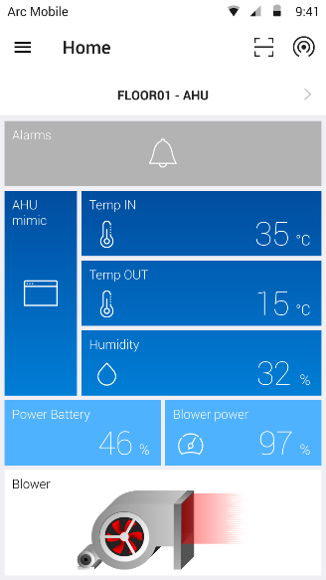
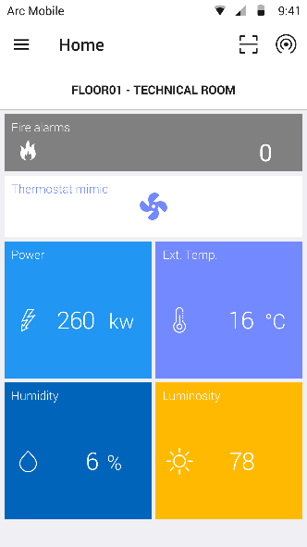
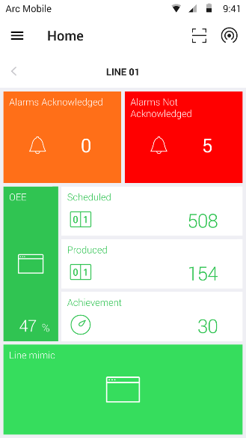

Figure 76 – SnapVue : screenshots

Smart Bots

Smart bots is a feature that shall come with the mobile app to assist the mobile user through an interactive messaging interface.
A smart bot shall offer but shall not be limited to the following features :
  - Allows a chat with the user on event or on demand in SnapVue
  - Guides the mobile user in a specific context with an interactive messaging process flow
  - Custom scenario for bot messaging can be designed with no code
  - Can interface with O365 calendars
  - Can interface with Web Server endpoints as part of workflows as : Telegram, Line, REST API, CMMS API

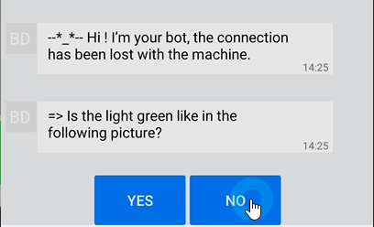

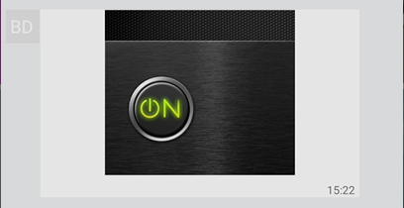
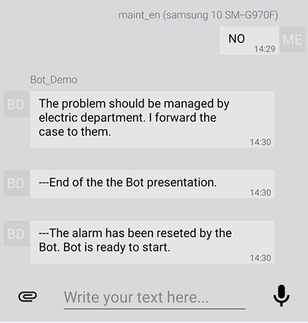
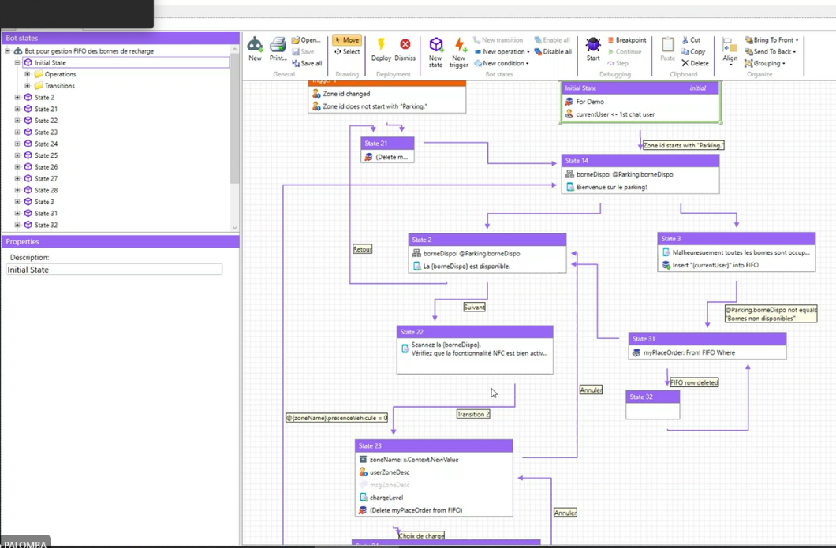

Figure 77 – Screenshot of smart bots: run-time and design

Example of Architecture

PcVue is a very flexible and scalable platform that can be configured for many different architectures.
Below an example of one architecture:
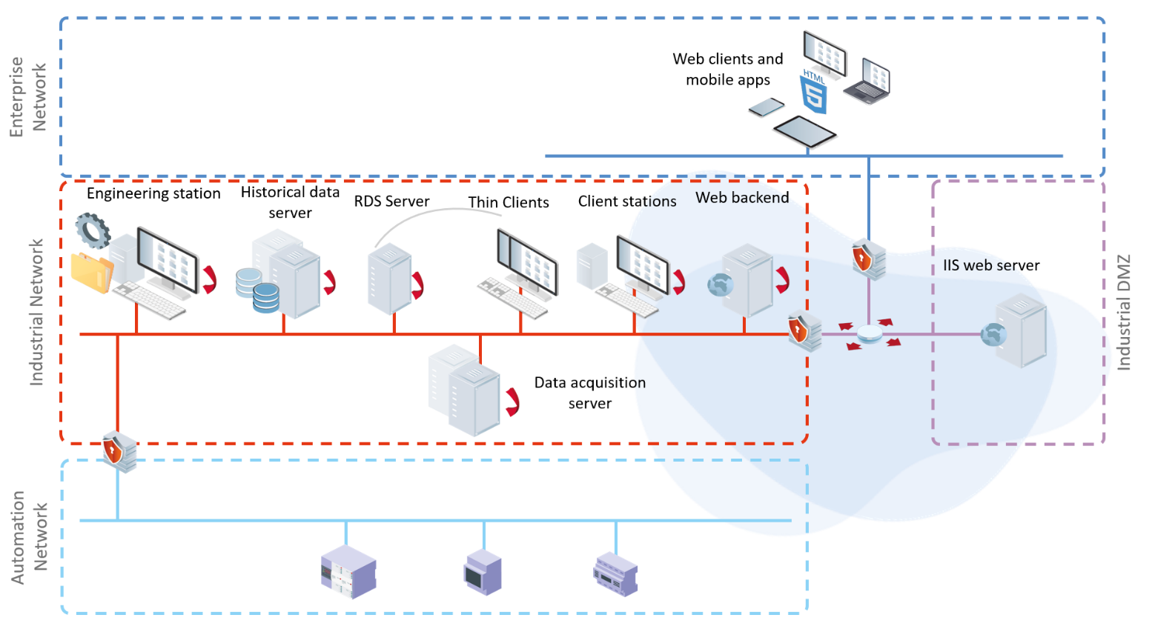

Figure 78 - Example of architecture

This example of architecture leans on the following elements:
- The data acquisition is performed by redundant acquisition servers on the industrial network.
- Redundant archive servers ensure continuous recording of supervision data.
- A development station is used for the centralized management of the project.
- The operation is performed by the clients stations on the computer network isolated by a firewall
- A station installed on a Windows server in a demilitarized zone (DMZ) isolated by firewalls, hosts a web server, a mobile server and a Windows RDS Server .
- Clients can be run remotely through RDS instances using the Windows Remote Access Office.
- An interface installed on the server allows the display of client instances on any device that supports HTML5.
- The web clients allow operation from a standard web browser.
- A mobile application connected to mobile server is used for the notification and acknowledgment of alarms and control from a smartphone or tablet.
- The exchanges between the Web server and terminal use secure sockets HTTPS.
- Users access of the entire system is managed by Windows Active Directory for single sign-on (SSO)
A number of precautions must be taken to protect the components of a PcVue multi-level architecture.
Thus, the necessity to:
- Segment the various networks (computer and industrial for example) by the creation of separate logical areas (VLAN) that require the same level of security
- Filter the data by using firewall.
The use of a DMZ and routers also allows to isolate the network from the outside and prevent unwanted intrusions.The establishment of VPN tunneling solutions may also be necessary to protect traffic between two network components. Typically, a VPN can be established between a PcVue acquisition station and a PLC communicating via TCP / IP, or between multiple remote monitoring sites communicating with inter-station TCP / IP messaging.
PcVue Solutions, in partnership with MOXA offers a complete solution of hardware protection to address the issues mentioned above:
- Full range of secured Firewall / VPN industrial
- Traffic limitation and control between different network zones

Security and Safety

Faced with constantly evolving cyber threats, ARC Informatique has made cybersecurity a structuring pillar of its offering. This approach applies at all levels: internal organization, development lifecycle and product features.
This commitment is based on three complementary pillars:

- An organizational security culture, mobilizing teams on a daily basis to secure the company and its development processes.
- A product designed for security, with PcVue natively integrating the mechanisms required for the approval of the most sensitive systems.
- Compliance with international standards, guaranteed by independent certifications covering quality, information security and industrial cybersecurity.

These three pillars are detailed in the following sections, from general commitments through to the most detailed technical mechanisms.

Commitments and Security Policy

Any software product may be exposed to vulnerabilities likely to endanger the systems into which it is integrated. To limit their impact, ARC Informatique adopts a transparent and proactive approach towards its customers, competent authorities and the general public.

Beyond the secure design of its products, ARC Informatique is committed to:

- Making its expertise available to its customers and partners to support them in deploying secure solutions.
- Ensuring active monitoring and continuous follow-up of alerts and vulnerabilities concerning its products.
- Coordinating its actions with the international CERT (Computer Emergency Response Teams) network and recognized cybersecurity stakeholders.
- Communicating transparently on identified vulnerabilities — whether discovered internally or reported by third parties — through published security alerts.
- Publishing security bulletins in order to provide, as quickly as possible, the information required to reduce risks.
- Capitalizing on field feedback to design increasingly robust versions.

Regulatory Compliance and Certifications

ARC Informatique’s cybersecurity approach is based on an internationally recognized normative framework. The certifications obtained cover two complementary dimensions:

- The organizational dimension: quality governance and protection of the company’s information assets.
- The product dimension: secure development lifecycle and validation of the protection mechanisms integrated into PcVue.

PcVue also integrates into architectures subject to the strictest regulatory requirements.

Summary table of certifications and compliance:

Standard / Certification | Domain | Scope
ISO 9001 | Quality management | Design, development and production.
ISO 27001 |  | Information Security Management System (ISMS) covering the organization’s assets.
  Information security
IEC 62443-4-1 | Industrial cybersecurity | Secure Development Lifecycle (SDL) — processes and methods.
IEC 62443-4-2 | Industrial cybersecurity | Technical security requirements for SCADA software components.
NIS2 | European regulation | Compliance with resilience requirements for essential and important entities.
ANSSI – CSPN | National certification | Software robustness over a defined scope, validated by ANSSI.

ARC Informatique and PcVue hold the following cybersecurity certifications and standards:
ISO 9001 – ISO 27001 – IEC 62443-4-1 – IEC 62443-4-2.
The platform implements the features required to protect supervision systems against growing cyber threats.

Product Security — Design and Integrity

PcVue security is taken into account from the design phases. Each version is developed according to a secure development lifecycle (SDL, compliant with IEC 62443-4-1) and delivered with verifiable authenticity and integrity guarantees.

This approach is structured around three complementary axes: component integrity, attack surface reduction and runtime protection.

Authenticity and Integrity of Binaries

- Digital signatures: all binary files and installation components are digitally signed by the publisher in order to certify their origin and prevent any alteration.
- SHA-256 verification: systematic integrity control of downloads and installed files.
- Secure file architecture: strict separation between binaries (“Programs” directory) and application data (“ProgramData” directory), limiting the risks of accidental or malicious alteration.

Attack Surface Reduction

To limit exposure from installation, PcVue applies the following principles:

- Non-secure or rarely used services are disabled by default (VBA, DDE, 3D interface).
- Optional features can be disabled or uninstalled according to deployment requirements (Telnet, FTP, Web interface, control protocols, serial interfaces, USB ports, etc.).
- Default configurations are progressively hardened to reflect security best practices.

Runtime Protection

- DEP (Data Execution Prevention) and SEHOP: PcVue takes advantage of the native protection mechanisms of the Windows operating system to counter the execution of malicious code in memory.
- Root key: a secret defined at deployment time is used as a root key to protect sensitive data on the workstation. Encrypted files cannot be decrypted or reused without this key.

Communication and Data Flow Security

Data exchanges are protected at all levels of the architecture, from communications between workstations to field acquisition protocols.

This security is based on three levels: inter-workstation communications, field protocols and network architecture.

Inter-workstation Communications

- TLS 1.3: encryption of configuration and archiving flows between PcVue workstations. Support for preloaded keys and X.509 certificates.
- Integrated PKI: PcVue integrates a public key infrastructure enabling full lifecycle management of security certificates.
- HTTPS: all Web interfaces (WebVue, WebServices) use the HTTPS protocol exclusively. Compatibility with corporate proxy architectures.

Field Data Acquisition

PcVue natively supports secure variants of the main industrial protocols:
- OPC UA (with session security and message encryption).
- BACnet Secure Connect (BACnet SC).
- DNP3 Secure Authentication.

Network Isolation and Segmentation

Architectural security also relies on segmentation recommendations:

- VLAN segmentation to isolate supervision networks from corporate networks.
- Implementation of demilitarized zones (DMZ) for remote access and exchanges with third-party systems.

Access and User Management

Access to the PcVue system is controlled by a multi-level rights management mechanism, ranging from individual authentication to integration with corporate directories, through to regulatory requirements specific to certain industries.

Profiles and Access Rights

Before using PcVue, each user must identify themselves with a username and password. The account thus defined determines all accessible features: mimics, configuration tools, command variables, alarm acknowledgements and access to the operating system.

The security model is based on two complementary concepts:

- User: a named identity with a username and password. Several users can be configured without limitation in number; only one can be logged in at a time on the same workstation.
- Profile: a set of access rights associated with one or more users. PcVue provides 10 hierarchical profile levels, with no limitation on the number of configured profiles.

The security mechanisms include:

- Automatic logout after a configurable period of inactivity.
- Password policy: strength check at creation, validity period, mandatory change at first login.
- Account lockout after failed login attempts.
- Configurable expiration date for each user account.
- Granular locking: restricted access to specific mimics, command or archived variables, alarm acknowledgement and masking functions.
- Differentiated profiles depending on the login workstation, in multi-workstation architectures.
- Encryption of the user rights configuration file.

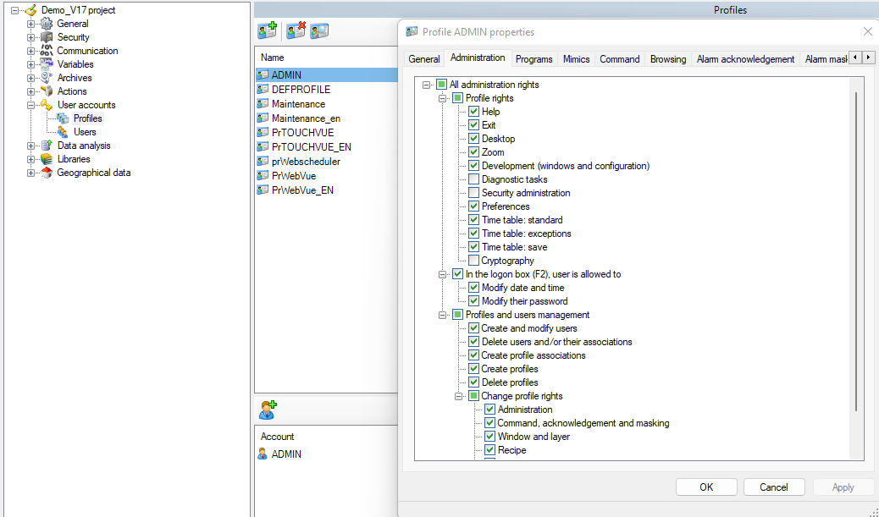
Figure 79 User profile configuration

Integration with the Corporate Directory (Active Directory)

For organizations with a centralized corporate directory, PcVue natively integrates with Windows Active Directory via LDAP or LDAPS. In this mode:

- Users are not declared locally in the supervisor.
- The association between PcVue Profiles and Active Directory Groups automatically determines each user’s rights (operation rights, alarm acknowledgement levels, etc.).
- The mechanism is entirely transparent for operation and requires no manual action when the directory evolves.
- Two-factor authentication (PIV smart card) is supported for high-sensitivity environments.

21 CFR Part 11 Compliance

The FDA (Food and Drug Administration, United States) 21 CFR Part 11 regulation defines the requirements applicable to electronic records and electronic signatures in the pharmaceutical sector. PcVue natively integrates — free of charge in all its versions — the features covering the following subparts:

- Subpart B — Electronic Records: controls for closed systems (PcVue is considered a closed system). Audit Trail of operator actions.
- Subpart C — Electronic Signatures: simple signature (recording the operator for each command) and double signature (entry of the username and password of the operator and of a line manager for sensitive operations).

Important note: the use of these features does not in itself guarantee compliance. Effective compliance is achieved through the combination of the software, appropriate operating procedures and restricted physical access to workstations. Since 21 CFR Part 11 remains open to interpretation, its application must take into account the guidance documents regularly published by the FDA.

Supervision, Audit and Traceability

Incident detection and traceability of security events are ensured by several complementary mechanisms:

- Syslog: real-time export of security events to third-party logging servers, enabling integration into a SIEM (Security Information and Event Management) and centralized analysis.
- System variables: a set of dedicated variables enables real-time monitoring of the status of PcVue processes and workstation integrity, directly exploitable in supervision mimics.
- Secret objects: sensitive parameters (private keys, passwords for connection to data sources) can be hidden in the application configuration, making them impossible to view from the operating environment.

Table of Available Security Features

TLS 1.3 | Encryption of all inter-workstation communications and archiving. Support for preloaded keys and X.509 certificates.
Integrated PKI | Support for a public key infrastructure (PKI) for certificate lifecycle management.
Active Directory (LDAP/LDAPS) | Delegation of authentication to the corporate directory. Automatic association of AD groups with PcVue profiles.
Root key | Secret defined at deployment, used to protect and encrypt the user directory and files.
Secure field protocols | Native support for OPC UA, BACnet SC and DNP3 Secure for data acquisition.
DEP / SEHOP | Activation of native operating system protections against malicious code execution.
Service disabling | Unused services (Telnet, FTP, VBA, DDE, 3D interface, USB ports, etc.) can be disabled. Restrictive default configuration.
Syslog | Export of security events to third-party logging servers (SIEM).

Commissioning tools

Variables

A built-in component can be used to display and control any data (real time or historical) which is useful for commissioning for example.

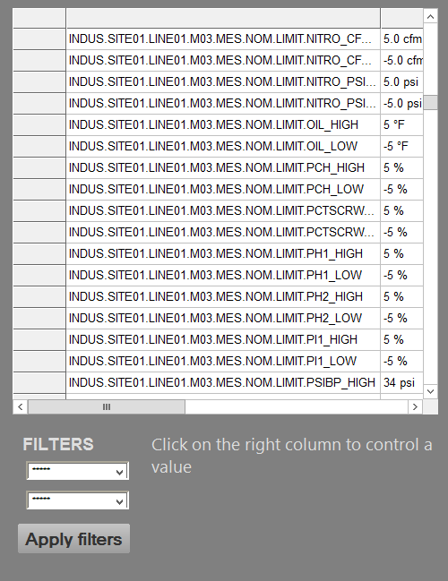

Figure 82 - Variable tracking table

System variables

PcVue has many System Variables which contain information about system behavior and performance.
This variables can be used anywhere in the project to display the status of the system components.

Audit diagnostics

The Audit Dialog contains information about the internal operation of the Supervisor. Its main use is as an aid to diagnose unexpected or erroneous behavior but it can also be used to check the general "health" of a project. The information comes from the executables (.exe) from which the Supervisor is composed, and the individual managers contained therein. The Audit Dialog contains two tabs.
• Counters
• Objects - System resource and configuration object counters
• Instance - Counters of messages between the Supervisor's managers and the memory that has been allocated.
• Time - The time spent processing the messages for each manager.
• Flow - Data flows associated with the change of real-time value of variables in the Variables Tree.
• Monitoring - Detailed information about the data flows associated with the change of real-time value of variables in the Variables Tree, presented in a graphical format. Two graphics are available, one that shows information about data acquisition (data into the Supervisor) and the other about data commands (data sent from the Supervisor).

The information from the Counters Tab is also dumped in text files that can be found in the Log Files folder.
The information from the Flows tab is also available in system variables in the Variables Tree. These variables must be enabled in the Audit Configuration dialog before the Supervisor creates them.

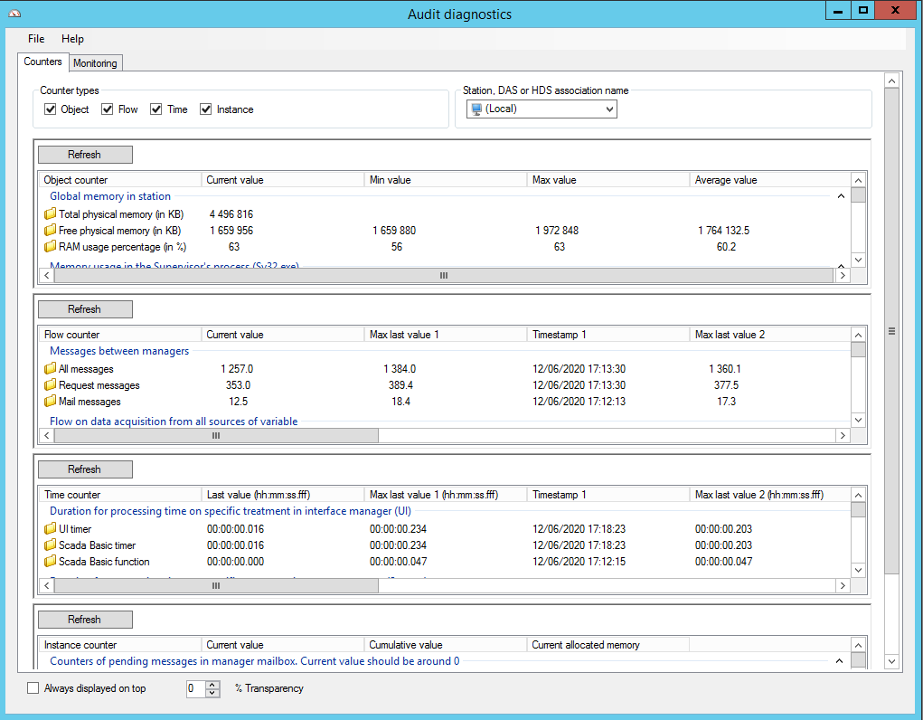

Figure 83 - Audit diagnostics

Monitoring

The monitoring tab contains information about the flow of real time data between the Supervisor's managers. Using the drop down list box at the top left hand corner of the dialog you can choose to display information about either data being acquired by the Supervisor, or data being produced by the Supervisor.

• Data acquisition - Data being acquired by the Supervisor. For example, the contents of a read frame of one of the native drivers.

• Data command - Data being produced and sent by the Supervisor. For example, the contents of a write frame of one of the native drivers.

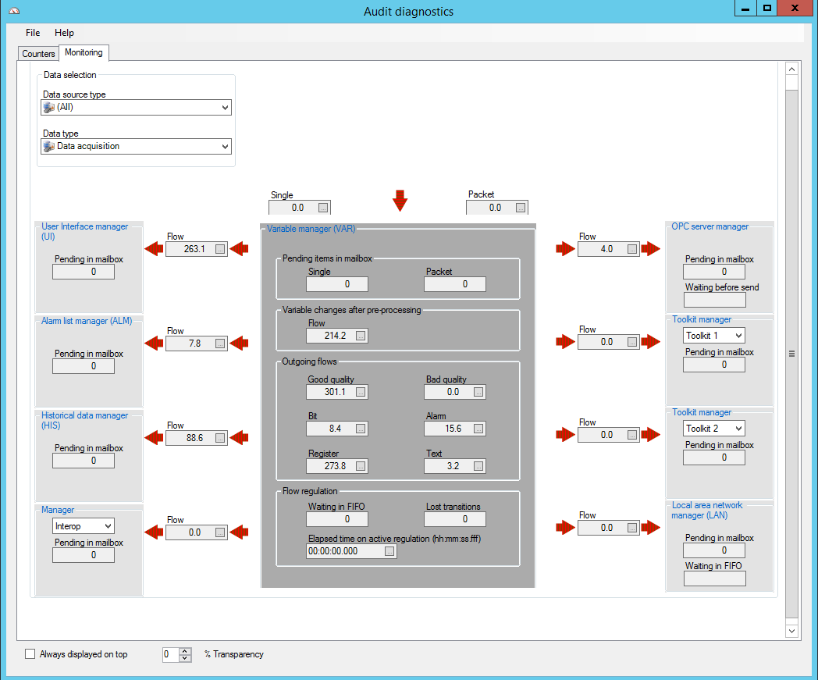

Figure 84 - Data flow monitoring

Cimway® data acquisition engine diagnostic tool

In addition to the integrated audit diagnostics of the supervisor, a specific monitoring tool for communication manager is provided. It has a system for errors specific to each protocol used to view real-time information and errors given by the protocol.

Logging and tracing

Event log

This tool displays in real time every messages, information or errors from the core of PcVue system, allowing tracking any abnormal behavior and understanding any malfunctions.

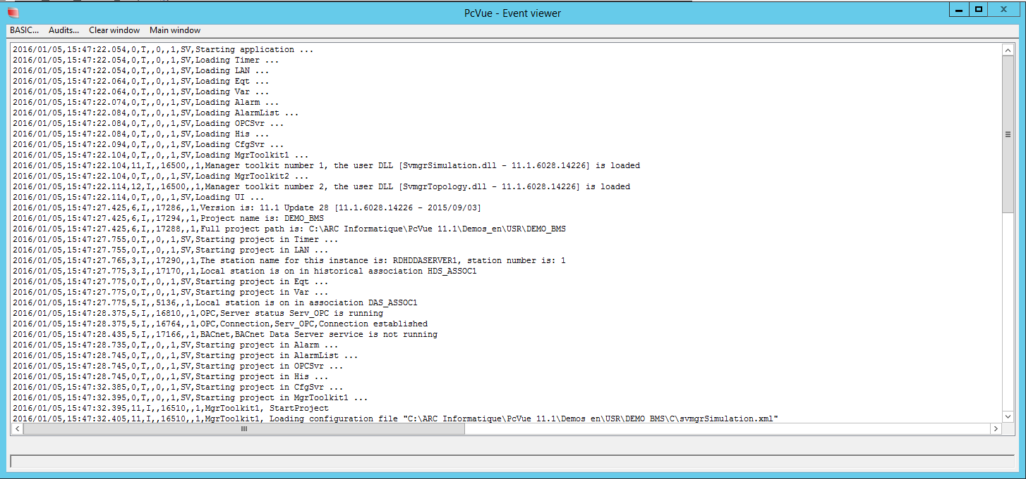

Figure 85 - Event viewer

SYSLOG and Windows events viewer

PcVue enables event logs to be aggregated by 3rd party IT system monitoring tools for events correlation and analysis: PcVue supports for Windows event viewer and SYSLOG over UDP, TCP & TLS – RFC 3164 & 5424 and is compliant with the ANSSI and IEC 62443 requirements for logging and tracing.

References
Figure 1 - Quickstart project 3
Figure 2 - Application Explorer 5
Figure 3 - Configuration wizards 6
Figure 4 - Application Architect : templates 7
Figure 5 – Application Architect : differentiation menu 8
Figure 6 – Parameter example 8
Figure 7 – Application Architect : Instantiation 9
Figure 8 – Application Architect : Example of customization 9
Figure 9 – Variable tree 12
Figure 10 - Data structure and genericity 13
Figure 11 - Example of an alarms viewer with filters using extended attributes 15
Figure 12 - Example of a detail popup with information displayed from the extended attributes 15
Figure 13 – Bit associated label creation 16
Figure 14 – Alarm associated label 17
Figure 15 - Alarm levels settings 18
Figure 16 - Thresholds variables 19
Figure 17 - Masking variable 20
Figure 18 - Alarms synthesis configuration 20
Figure 19 - BACnet : configuration interface 23
Figure 20 - BACnet : browsing and mapping editor 25
Figure 21 - BACnet : Helpers 26
Figure 22 - BACnet : Smart Generator 27
Figure 23 - SNMP : MIB browser 29
Figure 24 - SNMP : modeling tool 29
Figure 25 - Design and Run-time mode 34
Figure 26 - Example of a 3D mimic 34
Figure 27 - Graphical design tools 35
Figure 28 - Example of objects available in the libraries 36
Figure 29 - Example of an electrical diagram using the libraries 37
Figure 30 - Example of a mimic for BMS designed using the libraries 37
Figure 31 - Example of a mimic using tabs 39
Figure 32 - Example of a mimic using a navigator panel 39
Figure 33 - Example of a mimic showing 2 generic pop-up mimic 40
Figure 34 - Example of an Alarm viewer 41
Figure 35 - Example of an alarm viewer using several timestamps 41
Figure 36 - Example of an alarm pop-up 42
Figure 37 - Alarm viewer : customizable toolbar 42
Figure 38 - Example of an alarm viewer with filters 43
Figure 39 - Example of a Trend Viewer 44
Figure 40 - Example of Y=f(X) chart 44
Figure 41 - Example of charts 46
Figure 42 - An event viewer 46
Figure 43 - The built-in controls 48
Figure 44 - Mimic embedding a Map Control 49
Figure 45 - Markers displayed on a Map Control 51
Figure 46 - The marker editor 52
Figure 47 - The map cache creator 52
Figure 48 – Key parameters 53
Figure 49 – BIM viewer configuration 55
Figure 50 – BIM viewer run-time 56
Figure 51 – ONVIF Video equipements - configuration 57
Figure 52 – ONVIF video equipements - Run-Time 58
Figure 53 – Built-in RSTP flow player 59
Figure 54 – Mimic with instant messaging control 60
Figure 55 – Mimic showing the time distribution and geographical electrical consumption of heating for several floors 67
Figure 56 - Total balance electrical consumption of the building compared to floor 1 67
Figure 57 – Machine working time report 68
Figure 58 – Machine states report 68
Figure 59 – Failures report 68
Figure 60 : Example of meter view 72
Figure 61 : Example of weather view 73
Figure 62 : Example dashboard view 73
Figure 63 : Architecture 74
Figure 64 - Message profile 75
Figure 65 – Webscheduler 76
Figure 66 – Event action settings 77
Figure 67 – Cyclic action settings 78
Figure 68 - SCADA BASIC Script Editor 78
Figure 69 – VBA Script Editor 79
Figure 70 - Central version management 82
Figure 71 - Web deployment console interface 83
Figure 72 - Mimic displayed in WebVue 85
Figure 73 -TouchVue screenshots 87
Figure 74 – SnapVue : concept 87
Figure 75 – SnapVue : technologies 88
Figure 76 – SnapVue : screenshots 89
Figure 77 – Screenshot of smart bots: run-time and design 90
Figure 78 - Example of architecture 91
Figure 79 User profile configuration 96
Figure 82 - Variable tracking table 98
Figure 83 - Audit diagnostics 99
Figure 84 - Data flow monitoring 100
Figure 85 - Event viewer 101



PcVue features

BTL : BACnet Testing Laboratories http://www.bacnetinternational.net/
B-OWS : BACnet Operator Workstation
B-AWS : BACnet Advanced Workstation
BIBB : BACnet Interoperability Building Blocks
ePICS : Electronic Protocol Implementation Conformance Statement
Notifications are not available in this environment
Demilitarized Zone
Remote Desktop services
HTTPS : HyperText Transfer Protocol Secure
Single Sign-On
VLAN : Virtual LAN
VPN : Virtual Private Network

