Supervision System Specifications

Last update : | March 2024
Revision : | 19
Content :  Confidentiality : | Specifications for supervision like PcVue16  C0 - Public

The information in this book is subject to change without notice and does not represent a commitment on the part of the publisher. The software described in this book is furnished under a license agreement and may only be used or copied in accordance with the terms of that agreement. It is against the law to copy software on any media except as specifically allowed in the license agreement. No part of this manual may be reproduced or transmitted in any form or by any means without the express permission of the publisher. The author and publisher make no representation or warranties of any kind with regard to the completeness or accuracy of the contents herein and accept no liability of any kind including but not limited to performance, merchantability, fitness for any particular purpose, or any losses or damages of any kind caused or alleged to be caused directly or indirectly from this book. In particular, the information contained in this book does not substitute to the instructions from the products’ vendor. This book may contain material belonging to third-parties. Such information is used exclusively in internal work processes and is not intended to be disclosed. In addition, this notice is not a claim of property on such third-party information.
All product names and trademarks mentioned in this document belong to their respective owner.

Content

1. General specifications 6
1.1 Software licensing 7
1.2 Upward Compatibility 7
2. Template project 8
3. Advanced Configuration Environment - ACE 9
4. Data Base structure 11
4.1 Data Types 12
4.2 VTQ – Value Time Quality 12
4.3 Properties 13
4.4 Attributes and Filters 13
4.5 Associated labels 13
4.5.1 Bits and alarms associated labels 13
4.6 Associated behaviors 13
5. Data acquisition 15
5.1 Field communication drivers 15
5.2 IoT drivers 16
5.3 Network communication 16
5.4 Interface with other systems 18
5.5 Universal data connector – ADO.NET 18
6. User interfaces - HMI 19
6.1 Design 19
6.2 Graphic Editor 2D and 3D 19
6.3 Animations 20
6.4 Generic object library 20
6.5 Mimic Templates 20
6.6 Multi-screen 21
6.7 Multi-language 21
6.8 Zoom and layers 22
6.9 The mimic tab control 22
6.10 The mimic Navigator 22
6.11 Data Visualization Viewers 24
6.11.1 Trend viewer for Real-time and Historical Data Trends 24
6.11.2 Chart Control for Y=f(X) Trends 25
6.11.3 Charts 25
6.12 Geographical interactive map 28
6.12.1 Markers 28
6.12.2 Off line map generator 29
6.13 BIM operations 31
6.13.1 BIM animated 3D viewer 31
6.14 Video Integration 34
6.14.1 ONVIF 34
6.14.2 RSTP flow 36
6.15 Instant messaging 37
7. Alarm management 39
7.1 Alarms status 39
7.2 Alarms features 39
8. Data processing 41
8.1 Archiving 41
8.2 Visualizing archived data 42
8.2.1 Replay feature 42
8.2.2 Logs viewer 42
8.2.3 Trend viewer 43
8.3 Data processing and reporting 44
8.4 Scheduler 45
8.4.1 Web Scheduler 45
8.5 On Call management 45
8.5.1 SMS & Emails 45
8.5.2 Advanced On-Call Management 46
8.6 Recipes 48
8.7 Expressions 48
8.8 Events actions 49
8.9 Cyclics actions 50
8.10 Scripts Editors 50
8.10.1 Script editor 50
8.10.2 Microsoft™ VBA Script Editor 51
9. System access & cybersecurity 52
9.1 Users management 52
9.2 Security and cyber security required features table 53
9.3 Cybersecurity 53
9.3.1 Network Diagnosis 54
9.3.2 Hardware Diagnostic and Advanced Network software 54
10. Architecture and deployment 55
10.1 Virtual environment 55
10.2 Multi-Station Architectures 55
10.3 Mobile solutions 56
10.3.1 Web deployment console 57
10.3.2 Web client 58
10.3.3 Remote access 58
10.3.4 Mobile application with alarms & events notification services 59
10.3.5 Geolocation and contextual mobile app 59
10.4 Central Project management 62
11. Commissioning tools 63
11.1 Variables 63
11.2 System variables 63
11.3 Audit diagnostics 64
11.3.1 Monitoring 65
11.4 Data acquisition engine diagnostic tool 66
11.5 Logging and tracing 66
11.5.1 Event log 66
11.5.2 SYSLOG and Windows events viewer 66

GLOSSARY
Here under to facilitate the understanding of this document a list of the term and abbreviations in use commonly:

I/O Input/Output
HTML Language for describing pages interpreted by Web Servers.
IP Internet Protocol specifying the format for addresses and units of packets of transmitted data.
LAN Local Area Network
Mbit/s Megabits per second
MODBUS Master/Slave communication protocol commonly used for industrial PLC applications.
PLC Programmable logical controller
FO cable Single or multiple core fiber optic cable
CPU Central Processing Unit
Ethernet Local transmission network technology, used to interconnect all equipment.
OPC Open Platform Communications – Standard software interface, facilitating the interoperability of application in industrial automation environment.
Gateway Intelligent link between local network and other external networks of different structure.
Protocol Data transmission procedure, describing message format and the data flow.
RJ 45 Connector used worldwide for phone, RNIS connections and IT LAN network. TCP/IP Communication protocol between different equipment on a network.
SCADA Supervisory Control and Data Acquisition
HMI Human Machine Interface
BMS Building Management System
BTL BACnet Testing Laboratory
B-AWS BACnet Advanced Work Station
IEC International Electrotechnical Commission
IEEE Institute of Electrical and Electronics Engineers
TCP Transmission Control Protocol
BACnet Building Automation and Controls network
DNP3 Distributed Network Protocol
DDE Dynamic Data Exchange
LonWorks Local operating network for building automation devices
Mimic Graphical User Interface screen
VBA Visual Basic for Applications
OS Operating System
KNX an OSI-based network communications protocol for building automation.
OSI Open Systems Interconnection
FTP File Transfer Protocol
DNV GL Testing and certification company for the global energy sector.
RDS Remote Desktop Session a Microsoft technology
CIP Common Internet Protocol for industrial equipment
SDK Software Development Kit
MAC Media Access Control
IIS Internet Information Services

Note to the reader
This document aims to describe the behavior of a SCADA software such as PcVue. The version of PcVue is version 16.
It can be used to edit a RFP document.

SUPERVISION SOFTWARE FEATURES AND DESCRIPTIONS
This chapter is delineating the main functional specifications of a supervisor application, including projects for SCADA, BMS and HMI.

General specifications
The supervisor shall have, as a minimum, the following characteristics:

- Supported on current versions of Microsoft Windows OS.
- A configuration-based development platform with minimal scripts required to implement functionality.
- An object oriented I/O database with a multi-level hierarchical structure supporting reusable component development via branch management in real-time.
- Communication with heterogeneous devices using multiple simultaneous protocols, with, at a minimum, built-in integration of the following data acquisition methods:
  - BACnet
  - LonWorks
  - KNX
  - IEC 61850 client, IEC 61870-5-104 client/server
  - IEEE 1815 (DNP3)
  - TCP / IP protocols (Modbus, CIP, and others)
  - SNMP manager/agent v1,v2/v2c,v3
  - OPC
- Integration of exchange interfaces with external systems, including at least the OPC, Web Services and DDE interfaces (for compatibility with legacy systems).
- Active X container (insertion of external software components) and Microsoft VBA compatible.
- Built-in management of redundancy of servers, redundancy of Ethernet network and redundancy of PLCs.
- Mimic modification shall be able to be done online without stopping or re-compiling the application.
- Built-in online help and full documentation of all features.
- Ability to access the supervision project from a remote PC, a smartphone or a tablet.
- Ability to archive system state to different repositories (text, databases).
- Alarm and event management including filtering and archiving.
- Display of simultaneous real-time and archived values.
- Support for VBA extensions and programmatic management of supervisor behavior at run-time.
- Ad-hoc exporting and reporting of supervised and treated data.

The supervisor shall be based on an object-oriented architecture with the following capabilities:

- A library of pre-animated objects, which may be modified on-line without third party software.
- Modifications to an object template shall be transferred to all objects incorporating the template (instantiation), without further user actions.
- The context of use is passed on to other generic objects with no level limitation (inheritance).

Software licensing
- The software license shall be delivered in the form of a hardware dongle (such as a USB port dongle) or a software license key.
- The licensing of the supervisor shall be according to real physical or external data connected to the supervisor.
- The supervisor licensing shall propose at least 7 different I/O levels of software licenses.
- There shall be no limitation on the number of internal tags used in the supervisor for any license level
- It shall be possible to remotely manage the license without exchange of the physical dongle. This includes:
- Upgrade to a higher level I/O system
- Add options such as protocols or graphical features

Upward Compatibility

The application shall protect the application against changes to operating system and database technologies. This supervisor project shall:

- Operate without modification on current and future releases of Microsoft Windows OS.
- The supplier shall demonstrate upward compatibility by showing an application developed in a previous version of Microsoft Windows and a version of the supervisor platform 2 major versions previous (N-2). Then demonstrate it running in the current Version N without having to modify the supervisor configuration.

Template project

The supervisor shall provide a way to create in few clicks a custom designed project with a ready-to-go configuration without starting from scratch.
A configuration wizard shall help the user through the few steps to configure a project:
- select different designs and styles
- select the screen resolution
- create your menus
The user shall be able to create a “ready to go” project including standard mimics and configuration:
- Trends viewer
- Logs and archiving ready
- Alarms viewer and system alarms ready
- User profiles
- Sample scripts…

Many styles and ergonomics are available:
- 5 styles
- 2 themes: Light/Dark
- 4 color skins
- 4 resolutions
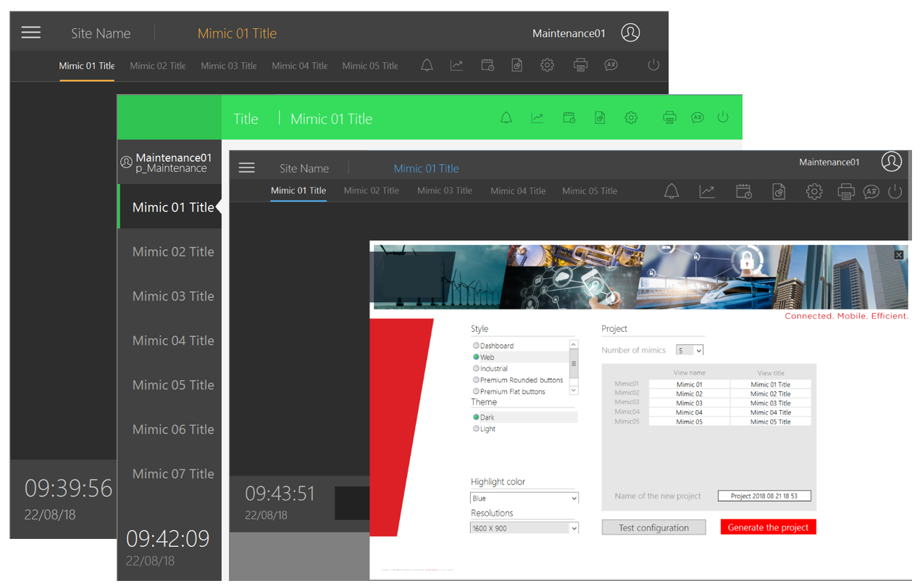
Figure 1 Project template

Advanced Configuration Environment - ACE

The Advanced Configuration Environment of supervisor brings a consistent and innovative platform to develop your application. The advanced configuration environment shall be designed to maximize productivity by providing components with similar user interfaces. It presents a single interface in which all developments are done. This environment brings many features for creating object descriptions, mimics, communication frame with PLC, user rights, etc.. .
It also provides advanced tools for creating the client/server architecture and deploying the software throughout the network.
The intuitive ergonomics of the configuration environment shall facilitate the design of a project using configuration wizards (by configuration and without scripting), to guide the developer through the process of using key features.

It shall include:
  - An “All in one” configuration interface, including the features for configuring all parts of supervisory project:
- Communication/Networking
- Variables
- Archives
- Data processing
- User management
- Libraries
A consistent and modern user-friendly interface based on the ergonomic rules for systems environments to make the design easier and faster such as:
- Based on a tree view structure with element lists
- Easy duplication of branches and sub elements
- Multiple document Interface
- Copy, cut & paste including sub-elements
- Intuitive navigation: previous & next
- Various display options: icons, list, details...
- Standard Windows’ keyboard shortcuts

  - A template generator to model objects and create applications

The supervisor shall have a tool that can generates part or all of an application (project) by designing and instantiating models. A model is a representation of a real object in terms of supervisor configuration elements (data, graphics, processing, etc.)
A model can represent anything together, from a simple on-off switch to a complete process.
It shall be possible to create included templates and inherited templates so that templates can be easily created from sub-templates.
This object-oriented approach to models is necessary to encourage and help the developer to structure applications in a way that makes modification and maintenance much easier and faster for the end user. Templates can be stored in a library so they can be reused for possible expansions, greatly reducing setup time.

This tool will allow in particular:
- to generate the elements of a project by instantiation of models
- to synchronize the project in case of model or instance changes
- to customize models and instances as much as possible and differentiate them with dynamic parameters

  - A suite of import tools for mass configuration
  - The Supervisor shall be able to generate an application automatically importing elements from external sources or in-house configuration tools (PLC programs, CAD drawings, user software and legacy SCADA/Building Management Systems).
This shall facilitate and dramatically accelerate the development of an application avoiding the loss of time of a double configuration and risk of error. Wizards shall guide the developer through the process of extracting data from third party applications. Elements of configuration (variable database, communication configuration, mimics etc.) shall be generated. The following import shall be supported:
      - TIA portal
      - Unity pro®
      - WAGO®
      - MOXA®
      - OPC
      - ISaGRAF™
      - CAD (AutoCAD)
      - LNS®
      - FactoryLink®
      - STEP7®
      - DALI®/WAGO®
      - Stardom™
      - Harmonas®
      - SAIA PCD™
      - TwinCAT®
      - BACnet™
      - Generique XML

Data Base structure

- The supervisor real time database shall be structured in such a way that variables can be grouped in a logical way by type of device or by physical location (for the device they refer to)
For example a building could be structured as shown below:
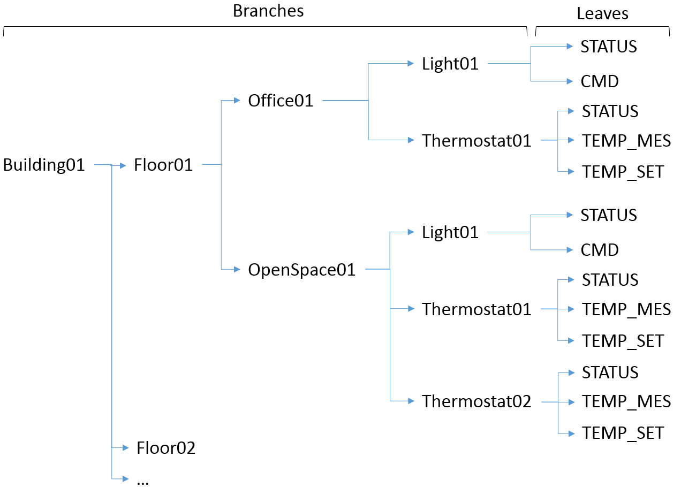
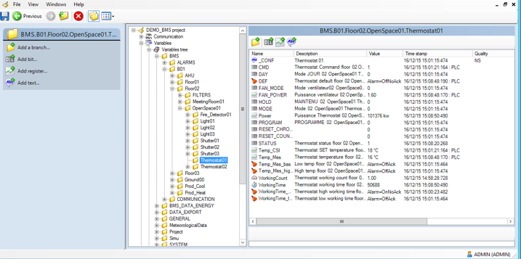
Figure 2 Variable tree
- Variables can be grouped in a hierarchical way (by branches) allowing easier readability and facilitating the development and the maintenance of the database as compared with a one dimensional, “flat” database.
- The supervisor database shall support at least 12 levels of branches.
- The name of variables shall be able to contain up to 255 characters.
- The management of the real-time variables database shall:
- Avoid repetitive tasks such as the creation of similar animated objects, shortening the engineering time for application development.
- The developer shall be able to create its own reusable object library, specific to their industry sector that is reusable as a template.
- When an object is inserted in a graphical mimic using a template it shall have the characteristic of inheritance such that if a modification is required to the template all the objects inserted in all mimics using that template shall be dynamically updated.
- It shall be possible to enter the supervisor real time data base variables using an external tool such as Excel.
- It shall be possible to import an xml configuration file of a specific format, in order to create and generate the supervisor’s real time database. All details of the variables such as properties, units, threshold values, mapping address etc., shall be contained in this configuration file.

Data Types

The following variable types shall be supported.
- Bit - Logical or two state data
- Alarm - A sub-type of bit with modified behavior
- Register - Any analogue data (byte, word, double word, float etc.)
- Text - String data
A variable could be:
- An Internal variable – the data value is calculated in the supervisor
- An Equipment variable - the data value is given by the communication layer

VTQ – Value Time Quality

Each variable shall have three real time properties, value, quality and timestamp - also known as VTQ. The timestamp has millisecond resolution and is the time that the value last changed.
Timestamp can also be provided directly by the PLC by using one of our timestamped protocols.
Any variable can be configured to be shared on multi-station architectures and/or made available for third party software through several interfaces (OPC, webservices,…). In such case the VTQ is broadcast.

Properties

Variable configuration shall be rich in properties with all variables having a Description, Source, filters criteria (Domain, Nature), and Command level plus properties specific to each variable type, Maximum, Minimum, Units, Associated Label etc.

Attributes and Filters

Extended attributes shall provide the opportunity to associate a number of binary and text attributes with each variable. The single binary attribute takes the form of a 32 bit integer than can be entered either as a number or as 32 individual bits. The text attributes are entered as a string or as the name of another variable. If you use the name of another variable, when that text attribute is referenced, the value of that variable is used.
Up to 16 free format extended text attributes can be configured for each variable.
Extended attributes have many uses such as:
  - Cataloguing data for better filtering particularly in the alarm viewer or logging :
  - Add details of specific characteristics to a variable. For example you might want to include the name of the equipment manufacturer or a reference that can be displayed on a mimic:

Associated labels

Associated Labels shall be supported. Associated labels are a set of text strings which can be associated with a variable and as a result substituted for the variable's values when displayed. For example, instead of a bit variable displaying ANIMATION 0 or ANIMATION 1, it might display STOPPED and RUNNING.
The strings provided by associated labels are displayed in mimics in the alarm and log viewers, and by the Text-Label and the Send-Bit animations.

Bits and alarms associated labels

Each bit associated label shall contain several strings.

Each alarm associated label shall contain strings for each of the possible alarm states plus Acknowledgement, Command to 0 and Command to 1.

Associated behaviors

Associated behavior shall add features to a variable in addition to that provided by its main properties. The following is a summary of the main behaviors:
- Threshold - Set bits when the value rises above or falls below a value. Typically used to generate alarms from analog values
- Chronometer - Measure the period for which a bit has been set
- Counter - Count how many times a bit has been set
- Discrepancy – DCS style mechanism that checks that the value of one bit against another within a configurable period. An alarm is generated if the check fails
- Alarm – Acknowledge trace, Associated action (open a mimic or run a script), Masking by bit or expression
- Event - Run a program or send a message (SMS or email) on change of value
- Trend - Record the VTQ in an archive unit for replay through a Trend Viewer or export to a 3rd party application

Data acquisition

The supervisor shall offer a high level of communication with field devices as well as great interoperability to exchange data with third party systems using open and standardized interfaces.

A single platform shall be used to gather the data coming from all types of equipment and software interfaces for a unified system wide view of supervised equipment and other assets.

The supervisor shall integrate built-in communication control features and shall provide status concerning the quality of the data exchanges. The status shall be directly exposed through variables of the real-time database (system variables). It shall be possible to use system variables in all the features of the supervisor, such as animations on mimics, alarms viewers, archives, and programs.

The supervisor shall provide a native “watchdog” feature to complete the detection of communication anomalies (response timeout or missing device), with industrial equipment such as BACnet controllers or PLCs. The supervisor shall manage natively (without the need to program) the watchdog mechanism so that it shall be possible to detect a possible freezing of processing of the device controller even if its communication coupler responds correctly to the communication requests.

In addition, the following features shall be supported:

- Data timestamps to millisecond
- External time stamped data. The source time stamped mode shall be managed for the protocols that support it
- Display and archive of the origin of the timestamp whether it be from external or from the supervisor
- Built-in management of redundancy features (servers, Ethernet networks, PLCs) for the protocols that support it.

Field communication drivers

The supervisor shall be able to communicate with the acquisition, control and automation systems such as BACnet controllers and PLCs.
The supervisor shall natively have a set of protocols, serial and TCP / IP, covering the main manufacturers of device on the market and including at least standard drivers such as:

- BACnet Advanced Work Station (B-AWS) with BTL listing confirming that the supervisor has been tested to highest level of BACnet Work Station functionality and interoperability.
- OPC DA (v1.0,v2.0,v3.0) Client / Server,OPC UA (v1.03)
- OPC XML (v1.0)
- LonWorks supporting all the available LNS versions of Echelon which shall allow to benefit from the online modifications of the LON DB (Polling / Binding).
- KNX
- ModBus / JBus, Modbus / TCP
- IEC 61850 Client GL-DNV Certified
- IEC 60870-5-104 Client / Server
- IEEE 1812 (DNP3)
- Common Internet Protocol
- FTP
The supervisor editor should be an active participant with IEC Standards working groups, BACnet® International and the DNP Users Group.

IoT drivers

The supervisor has a set of components, functions and services allowing to:
- Connect sensors or "objects" through IoT drivers
- Implement and create IoT elements in a project
- Operate and maintain an installation using connected objects by exploiting the data collected

The supervisor can connect “IoT” objects independently of manufacturers, on private or operated networks and is compatible with most networks (LoRa, sigfox), operators, protocols (LoRa, sigfox, MQTT,…) and sensors on the market.

It is compatible with many gateways including the “Node-Red” gateways.

It natively integrates the LoRA protocol and the MQTT driver.

Network communication

The supervisor shall provide support for SNMP networking devices, with the following characteristics:
- SNMP Manager and Agent
- All SNMP versions supported:
  - V1
  - V2/V2c
  - V3 – Authentication & encryption
- Multi-vendor support
- PING management (ICMP) for unmanaged devices
- Built-in MIB browser
- Online/offline browsing – No import necessary
- Standard MIB files installed with the supervisor
- Trap support
- Up to 1000 SNMP devices/500 concurrent SNMP requests
- Pre-defined set of libraries

Interface with other systems

In order to interface with other external systems such as other software components or hypervisor, the software shall have at least:
- An SDK to be able to integrate to any other specific communication protocol or software.
- Web Services features, to allow other systems to access data from the supervisor using a Web Server. There shall be a SOAP and REST web services tool kit available to program and configure such interfaces.
- Generic import toolkit for third party configurations
- Built-in OPC DA v3 Client/Server and OPC XML v1.0 Client
- Built-in SNMP agent to share variables to an external network hypervisor
- Capability to behave as a Modbus slave device.
- Capability to upload and download files from a FTP server using password and/or FTP status variable.

Universal data connector – ADO.NET

The supervisor shall feature a SQL bridge based on ADO.NET allowing to interface with an infinity of data sources (DBMS, ERP, MES, CMMS, Big data, REST services, social networks, files...).

The Universal Data Connector shall include the following features:

- Connect cloud or on premises data sources
- Handles all the connection, and redundancy mechanisms
- Support for SQL requests: SELECT, INSERT, UPDATE
- The result of the SQL request shall be map to a variable as for any other driver
- SQL request can be executed on event or cyclically
- Supported in web and mobile client
- Support for scripting and SV manager toolkit
- Support for displaying data with a grid

User interfaces - HMI

All the displays shall be in full graphic mode. Any pointing device recognized by the operating system (mouse, trackball, touchscreen, optical pencil, etc.) and / or by the keyboard shall carry out operator actions.

Design

The supervisor shall have its own graphic editor that shall use the latest vector drawing technologies to provide maximum productivity when creating mimics.

The supervisor shall have tools for editing and graphic design including:
- A drawing property manager allowing controls on how properties are applied to drawing elements, both individually and in multiple selection. It shall also copy the properties of an element to other elements.
- A graphical explorer allowing to have a hierarchical view at a glance of the elements constituting a mimic, and to modify them.

Using the object-oriented concept, graphic objects shall be easily created and reusable without any specific development. Modification of any object shall automatically propagate to other instances, reducing the risk of errors and facilitating the maintenance of the application.

Graphic Editor 2D and 3D

- The supervisor shall have a vector graphic editor, to configure and develop mimics. This editor shall include all necessary drawing tools, animation tools, etc, required to complete the graphical user interface. The graphic editor shall allow to insert in mimics, external images with the following formats: GIF, animated GIF, AVI, BMP, JPEG, PNG and WMF.
- In order to have the most realistic representation of some processes or facilities the software shall have the possibility to manage 3D objects using the DirectX format.
- The supervisor shall be able to import directly CAD files (DWG and DXF files). Mimics generated by this process shall have animated symbols and variable corresponding to block references if they are used in the CAD file.

Animations

- All real time data from the supervisor, (logic, analog, text, date, time) shall be available for use in the mimics. According to the type of animation used on those mimics, those data shall be directly accessible for read only (display) or read/write (display and control).
- The display shall be according to the animation type, text and font type. Display should consider such elements as colors, bar-graph style, appearance of symbol, moving objects and variable lists.
- The supervisor shall have at least 60 standard animations that can be combined together on a single object to obtain complex behavior (multiple criteria animation).
- It shall be possible to link a help tooltip to animation in order to describe to the operator the functions available. The tooltip shall appear when the mouse points at the animated object.

Generic object library

- The supervisor shall be delivered with a standard object library (objects, icons, normalized symbols, etc.) and objects with ready to use animations. These objects shall be sorted in different standard libraries or in user-customized libraries.
- The user shall be able to modify or add online, objects in libraries with the graphic editor tools, without scripting and without external compiling.
- It shall be possible to use a substitution method to manage these symbols. So, if a modification is done on a symbol like a change of color or a change of animation or the addition of a variable, all the objects in the application using this symbol as reference shall be modified accordingly online without any required compilation.

Mimic Templates

- The supervisor shall include a facility to choose from several pre-defined Mimic templates that can be customized further for a specific project.
- The supervisor shall have a “Quick Start” project to easily create a new project selecting the desired layout from several pre-defined templates.

Multi-screen
The supervisor shall provide built-in management of multi-screen displays and video walls. By having multi-screen, an operator can have access to several aspects of the process simultaneously such as mimics and alarms.

Multi-language

The supervisor shall be designed to handle multiple languages. Development menus and dialogs are bilingual. The two languages that are available are chosen, from a list of ten plus, as part of the project configuration.
Each text of any graphic objects (text strings used in mimics, mimic templates and symbols) can be entered in two languages.
The translation shall be made using a translation Import/Export tool.
The translation Import/Export tool shall allow to easily export, modify (translate or check the spelling) and import back into the project each text of graphic objects.
In order to support the widest range of languages, the Import/Export tool shall support both ANSI and Unicode encoding.

Zoom and layers
- Every single object on a mimic shall have visibility attributes or “layers” and the zoom attribute.
- The supervisor shall have a minimum of 16 levels of layers.
- It shall also be possible to associate the visibility of a layer to a zoom level. For example, layer 3 shall only appear when the zoom level is at 300% on a particular mimic, in order to avoid overloading general mimic with too much information while also avoiding the creation of multiple mimics.
- It shall be also possible to associate the visibility of a layer according to a user right.

The mimic tab control

The supervisor shall support a mimic tab control as a built-in feature which enables to define multiple pages in a mimic which, at run time, are selected by tabs in a similar way to some configuration dialogs. The look and feel of the tab control shall be inherited from the Windows appearance configuration. The mimics displayed in a tab shall have the same properties as standard mimics.
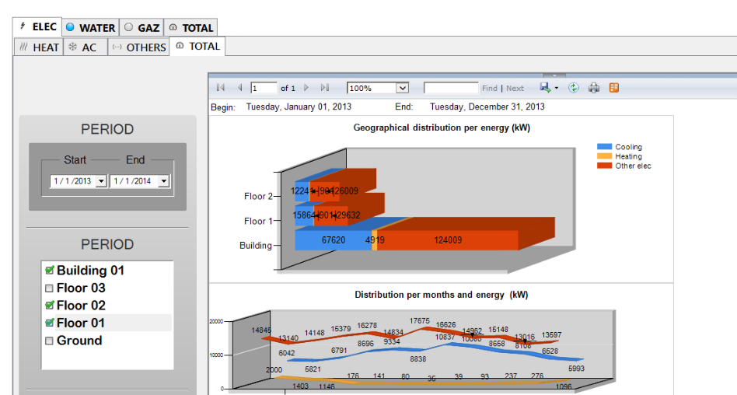

Figure 6 - Example of a mimic using tabs

The mimic Navigator
The supervisor graphical user interface shall support a mimic navigator which is an alternative method of scrolling a mimic that is larger than its container window. This feature is very useful to help user to navigate through a large mimic such as a building floor or an electrical bus-bar, particularly when the mimic has been zoomed.

It shall be a built-in tool available at both design and run-time.

The Mimic Navigator shall display as a thumbnail of the mimic with a black rectangle representing the current view. When dragged with the cursor the mimic shall update the view in real-time as it moves.

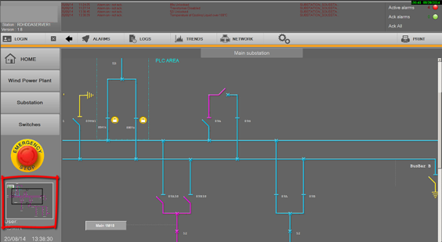

Figure 7 - Example of a mimic using a navigator panel

Data Visualization Viewers

The supervisor shall have built-in components for displaying trends of real-time data or archived data in time sequence (Trends) or variable relationships (XY Plots)

Trend viewer for Real-time and Historical Data Trends
The Trend Viewer shall include:
- Built-in control that can be embedded in any mimic
- Up to 16 traces per viewer
- Same user interface for both real-time and historical trends which can be displayed simultaneously
- Highly customizable interface
- Fully customizable legend to display properties, and/or dynamically hide/show traces, scales, change color, set thresholds display…in run time
- An easy to use calendar to search and display a specific period for a trend window.
- Multiple zoom capability
- A simple wizard to export trend data to Excel at run-time including statistics
- Thresholds display

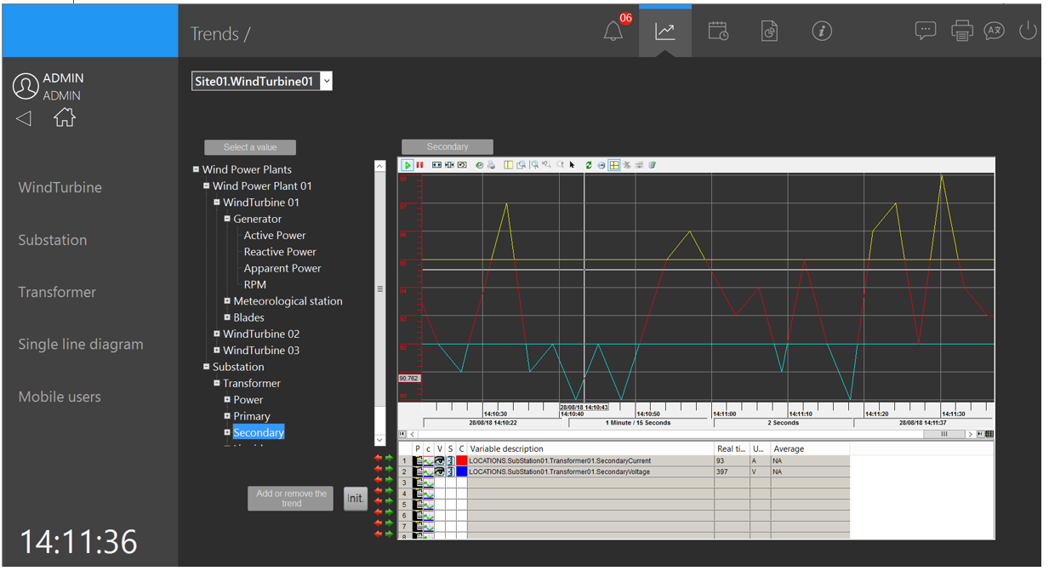

Figure 3 - Example of a Trend Viewer

Chart Control for Y=f(X) Trends
The Chart Control shall include
- Built-in control that can be embedded in any mimic
- Plots data series: values variables (Y-Axis) against one other (X-Axis)
- Up to 8 series each representing a register or a bit
- Draw types: lines, columns, cylinders, points …
- Graphical features: Legend, zoom, cursor, tooltip, print, popup on right-click.
- Reference series (lines, or ranges) for comparison (business-oriented series)
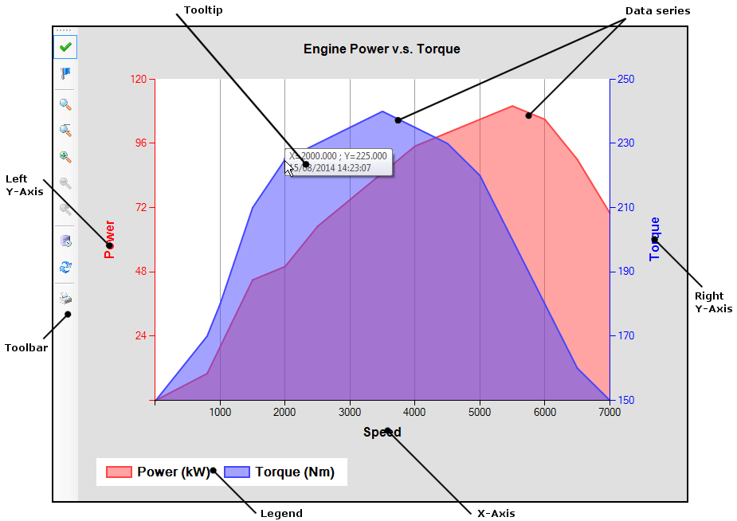
Figure 4 - Example of Y=f(X) chart

Charts

The supervisor shall support the following charts
- Doughnut,
- Pie,
- Pyramid
Supported Run time features
- Value format,
- Collection,
- Explode,
- Skins,
- Colors,
- Populate,
- 2D/3D,
- Save,
- Print,…

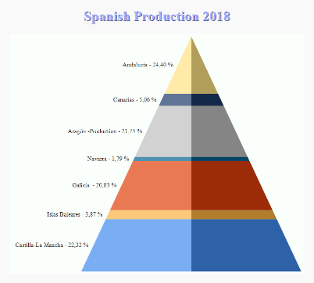
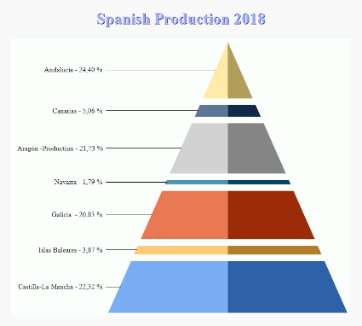
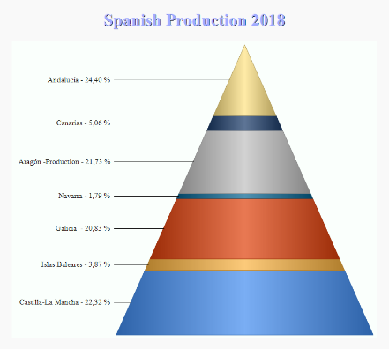

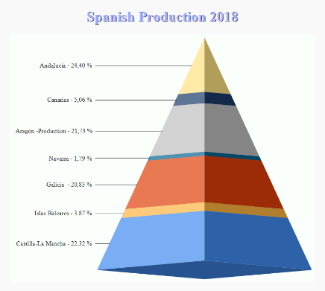
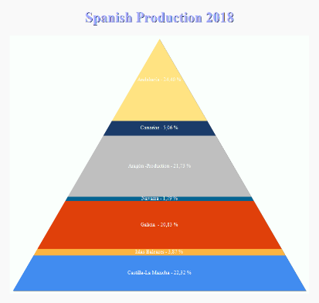

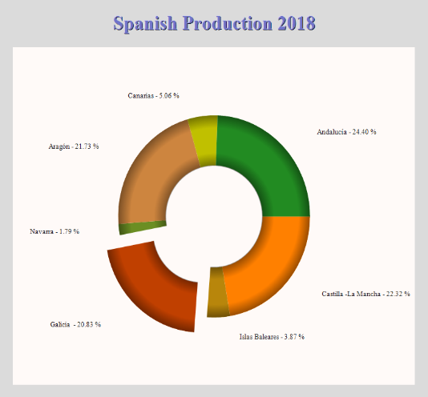

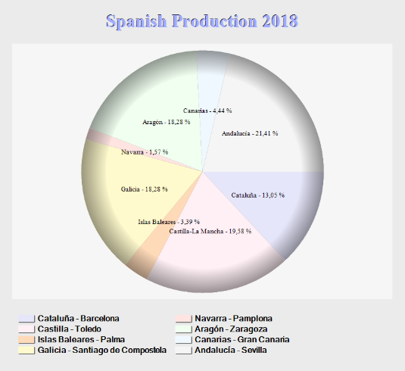
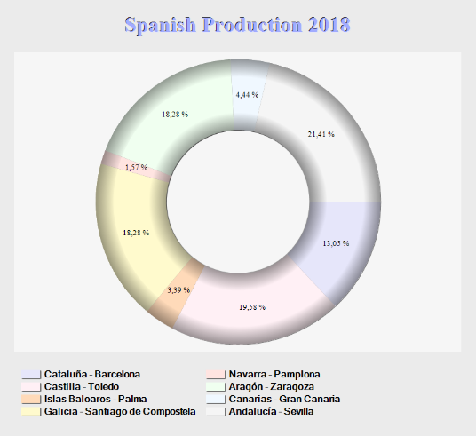

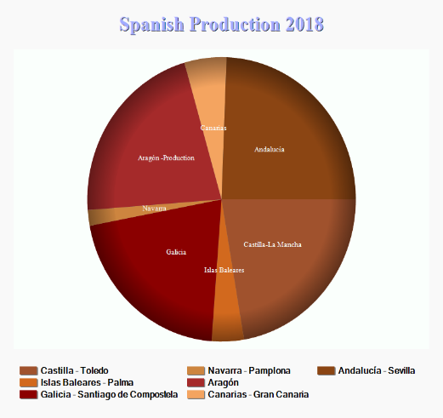
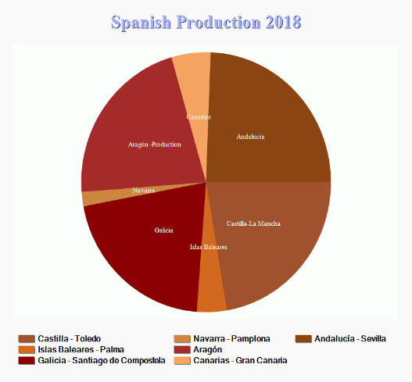
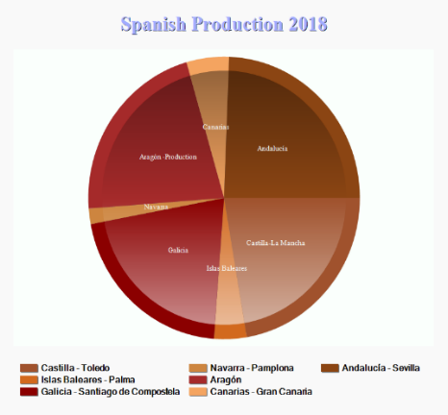
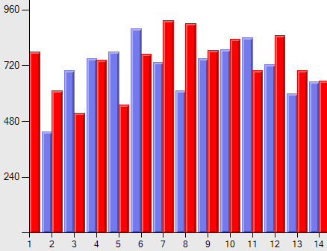

Figure 5 - Example of charts

Geographical interactive map

The supervisor shall support a built-in component client for a mapping services, capable of integrating GIS maps into mimics that have markers with real-time status. This capability shall include:
- Built-in map display component for GIS mapping service
- Main map providers – Online & Offline both supported
- Ability to use the supervision software built-in graphical objects as markers – Popup and mimic open on markers
- Tools provided to edit markers and create map caches for off line mode without the need of script
- Runtime animations & scripting
- Markers and layers shall be stored in a standard GPX file
- Shall allow for direct loading and rendering of GPX files – No import/export necessary
- Shall support standard map functions such as map center, zoom & panning

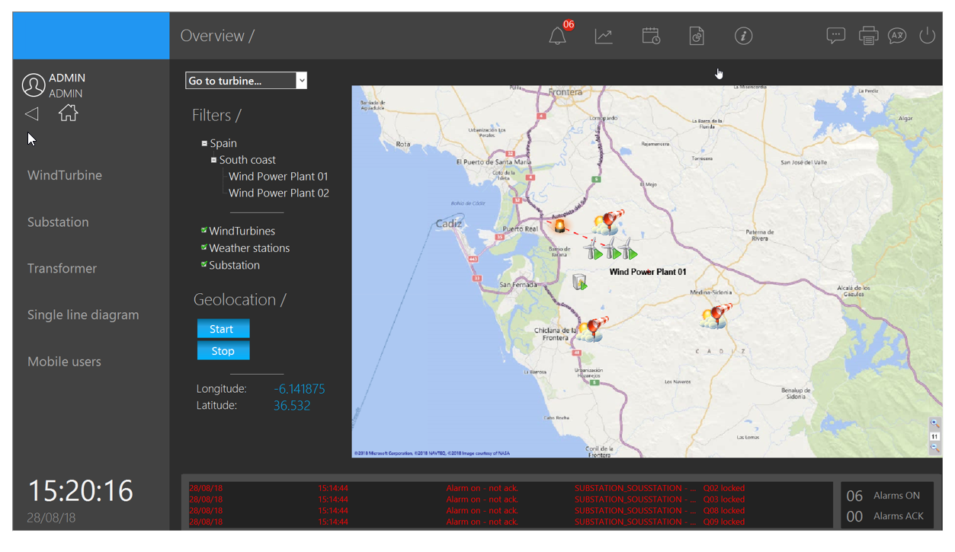
Figure 8 - Mimic embedding a geographical interactive map

Markers

The supervisor shall support the display of objects in overlay of the map that can be animated with real time data.
The following features shall be supported:
- Any symbols of the supervisor shall be used as a marker on a map
- Basic markers, such as shapes, images or texts
- Display/control of variables value or attributes
- Popup and mimic open on markers
- Markers and layers are stored in a standard GPX file loaded and rendered by the map control
- A Map Markers Editor shall come with the supervisor to create and to edit GPX files

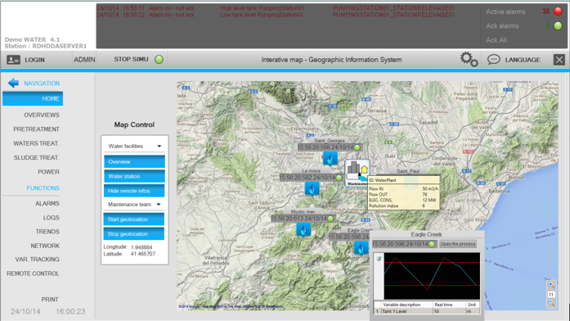

Figure 9 - Markers displayed on a Map

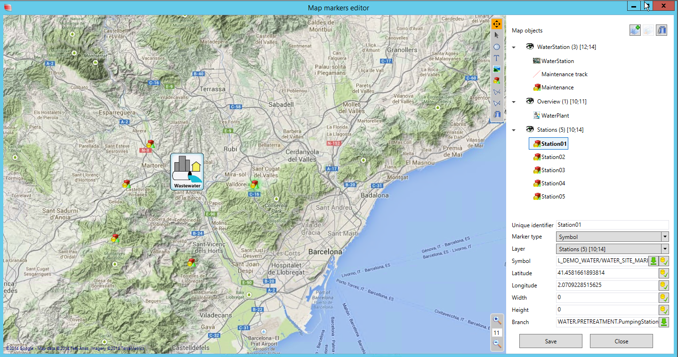

Figure 10 - Marker editor

Off line map generator
A tool to generate off line maps shall come with the supervisor to:
  - Retrieve map data online
  - Prepare the map cache for offline run-time use

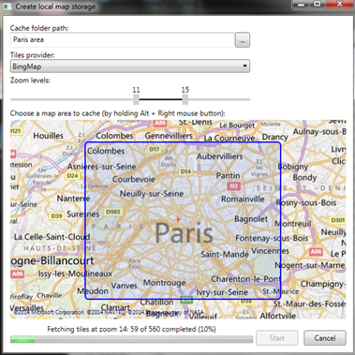

Figure 11 – Off line map generator

BIM operations

The supervisor shall allow designing a BIM-based project for BIM-driven building and facility management system.
It shall support for BIM operations features such as a BIM animated 3D viewer.

BIM animated 3D viewer

The BIM animated 3D viewer shall be a built-in control allowing visualizing the BIM geometric model. It shall support the following features:

- Animated BIM 3D viewer based on IFC files
  - Displaying a 3D model and navigate in 3D space
- Animating objects according to real time data, using animations or scripts
  - Advanced animations features: presets, color, zoom, callbacks,...
  - Automatic navigation in the model on an alarm raise
- Accessing properties of every object in the model
- Support for .xbim files

BIM configuration

The BIM control shall be configured with no code.
It shall include the following features:
- Browse in the model
- Create groups of objects
- Select animations on objects or groups

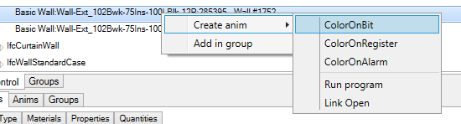
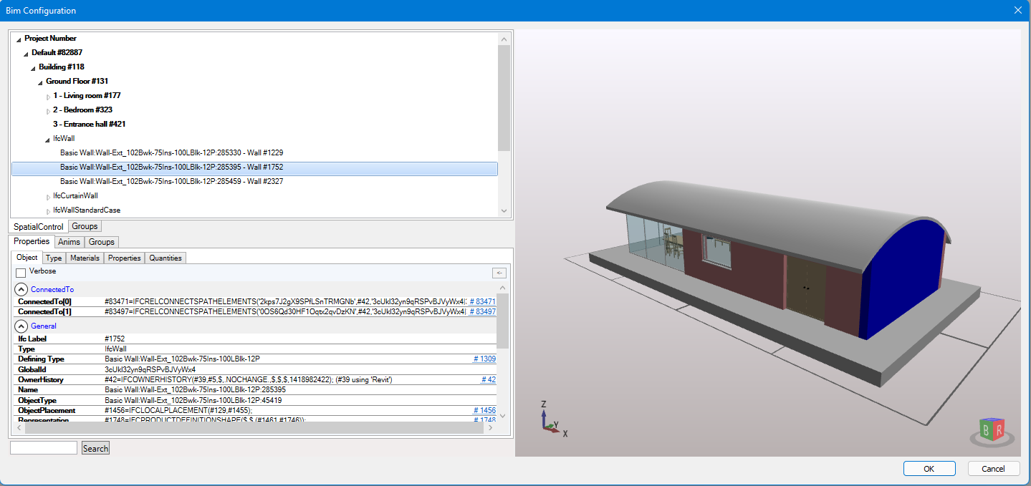
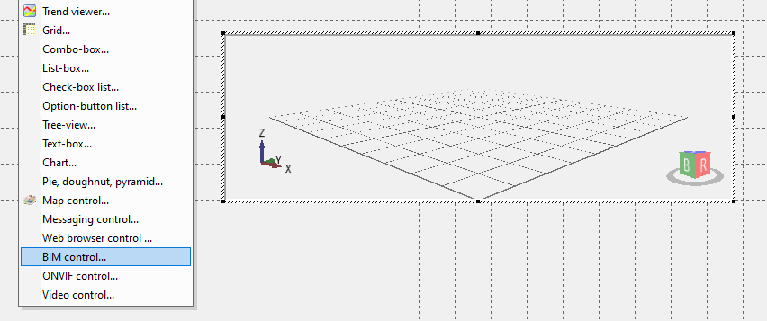
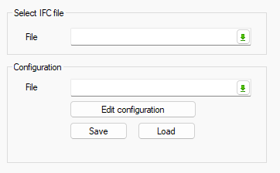
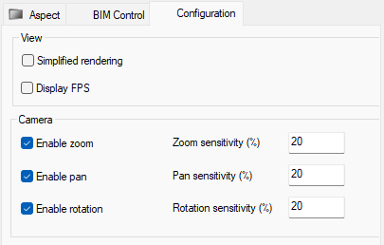

Figure 49 – BIM viewer configuration

BIM run-time
Animations
- Colorize an object with plain or blinking colors
- Zoom on an object
- Show or hide an object
- Add a callback on an object, to open a mimic or execute a program
Presets
Presets are a camera position and a cut plan position that can be saved and called back at runtime
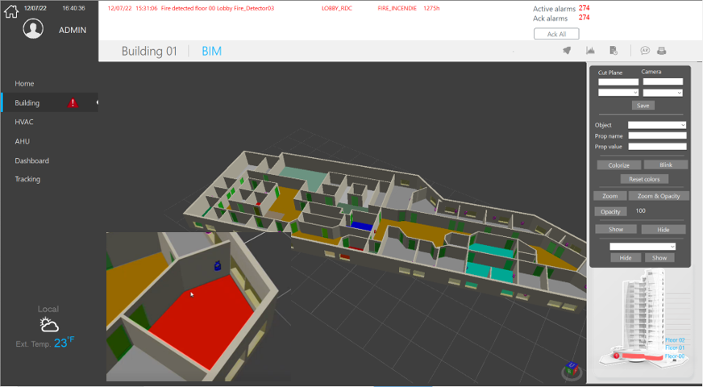

Figure 50 – BIM viewer run-time

Video Integration

The supervisor shall make it possible to integrate video equipment and to restore video streams in mimics via native ONVIF interface.

ONVIF

Video equipment compatible with profile S of the ONVIF standard shall be supported. They shall be integrated into a project, and shall have the following characteristics and functions:

- ONVIF Profile S
  - For IP-based video systems
  - Video streaming and configuration
- Control of cameras
  - PTZ control
  - Audio-in
  - Multicast
- Guard tour
  - Rounds of camera presets in sequence
- Presets
  - Predefined Camera position + Zoom level
  - Load & save presets
  - Go to preset
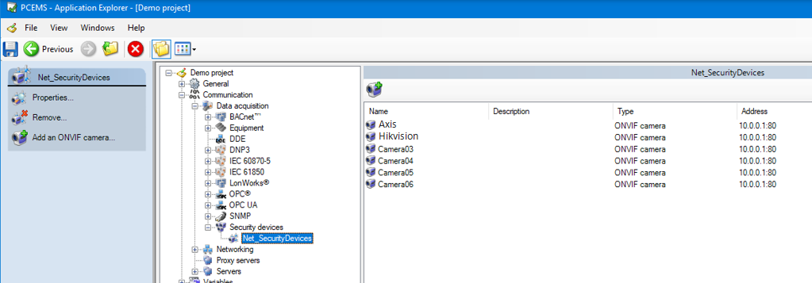

Figure 52 – ONVIF Video equipements - configuration

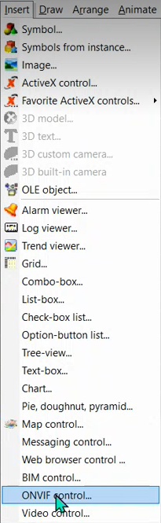
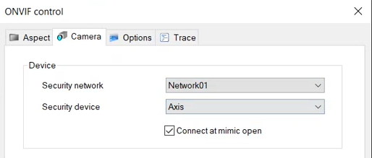

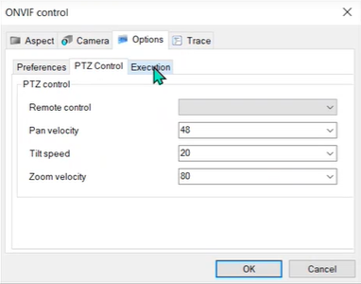

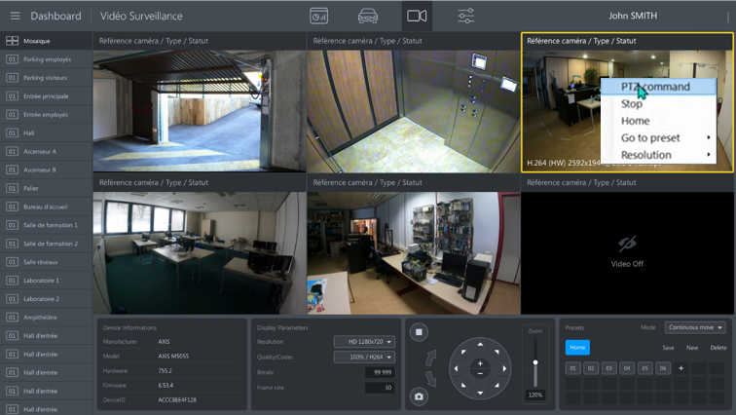

Figure 53 – ONVIF video equipements - Run-Time

RSTP flow

The integrates a native video player allowing the control of video streams and live broadcasting.
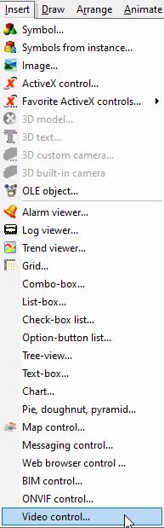
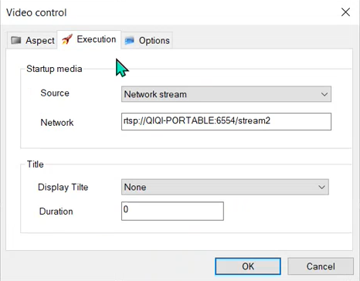
Figure 54 – Built-in RSTP flow player

Instant messaging
The supervisor comes with a messaging control that provides access for a user to the Instant Messaging service. The Instant Messaging service allows a user to communicate, by sending and receiving text messages, to one or more other users on another the supervisor station and / or one of the mobile applications.
Instant messaging uses a conversation known as a chat (or chat room). Chats are created, and owned, by a specific user. Once a chat has been created, the owner can invite other users and change user permissions. In the supervisor desktop application, chats are managed at run-time using the Messaging Control. Several instances of the Messaging Control can be inserted in different mimics, to serve different purposes:
- In a mimic accessible in one click from the mimic header (or a function key), a Messaging Control locked on a chat dedicated to general talks among team members.
- In mimics corresponding to process parts or sites, a Messaging Control locked on the chat corresponding to the installation.
- In a mimic dedicated to chat, a Messaging Control allowing users to create and manage ad'hoc chats.
The instant messaging control includes but it is not limited to the following features:
- One or several messaging control can be inserted in any mimic
- Several chat can be created with different members
- Several chat user access levels giving permissions
- Several medias can be sent
  - Text
  - Record voice
  - Attached file

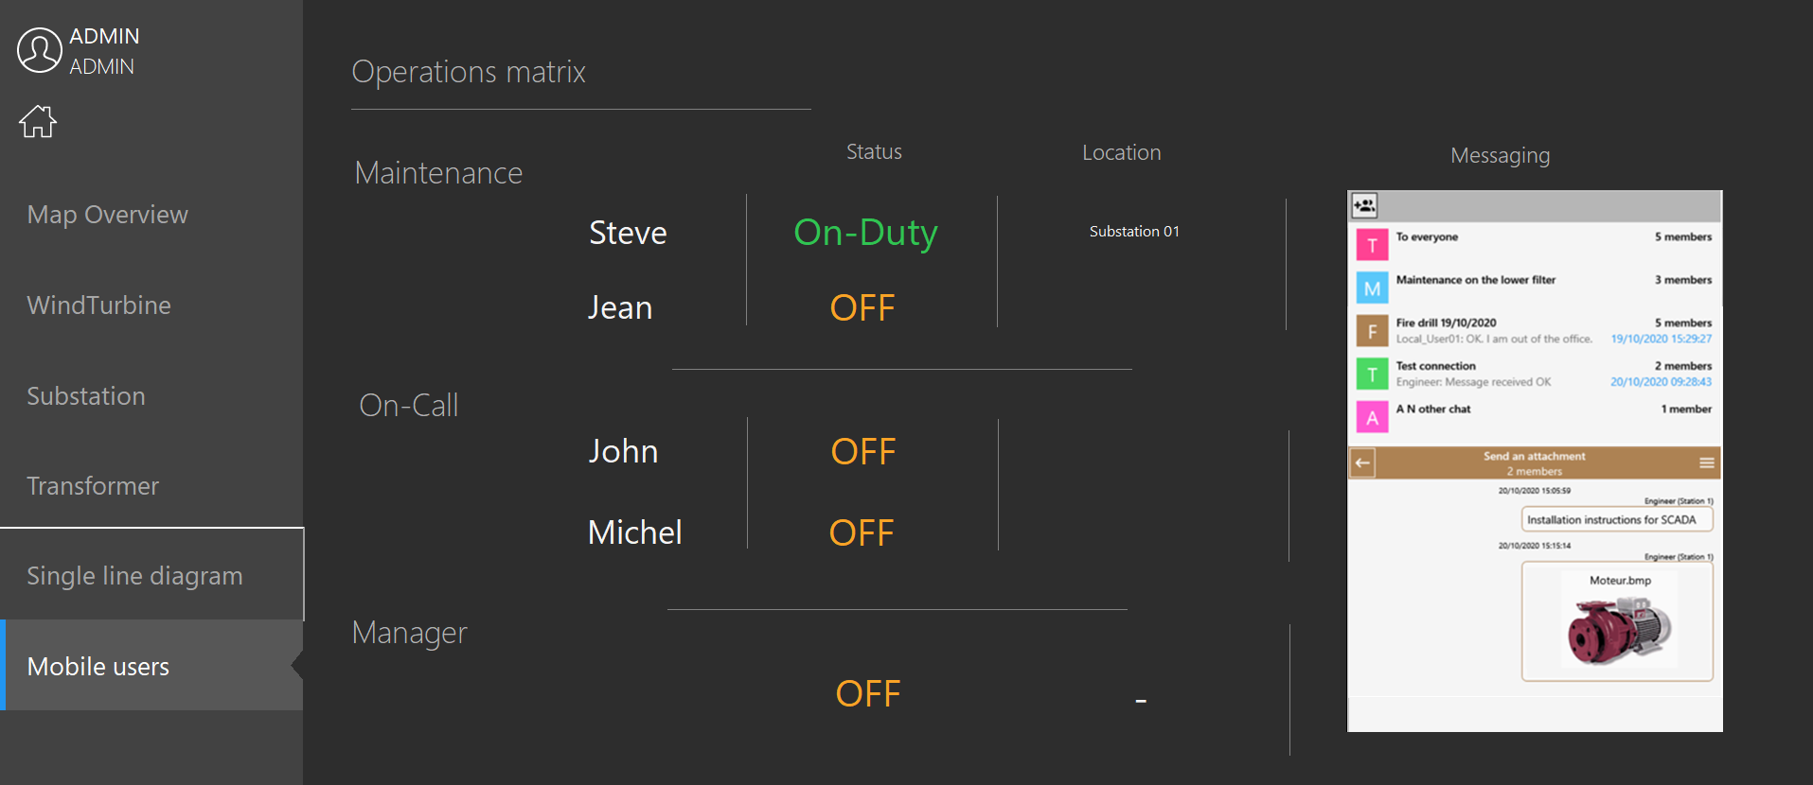

Figure 17 – Mimic with instant messaging control

Alarm management

The supervisor shall be able to warn the operator in case of any problem within the supervised process and allow taking into account the alarms and their follow up.

Alarm can be used for any status variable including specific animations such as colors, text, and symbols. Status variables used to represent the acknowledgement status. Colors, text, blinking can be fully customized by priority type. The supervisor shall have a minimum of 30 alarm levels.

Alarms status
An alarm shall have the following behaviors:
Off | The alarm is off.
Off - not acknowledged | The alarm is off, but it has previously been on and not acknowledged by a User.
On - not acknowledged | The alarm is on and but has yet to not been acknowledged by a User.
On - acknowledged | The alarm is on and has been acknowledged by a User.
Unavailable | The alarm is masked by the condition of another Alarm or Bit, or inhibited by a User.

Alarms may be:
- Displayed as a real time list in an Alarm Viewer.
- Displayed individually using certain animations, for example Color on Alarm.
- Acknowledged, inhibited and set to maintenance by the User.
- Recorded in the archive files and played back through a Log Viewer.
- Printed in real time as they occur.
- Counted in special register variables according to the alarm state, alarm level, Domain and Nature.
- Used to generate an external sensory alert, such as audible alarms.

Alarms features

The supervisor shall be able to manage as a minimum the following features:

Mask of alarm
Possibility to mask temporarily one or several alarms. This masking can be done by operator request or automatically according to the value of another variable (another alarm or status).

Specific alarm counters
Possibility to create system variables to reflect the number of alarms for a specific filter in real time. User defined Alarm counters.

Alarm filters
Alarms shall be displayed in list mode. It shall be possible to filter the alarm in the lists to display only certain types of alarms. The operator shall be able to filter by:
- Alarm type (alarm on, alarm on acknowledged, on not acknowledged, off not acknowledged, off acknowledged)
- Level (from the 30 available priority levels)
- Location or by alarm domain

Contextual action to an alarm
From the alarm list, the operator shall be able to highlight a specific alarm and using the « right click » an associated action can be available.

Access filter by station
It is possible to set alarm display and treatment filter according to the station (PC) the operator is using.

Consistency check
The supervisor shall provide a consistency check feature. To control the value returned following a command. After a time period (customizable) an alarm shall appear if the comparison between the command sent and the value returned is not consistent.

Activation
It shall be possible to configure the activation of the alarm:
- Positive transition - The alarm is activated (On - not acknowledged) when the value of its underlying bit changes from 0 to 1.
- Negative transition - The alarm is activated (On - not acknowledged) when the value of its underlying bit changes from 1 to 0.

Priority
The priority of the alarm in the range 0 to 29. An alarm's priority defines its color and its behavior in the Alarm Viewer.

Temporization
A period in seconds between the source changing to the active state and the bit state following it (and hence the alarm activating). Shall the source return to the inactive state before the temporization period is over the alarm shall not activate. A value of 0 disables temporization and the alarm activates immediately the source changes to active.

Alarms on thresholds
- It shall be possible to generate alarms when the thresholds are exceeded or above the measured value. The threshold values shall be settable with the possibility of defining hysteresis values.
- Up to four thresholds can be specified per measurement.

Alarm Notification
- The supervisor shall automatically send an email and/or an SMS on events including alarms. The content of the email/SMS shall be configurable to display text with real time values substitution at the time of the send. See chapter 7.6.1 for more details.
- The supervision software shall notify mobile device with a specific mobile app. See chapter 9.3.4 for more details.

Data processing

Archiving

- Data shall be saved on Hard disk in archiving units (different directories) or shall be printed.
- It shall be possible to archive in three different formats including:
  - Proprietary The proprietary format is specific to the supervisor used, to allow quick access to read data from the supervisor. If chosen, the use of the proprietary format shall not require any additional data base server software license.
  - Free The free format to archive data in a format set by the developer during the system configuration.
  - SQL Server For interoperability purpose, the supervisor shall support record in SQL Data Base format compatible with the latest Microsoft SQL Server version.
- The capability to archive in a SQL data base shall be in standard in the supervisor and shall not be subjected to the installation of any other software module (apart from the Microsoft SQL server itself).
- The SQL archiving module shall be capable of simultaneous archiving in several tables from several Data base. In order to optimize disk space, some properties (being unchanged for each value change of a variable), shall be recorded in static tables. These properties are then stored once only and not at every change. The choice of attributes for a variable that shall be recorded is entirely customizable (except for the compulsory attributes of the software used).
- It shall also be possible to record data at a user configurable sampling rate. Thus, there shall always be a data for each sampling period.
- The archived Data Base can be local (on the same PC) or remote on the LAN.
- The supervisor shall be able to manage redundant SQL Server archives.

Visualizing archived data

Replay feature

For security reasons operators shall be able to replay. The Replay feature shall enable to record changes in value (events) of variables on one Supervisor station and to play them back through mimics on another.
Main Replay feature characteristics shall be:
- Replay mimics at a different rate to the events, associated with a set of variables
- Facility for data recording for several weeks
- Replay information event by event to analyze incident sequences

Logs viewer

The supervisor shall manage the record of events and display the events in a log viewer, which shall be flexible both in its appearance and in operation.

The log viewer shall allow for online viewing of information and events recorded such as alarm appearing or disappearing, status feedback, and operator controls, through a particular log list. The log list viewer shall have searching tool on one or several criteria such as date and time.

The types of data which shall be available to display are:
- Alarm changes of state.
  - On and not acknowledged.
  - On and acknowledged.
  - Off and not acknowledged.
  - Off.
  - Unavailable.
- Bit changes of state.
  - Change to zero.
  - Change to one.
  - Change to invalid.
- Operator actions.
  - Commands.
  - Logon and Logoff.
  - Alarm acknowledgement.
  - Alarm masking.
  - Program start.
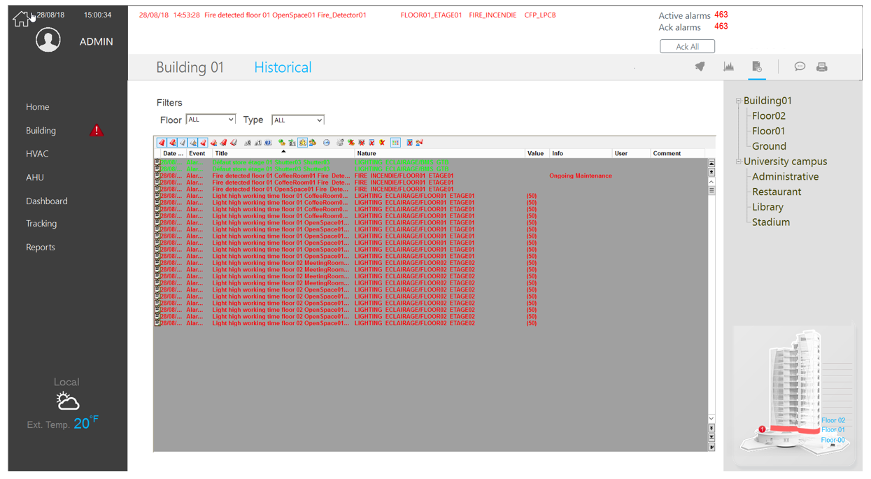
Figure 12 - An event viewer

Log Viewer features shall include:
- Log Viewers can be embedded in any mimic.
- Unlimited number of Log Viewers in each project.
- The size of Log Viewer shall be configurable from 1 line to the maximum allowed by the screen resolution.
- Data can be filtered by Domain and Nature and/or by time filter to search for records from a particular time (from date and time and a search direction).
- Optional toolbar and scrollbar.
- The format of the log lines in the display list is 100% configurable.
- Comment modification - the User is allowed to add a comment of up to 40 characters to each log entry.
- Sort modification - the User can change the sort column and direction.
- Can be configured so that the newest logs appear at the bottom or the top.
- Can be accessed by scripting languages such as SCADA BASIC and VBA to customize features.
- Can have a user-customizable context mimic

Trend viewer
See chapter 5.7.1

Data processing and reporting

The supervisor shall provide all the tools required for data retrieval, statistical calculations and reporting to enable operators to analyze and manage their applications in the short, medium or long term.
For medium- and long-term analyzes, comparatives, statistics or compliance checks, detailed Excel reports shall be generated. A built-in data export tool shall allow the operator, without any programming, to generate statistical data from archives and automatically create Excel and .csv reports
The supervisor shall also offer advanced reporting features with the aim of working on complex periodically generated and / or event-driven in order to analyze the existing system in the best possible way.
These reports shall be able to be generated without any particular programming and without knowledge of the databases.
The following features shall be included:
- Acquisition of real time data and archived data from several data sources
- The configuration of the tables exported shall be done directly from the supervisor tool.
- The configuration of the table exported shall be accessible with a Run Time license of the supervisor.
- Acquisition of real time data and alarms
- Availability of all common statistical functions like: Min, Max, Sum, Average, Counters, Standard deviation, Average gap, Meter index counting
- Use of statistic function in reports
- The export in Excel tables can use customizable Excel templates.
- The exports can be triggered by:
  - A manual action from a mimic by an operator.
  - On event
  - Cyclically
  - Periodically or on timetable
- Saving and archiving of reports locally or in a server on the LAN Network at a specific location.
- Possibility to upload exported reports to an ftp server or to send to an email address.
The supervisor shall also offer the possibility to integrate seamlessly within the application SQL Server Report Services reports with the ability to use the archives data of the supervisor, or others, and display the reports in mimics and filter the data displayed.
SQL Server Reporting Services (SSRS) is a server-based report generation software system from Microsoft. It is part of suite of Microsoft SQL Server services. SSRS enables users to quickly and easily generate reports from Microsoft SQL Server databases.
SSRS provides a full range of services and tools ready to use to create, deploy, and manage reports. They are fully integrated with SQL Server tools and components.

Scheduler

A scheduler feature shall allow configure actions based on a calendar (date and time).
These actions shall be executed following timetables and it shall be possible to configure exception periods such as public holidays. The operator shall be able to modify the standard week and create exceptions.

Web Scheduler
The supervisor shall have a web scheduler capability allowing an operator with proper user rights to access a Scheduler interface through a standard web browser such as Edge, Chrome or Firefox.
The web scheduler shall have a standard ergonomic interface and it shall be possible to display the schedule, in different period views:
- Daily view,
- Weekly view,
- Monthly view.
Characteristics of the web scheduler shall include:
- The smallest visible time interval in the daily view shall be 15 minutes.
- The web scheduler can be used to force data based on a predefined schedule at an exact time and date.
- It shall be possible from the web scheduler to set and change setting of a standard week.
- It shall be possible via the web scheduler to set and change exception periods, such as public holidays, off days and working hours.
- It shall be possible from the web scheduler to browse all data from the supervisor application in order to set and schedule an action on any variable.
- The web scheduler shall be compatible with the BACnet schedule objects profile.

On Call management

The supervisor shall offer built-in features for on call management, and the ability to connect to third party products for advanced on call management.

SMS & Emails

The broadcast of events notifications such as alarms, or real time data from the process is possible using SMS or email shall be directly sent from the supervisor.

These notifications shall have:
- Built-in device configuration
- Priority levels definition
- Possibility to define message templates including static or dynamic parameters as well as substitution characters associated with the context (value of a tag at the time of the message delivery)
- Automatic delivery of messages on alarm, event or any action
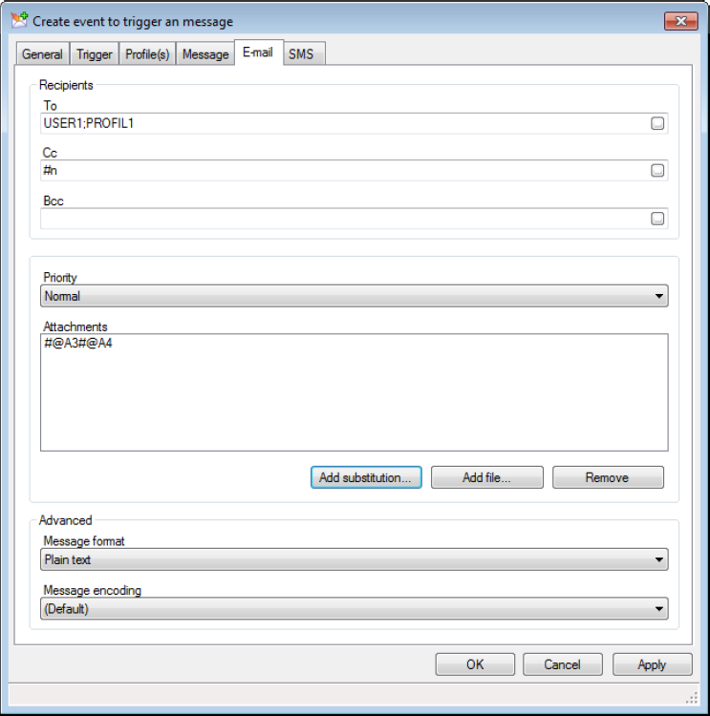

Figure 13 - Message profile

Advanced On-Call Management

A third-party software shall easily connect the supervisor through a dedicated interface (Mediator) as well as with other industrial supervisors, using DDE or the OPC protocol.

The on-call software shall issue information through various media:

- Telephone (landline or mobile): operators are called by telephone, listen to alarms and acknowledge them through the integrated voice server.
- Short messages (SMS) to alert operators working offsite via mobile phone or pager.
- Dedicated paging systems to quickly alert maintenance operators working on site.
- Fax, tele-printer and email to receive written reports of the alarms detected and their contexts.
- Internet browser or WAP-enabled mobile phone.
- The software, together with the operators’ acknowledgements of them, also logs the calls. Each acknowledgement of an alarm is automatically forwarded to supervisor.

Recipes

The supervisor shall feature a recipes management.
A Recipe is a list of variables each with a desired value. When a Recipe is sent the values are copied into the corresponding variables in the variables tree.
The most common use of Recipes is in a batch process where a production plant is being used to produce batches of different products. The instructions to the control device on how a product is to be made is sent to it as a list of values from a supervisory computer. The list is known as a Recipe. Recipes can also be used in conjunction with the Scheduler for simple time based control, such as that required in a building management system.
Recipes are normally created by the developer using the Recipes command on the sub-menu Configure.Station. When each recipe is created it is given a unique numeric reference and title to identify it when sending it or displaying its configuration. Recipes can optionally be allocated to a group known as a family, which can be then used as a criteria when selecting a recipe for modification or sending.
Recipes can also be created at run-time if the user has the necessary access rights.
In addition Recipes can be created from files downloaded by a host computer, or to provide other special options.Access to recipes is controlled by a user's access rights. A user can be given rights to change, send or create recipes.

Expressions

The supervisor shall have an expression engine for calculating a value using one or more operators (logical or mathematical functions) and variables.
Expressions are calculated automatically when the value of any element changes.
Expressions can be configured in various ways:
- Entering an expression directly in an animation
- Definition of expression model
- Definition of variables whose value is the result of an expression

Examples of expressions:
Motor01.Stop & Motor01.Start | Motor01.Fault
(Valve.Flow01+ Valve.Flow02) / 100
Tank01.Temp & 65520 (mask the first 4 states of value)
EXP (LOG (Valve.Pressure.Value) / 2) (Calculates the square root)

Events actions
The supervisor shall feature event action that can run the following :
- send a message via an e-mail
- send a message via a short message service (text/texto/SMS/TMS - here called SMS)
- a script (SCADA Basic program)
Event actions includes the following properties :
- Event actions are attached to a variable and are triggered when the value of the variable changes. The trigger condition is defined by a configurable expression, for example, when a register exceeds a pre-defined value. Events may be triggered on Bit, Alarm, Register or Text variables. For Bits and Alarms, the expression may include one or more conditions, for Registers and Text variables, only one condition is allowed
- Any number of events may be attached to each variable with a maximum total of 32000
- Event actions may also be configured using a script. These are known as temporary actions as they can be created and deleted under program control.
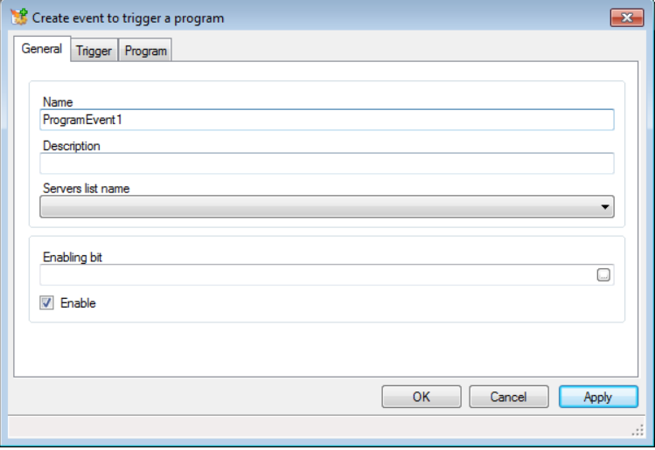
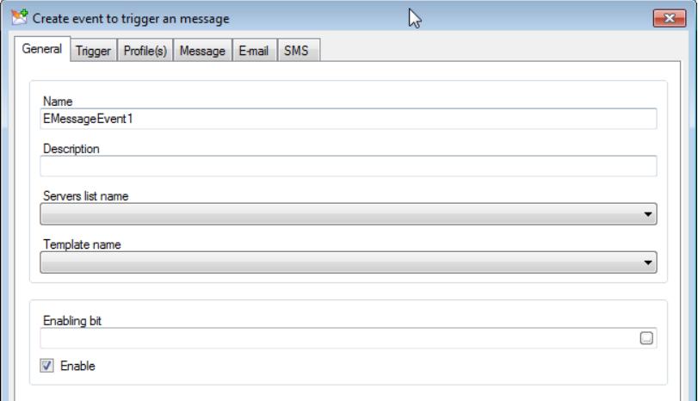
Figure 62 – Event action settings

Cyclics actions

The supervisor shall feature a Cyclic action mechanism. A cyclic action repeatedly runs a SCADA Basic program at a configurable period. Up to 512 Cyclic actions may be configured. The minimum period is 1 second. Cyclic actions are different to Scheduler actions where an action is triggered at a specific time.
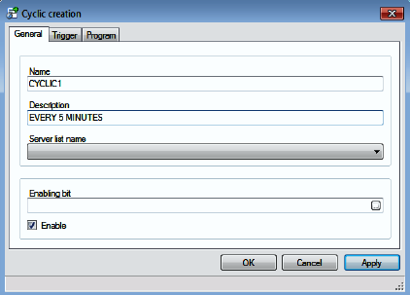

Figure 63 – Cyclic action settings

Scripts Editors
The supervisor shall offer many tools to perform the best SCADA application without any programming knowledge. However, for maximum flexibility the supervisor shall also includes two comprehensive scripting languages the SCADA Basic and the Microsoft™ VBA Scripting.

Script editor

The supervisor shall have a script editor to create programs.
Functions created by program shall manage all the supervisor functionalities (HMI, drivers, alarms, historical data, user rights…) allowing you to interact programmatically with most of features using a high level scripting language. The syntax is very similar to several high level languages making the transition easy for anyone with any programming experience.
A powerful editor is available with syntax highlighting, auto-completion and code snippet insertion. To ease your development contextual help for the language is provided and code snippets can automate insertion of frequently used pieces of code.
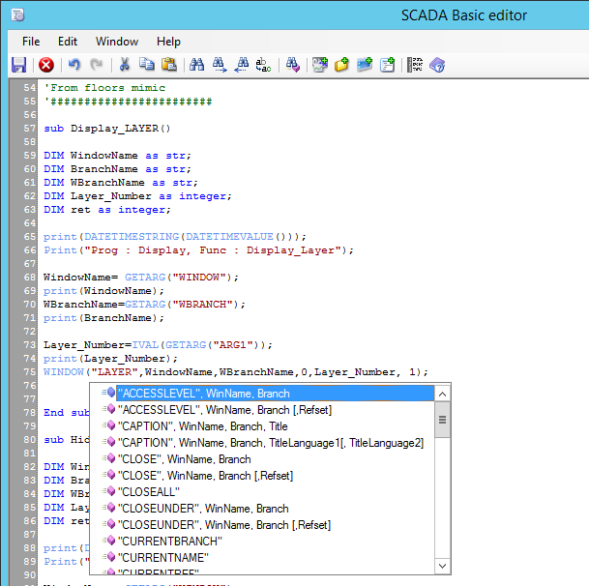
Figure 22 - SCADA BASIC Script Editor

Microsoft™ VBA Script Editor
The Microsoft™ VBA Scripting, which can interact with the supervisor Trends, alarms, mimics etc. Microsoft™ Visual Basic as an integral part of the supervisor provides programmatic access to the properties, methods and events of all built-in drawing elements, the project environment, variables and any ActiveX® components used in the project. Using VBA you can adapt the supervisor to the special needs of the user and easily integrate third party software such as spread-sheets, databases and reporting tools.

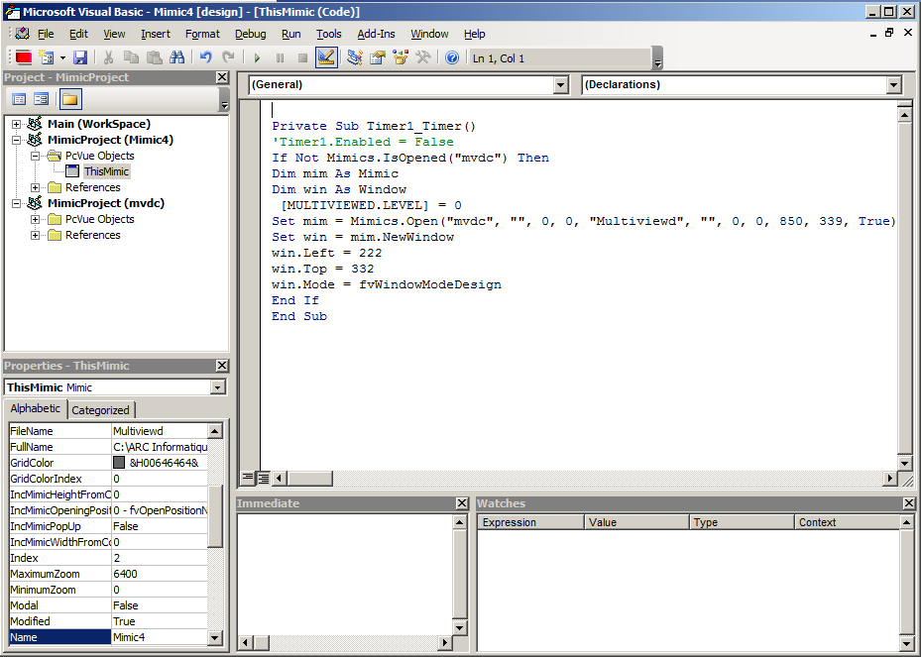

Figure 23 – VBA Script Editor

System access & cybersecurity

Users management

The behavior and graphical user interface of the supervisor shall depend on the rights of the operator who is logged in.
The following shall apply:
- An operator shall log in to the application by typing his user name and password, specific user rights shall then be associated to the user.
- Unlimited users can be configured but only one user at a time on a same station can be connected.
- Access rights shall give operational rights. For example, access to certain mimics or control rights on a mimic, alarm acknowledgement right. Access rights shall also control the rights for the PC itself or access to configuration tool of the supervisor.
- Depending on the station where the user is connected his/her rights can be configured differently and creation of zone shall be configurable.
- In order to ease the configuration and maintenance of user rights, user profile shall be used. When a user is created one user profile is associated to this new user.
- A same profile shall be associate to several users.
- There shall be no limitation of number of profiles and users configured.

For security reasons the supervisor shall:
- Auto disconnect a user logged in after a configured time of inactivity.
- Allow to configure a validity period for the passwords.
- Enforce password strength control
- Support 10 levels of hierarchical profiles
- Provide a facility for locking access to particular mimics, command variables, log variables, acknowledgements and alarm masking of access to various levels of model.
- Configuring different access profiles for a user according to the station logged onto, in a multi-station architecture.
- Ability to require password change on first login.
- Manages a user's "quarantine" after three unsuccessful login attempts
- Integrates user account information encryption
- Manage an expiry date of a user account
- Management of incorrect login attempts and automatic deactivation of the account
- Vulnerability test of passwords at their creation
- User Automatic logout after keyboard inactivity identified / pointing device according to a configurable period

In the light of certain standards, such as 21 CFR Part 11 applied in pharmaceutical, passwords management can be strengthened by operating on devices like:
- The signature and the recording of the user who send a control to the process
- The double signature making compulsory the user name and password entry but also a supervisor for qualified sensitive operations

Security and cyber security required features table

Feature/Technology | Comment
Secure HTTP (HTTPS)
Proxy | Web interfaces both compatible with a proxy
Active Directory | It is possible to use either the supervisor directory and its authentication mechanisms or to delegate authentication to Active Directory Compatible with Active Directory only.
Ability to disable or uninstall unused features and interfaces. For example: telnet access, FTP, web interface, Command & Control protocols,serial interface, USB port...
Root-Key | A secret used as root key can be set at the time of deployment of a station
User directory protection | -Based on the root key  -Cannot be deciphered or re-used w/o the root key  -Password hashes  PIV Smart Card support  2-factor authentication
Client/server networking over TLS | - TLS 1.3  - Support for TLS with Pre-shared keys  - Support for TLS based on certificates
Public Key Infrastructure | Support for a built-in PKI

Figure 69 – Required Security features

Cybersecurity

The system shall be designed for cyber security and work with appropriate cybersecurity constraints with a hardware and software solution adapted for industrial control systems to:
- Identify vulnerabilities
- Protect the system against intrusions
- Monitoring and detecting anomalies
- Restore the operational conditions - Ensure disaster recovery

In order to control the network flows and the devices on the Ethernet network, the system shall have simple but powerful tools. The software used may be a third-party software that it is fully compatible with the supervisor. They shall be simple to use, usable by a non-IT professional and cover all IP devices used in an automated and communicating industrial plant.

Network Diagnosis
A software that enables real-time hardware diagnostics on an industrial Ethernet network is required. It shall require no special device and shall be designed to allow non-specialist users to have the necessary elements to manage equipment on the network.

Through a friendly and intuitive interface, users have the following features:
- Automatic mapping of all TCP / IP devices from industrial Ethernet network via SNMP
- Real-time Identification and registration of hardware failures (MAC address duplicate, moving equipment, connection faults, ...)
- Providing safe type of analysis report (connection problem, speed changes, shift / unauthorized addition, Change of @ IP and / or MAC address)

Hardware Diagnostic and Advanced Network software
A complete solution for protecting critical industrial networks is required. The solution shall be based on the establishment of transparent probes connected over the network to capture and analyze information passing through the industrial control network.

The solution shall dynamically discover network to create an inventory of all connected devices and create a map of logical connections.

It shall also perform monitoring of data flows over the network, analyzes network protocols and extracts metadata such as firmware versions and frames. For example, it shall be possible to know the contents of messages exchanged between supervisor stations. Or to analyze the content of an exchange communication frame to a PLC.

The Network Manager shall be able to visually identify vulnerabilities in hardware and software points such as service connection left open, default password on a controller, and software errors.

To detect abnormal and suspicious behavior of the system the solution shall learn and continuously record all the parameters that characterize the "normal" operation of the industrial network during the various phases of operation. It shall allow the network manager to create a reference model of the network for devices, connections, protocols, and frequency and type of communications.

The solution then shall compare the instantaneous state of the system, based on information reported by the probes, with the reference model to detect events and abnormal behavior. Detected abnormalities shall trigger alarms in the control room where the operator shall follow a procedure in order to fulfill them. An unknown station detected on the network, a reconfiguration instruction sent out to a PLC or a new service protocol used between two devices, to name a few possible occurrences, shall be detected as abnormal events.

Architecture and deployment

The supervisor shall support flexible and scalable architectures including at a minimum the following:
- Stand-alone architecture, Client-Server architecture, redundant servers with multiple clients shall be supported in standard architecture.
- The configuration shall be done using wizards to simplify configuration.
- The link between supervisor client/server shall be using an optimized direct TCP/IP messaging system
- Server redundancy shall be supported by hot standby, defined as one duty server and a standby server taking over the when the duty server fails, or by dual duty server when the two servers are permanently live.
- The supervisor shall be able to support multi-level architectures such that a Server station in a standard Client/Server architecture can also become the client of a higher level Server station (e.g. a hypervision level). Such architecture modifications shall be possible without redesigning the supervisor application and shall be possible to defer until a future extension of the project.
- Changes in architecture or architecture alteration shall have minimal impact on the supervisor engineering.
- The SCADA project file loaded on each station shall be the same whether it is a Client or a Server station. Only the architecture configuration defines the role of each station but the project shall be the same on all-station in order to minimize supervisor configuration efforts.

Virtual environment
The supervisor shall be able to support virtualized architectures. A single physical machine with VMware or equivalent shall be capable of hosting all the different SCADA stations in isolated virtual machines. The supervisor shall support an architecture where virtual machines also host RDS, allowing multiple virtual RDS client stations to connect to them.

Multi-Station Architectures

The supervisor shall offer an extendable and flexible control system of high performance with a modular system architecture that consists of largely standardized components.

Client-Server architectures and inter-station messaging shall be built-in to supervisor and available within the Windows environment.

Mobile solutions

The supervisor shall offer alternative solutions to supervise the installations remotely using currently available technologies. Solutions shall be integrated seamlessly, each of which can be used independently or in conjunction with others as required.

Web and mobile solutions of the supervisor shall allow to setup mobile architectures with no gateway/plug-in, embedding all the necessary security features (https, Oauth, certificates) and the HTML5 technology as well as maintenance tools.

The following criteria shall be fullfilled:

- No gateway, no extra plugin
- No installation on client side
- Easy settings – no scripts – Wizard only
- Open to third-party application
- Adapted to any users: end-user, SI, IT
- Secure scalable architectures and communication
- Easy Diagnostic

Web deployment console

The supervisor shall provide a component for setting, deploying and maintaining a web or mobile architecture.
It shall support the following features:
- Deployment of web services and web apps on IIS
- Web Back-end endpoint management
- Data protection management
- Certificate management
- User access logging & OAuth Server management
- IIS auditing / diagnosis
It shall run on a server hosting a web server IIS.

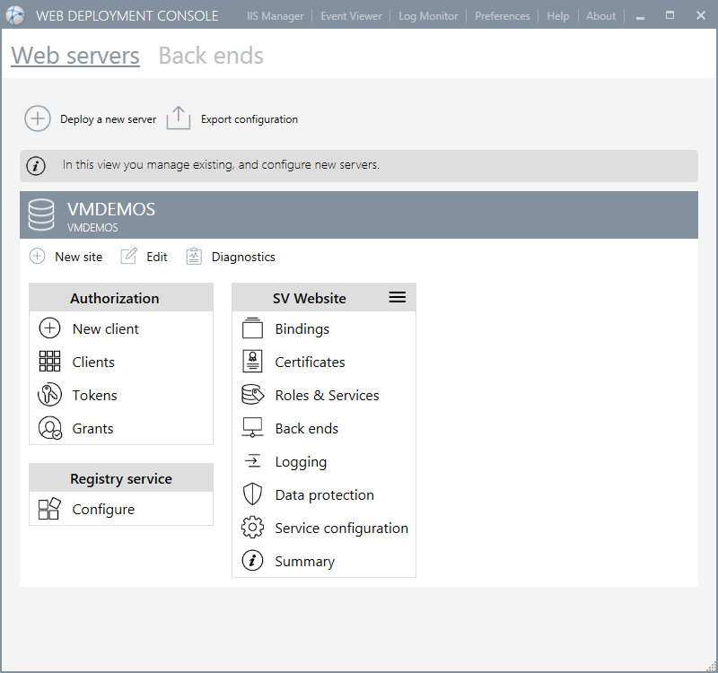

Figure 14 – Example of a web deployment console

Web client
A browser-based client or web client shall use a standard web browser and an internet or intranet connection to provide remote display and control of the processes. A user with appropriate user rights (user name and password) shall be able to access the supervisor from anywhere on the network. The web client shall be independent of the operating system. It shall display supervisor mimics directly without requiring additional configuration.

Communication between the supervisor and the web client shall use Microsoft IIS. The web client shall be continually refreshed and data exchanged using HTTPS (SSL V2).
The web client shall be compatible with the common web browsers including Edge, Firefox, and Chrome. Using supervisor’s public API REST Web Services it shall be possible to create a custom web portal to access the real-time and historical data of supervisor, mobile phones, tablet PCs etc. via standard web pages.
The web client features shall include:
- No software installation necessary on the remote device
- The mimics displayed on the web client shall look the same as the mimic visible from the SCADA stations clients or servers.
- It shall not be necessary to develop specific mimics and views for the web client capability. Meaning the mimics develop for the supervisor shall be automatically compatible with the web client. This in order to avoid extra engineering and to allow operator users to be immediately familiar with the supervisor graphical user interface.
- Real time monitoring and control shall be possible from the web client interface for an operator with appropriate user rights.
- An operator with web client access shall have the same rights from the web client interface as on the supervisor itself
- There shall be an auto log off feature to automatically log off a user connected to the web client after a determined inactivity period
- Up to 50 web client connections shall be able to access the supervisor concurrently
- There shall not be any limitation on the total number of web client users
- The web client application shall be able to access the supervisor through gateways and firewalls
- Access to alarms, alarm acknowledgement, trending real time or historical shall also be available from the web clients
- No license shall be required on the client station. Client access licenses shall be an option of the server.

Remote access
The supervisor shall support the Windows feature of Remote Desktop Services, which allows instances of the supervisor to run remotely using any devices that supports Remote Desktop, including HTML5 compatible devices.

This allows a user to access the application remotely with exactly the same features as a local client station.

This solution offers a high level of security since only the keyboard and mouse activities transit over the network reducing the risk of data corruption.

Mobile application with alarms & events notification services

It shall be possible to access data of a project from a tablet or smartphone using a mobile application for the supervisor.
The mobile app shall be an application displaying information and enabling actions on variables coming from a mobility server. The variables displayed are those whose level of navigation corresponds to the configuration of the user profile.
The mobile app shall run on the Android operating system (5.0 or higher) and iOS. It shall also work in a web browser without the notification feature below.
This application shall offer the following notification and control services:
- Notifications of alarms in real-time
- Access to real-time alarm list
- Alarm acknowledgment
- Access to the list of archived events
- View real-time data trending and archived
- View real-time values
- Sending commands and instructions
The implementation of this solution shall be simple and without specific development. A simple setting made via check boxes in the project shall allow defining what type of data shall be available on the mobile app. In addition, access to data and the level of visibility and control of these depend on the user profile and the rights associated with it in the project.

Geolocation and contextual mobile app
A mobile application shall allow a user, depending on their profile, to automatically obtain the contextual information related to their area of ​​responsibility (i.e. maintenance, operation, or supervision.) in the zone where they are and to have access to the actions they can undertake, directly from their mobile device. They shall be able to control the set points, analyse trends, consult a data sheet or exchange instant messages with other users.

This mobile application shall be based on the existing internal / external geolocation technologies including Bluetooth tags, NFC chips, QRCodes, and GPS.
It shall allow in particular the following functionalities:
- Automatic display of contextual information according to the geographical area in which the user is located and his profile
- Visualization and control of equipment in the vicinity
- Instant messaging with text, audio or video messages, and images
- Localization of mobile devices from a server visible on the mimics through animations or on an interactive map (Google maps, , or other mapping service)
- Facilitate information delivery to mobility workers by automatically delivery of information and controls required to perform their job function in a geographical zone, whether indoors or outdoors.

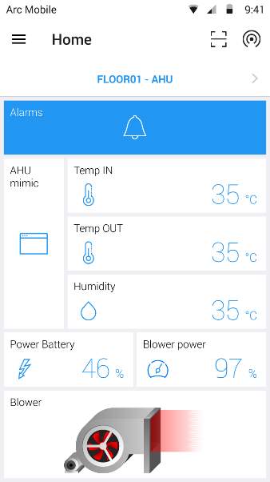

Figure 22 – Screenshot of contextual mobile app

Smart Bots

Smart bots is a feature that shall come with the mobile app to assist the mobile user through an interactive messaging interface.
A smart bot shall offer but shall not be limited to the following features :
  - Allows a chat with the user on event or on demand in SnapVue
  - Guides the mobile user in a specific context with an interactive messaging process flow
  - Custom scenario for bot messaging can be designed with no code
  - Can interface with O365 calendars
  - Can interface with Web Server endpoints as part of workflows as : Telegram, Line, REST API, CMMS API
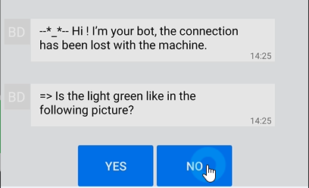

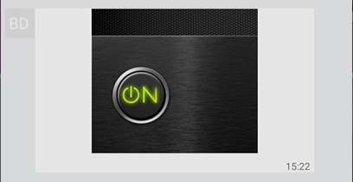
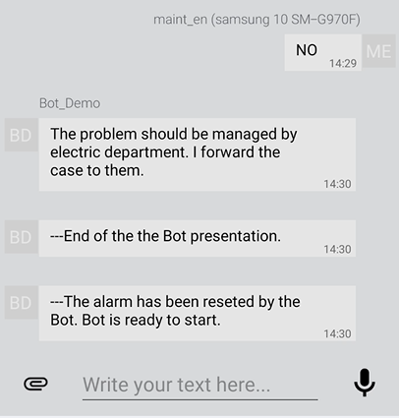
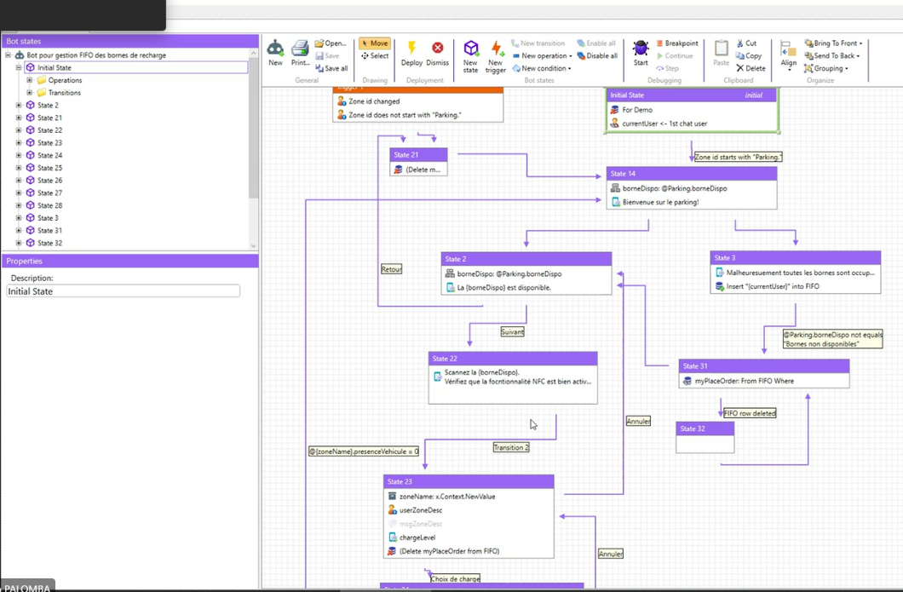

Figure 23 – Screenshot of smart bots: run-time and design

Central Project management

To make the maintenance and the deployment of a project easier and faster, the supervisor shall be delivered with a built-in central project management tool.

Different versions of a project and/or libraries shall be centralized in a shared directory on the network. The centralized project and/or libraries shall be capable of modification from any station on the network.
A dedicated development station shall be used to host the central project versions directory and to make the change for a project in a typical architecture.
Any station can manually load and run released or candidate versions, or automatically run the reference version of a project and libraries from the central project directory. This feature can shall also work with a stand-alone architecture.

Supported features shall include:
- 4 version types: development, operational, pre-reference and reference
- Configurable content of a version
- Track modification for each version
- Automatic version numbering system
- Unlimited number of versions (vs media free space)
- Tags can now be associated to versions of your project and libraries, and you can start your project based on a tag instead of a version identifier or state

Central project management shall allow tracing the evolution of versions of the project and if necessary be able to return to an earlier version.

Commissioning tools

Variables

A built-in component shall be used to display and control any data (real time or historical) which is useful for commissioning for example.

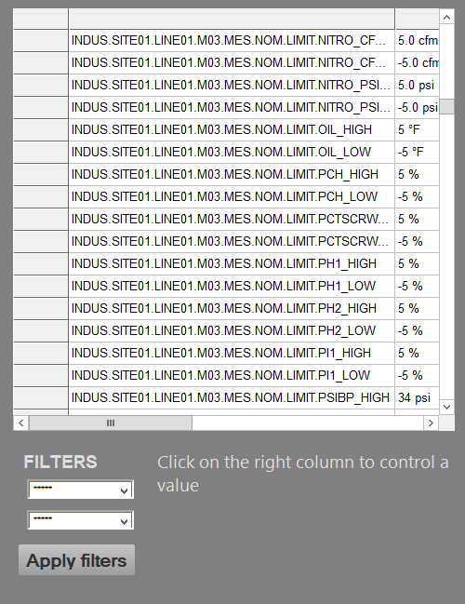

Figure 66 - Variable tracking table

System variables

The supervisor shall have many system variables which contain information about system behavior and performance.
This variables shall be used anywhere in the project to display the status of the system components.

Audit diagnostics

An Audit interface shall contain information about the internal operation of the Supervisor. Its main use is as an aid to diagnose unexpected or erroneous behavior but it can also be used to check the general "health" of a project. The information comes from the executables (.exe) from which the Supervisor is composed, and the individual managers contained therein. The Audit Dialog contains two tabs.
• Counters
• Objects - System resource and configuration object counters
• Instance - Counters of messages between the Supervisor's managers and the memory that has been allocated.
• Time - The time spent processing the messages for each manager.
• Flow - Data flows associated with the change of real-time value of variables in the Variables Tree.
• Monitoring - Detailed information about the data flows associated with the change of real-time value of variables in the Variables Tree, presented in a graphical format. Two graphics are available, one that shows information about data acquisition (data into the Supervisor) and the other about data commands (data sent from the Supervisor).

The information from the Counters Tab is also dumped in text files that can be found in the Log Files folder.
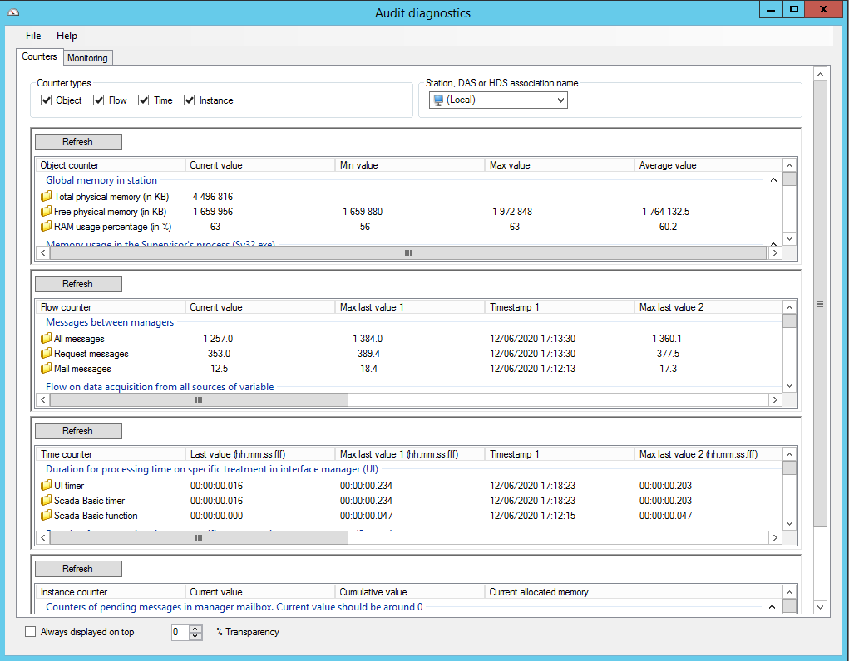
The information from the Flows tab is also available in system variables in the Variables Tree. These variables must be enabled in the Audit Configuration dialog before the Supervisor creates them.
Figure 67 - Audit diagnostic

Monitoring

The monitoring tab contains information about the flow of real time data between the Supervisor's managers. Using the drop down list box at the top left hand corner of the dialog you can choose to display information about either data being acquired by the Supervisor, or data being produced by the Supervisor.

• Data acquisition - Data being acquired by the Supervisor. For example, the contents of a read frame of one of the native drivers.

• Data command - Data being produced and sent by the Supervisor. For example, the contents of a write frame of one of the native drivers.

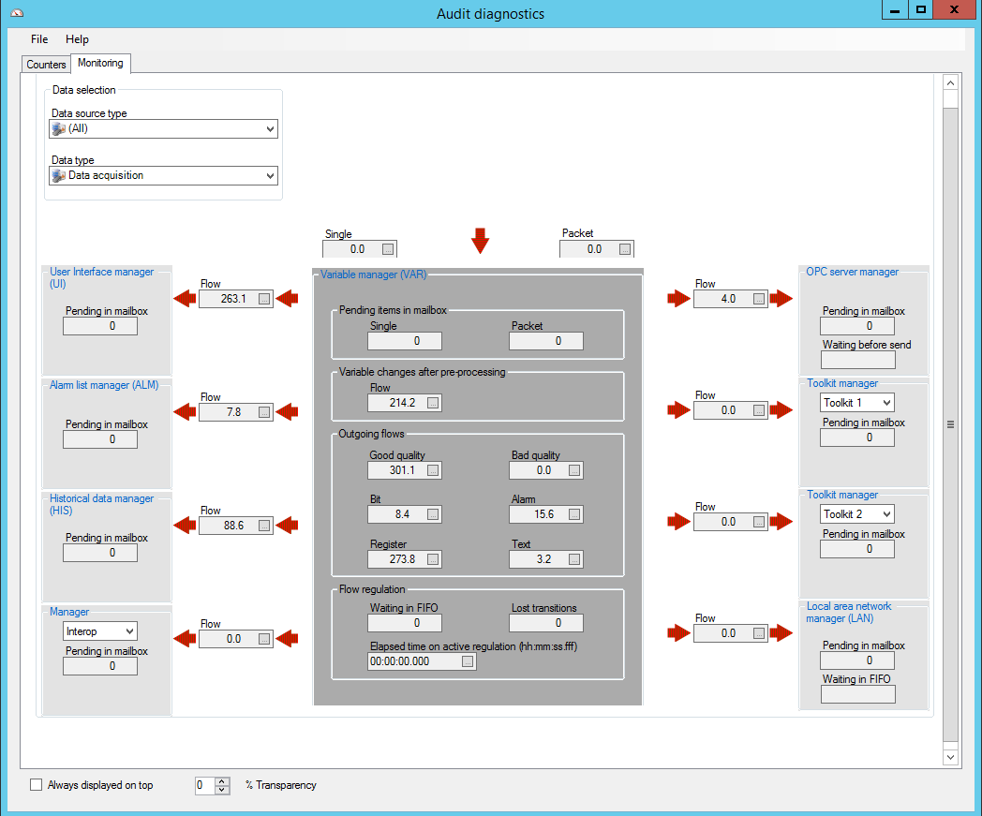

Figure 68 - Data flow monitoring

Data acquisition engine diagnostic tool

In addition to the integrated audit diagnostics of the supervisor, a specific monitoring tool for communication manager is provided. It has a system for errors specific to each protocol used to view real-time information and errors given by the protocol.

Logging and tracing

Event log

This tool shall display in real time every messages, information or errors from the core of the supervisor system, allowing tracking any abnormal behavior and understanding any malfunctions.

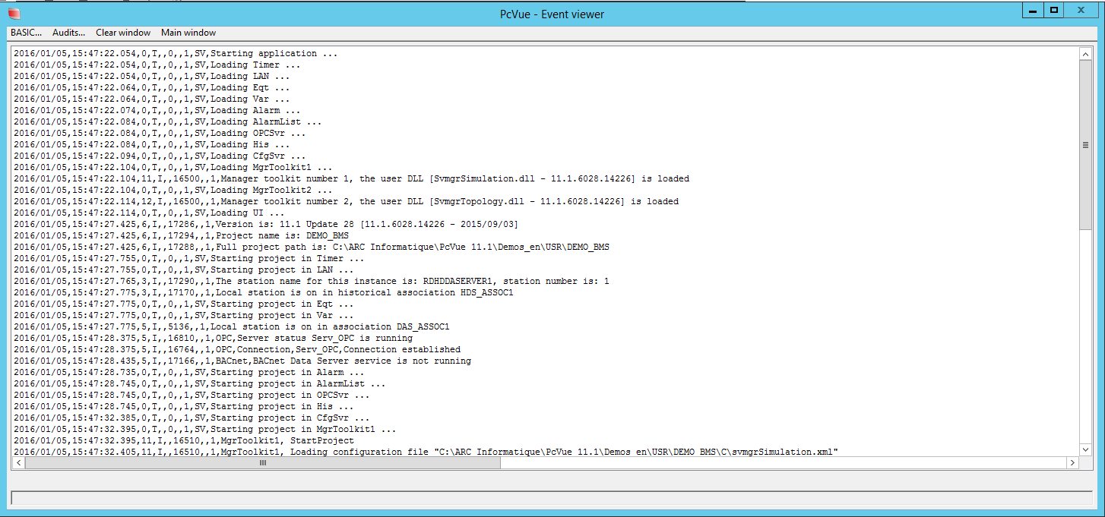

Figure 69 - Event viewer

SYSLOG and Windows events viewer

The supervisor shall enable event logs to be aggregated by 3rd party IT system monitoring tools for events correlation and analysis: the supervisor supports for Windows event viewer and SYSLOG over UDP, TCP & TLS – RFC 3164 & 5424 and is compliant with the ANSSI and IEC 62443 requirements for logging and tracing.
References

Figure 1 Project template 6
Figure 2 Variable tree 9
Figure 6 - Example of a mimic using tabs 20
Figure 7 - Example of a mimic using a navigator panel 21
Figure 3 - Example of a Trend Viewer 22
Figure 4 - Example of Y=f(X) chart 23
Figure 5 - Example of charts 25
Figure 8 - Mimic embedding a geographical interactive map 26
Figure 9 - Markers displayed on a Map 27
Figure 10 - Marker editor 27
Figure 11 – Off line map generator 28
Figure 49 – BIM viewer configuration 30
Figure 50 – BIM viewer run-time 31
Figure 52 – ONVIF Video equipements - configuration 32
Figure 53 – ONVIF video equipements - Run-Time 33
Figure 54 – Built-in RSTP flow player 34
Figure 17 – Mimic with instant messaging control 36
Figure 12 - An event viewer 41
Figure 13 - Message profile 44
Figure 62 – Event action settings 47
Figure 63 – Cyclic action settings 48
Figure 22 - SCADA BASIC Script Editor 49
Figure 23 – VBA Script Editor 49
Figure 69 – Required Security features 51
Figure 14 – Example of a web deployment console 55
Figure 22 – Screenshot of contextual mobile app 58
Figure 23 – Screenshot of smart bots: run-time and design 59
Figure 66 - Variable tracking table 61
Figure 67 - Audit diagnostic 62
Figure 68 - Data flow monitoring 63
Figure 69 - Event viewer 64



Supervision System Specifications

